A Service of Worship, Praise and Hope
Welcome to St. Timothy Saturday Evening Worship!
April 12, 2025, Palm Sunday Weekend



"Equip people to grow as Disciples faithfully serving our community"

We are glad to have you worship with us. All are welcome at communion. If you need gluten-free – please tell Pastor Joanie when you go up for communion. If you have any questions – just ask the Welcomer at the back of the sanctuary.

Please note** if you use a pew envelope for your offering – please write your name on the envelope so that the financial secretaries can post it as a gift from you. Thank You!
St Timothy Worship Planning Team
Pastor Lynn Bechdolt
Eric Mortensen, Director of Music
Parish Deacon, Frank Hofstetter

The Altar Palms are given by ___________

This Week at St. Timothy's
Monday, April 14 10am -Ruth Circle
Tuesday, April 15 1pm - WELCA
Wednesday, April 16
Thursday, April 17 No Prayer Group, 11am – Miniatures, 7pm – Maundy Thursday

Friday, April 18 7pm – Good Friday Tenebrae Svc
Saturday, April 19 4pm – Easter Vigil
Easter Sunday, April 20 7am – Sunrise Service, 8am – Breakfast, 9:30am – Traditional Service

Rooted in the past and growing into the future, the church must always be reformed in order to live out the love of Christ in an ever-changing world. We celebrate the good news of God’s grace, that Jesus Christ sets us free every day to do this life-transforming work. Trusting in the freedom given to us in baptism, we pray for the church, that Christians will unite more fully in worship and mission.
(from Sundays and Seasons for Reformation Weekend)
Welcome and Sharing of Congregational News
Preparation Hymn: Lift Up Your Heads W&P 88

Gathering Hymn: All Glory, Laud, and Honor ELW 344

Refrain
All glory, laud, and honor to you, redeemer, king,
to whom the lips of children made sweet hosannas ring.
1 You are the king of Israel and David's royal Son,
now in the Lord's name coming, our King and Blessed One. Refrain
2 The company of angels are praising you on high;
creation and all mortals in chorus make reply. Refrain
3 The multitude of pilgrims with palms before you went;
our praise and prayer and anthems before you, we present. Refrain
4 To you, before your passion, they sang their hymns of praise.
To you, now high exalted, our melody we raise. Refrain
5 Their praises you accepted; accept the prayers we bring,
great author of all goodness, O good and gracious King. Refrain

Blessing of the Palms
P: Almighty God, on this day, your son Jesus Christ entered the holy city of Jerusalem and was proclaimed King by those who spread garments and palm branches along his way. Let these branches be signs for us of his victory, and grant that we who bear them in his name may always hail him as our Lord, and follow him in the way that leads to eternal life. In Jesus name we pray.
C: Amen.
Confession and Forgiveness
P: Blessed be the Holy Trinity, + one God, whose name is majestic in all the earth, who rescues and heals in every time of trouble, who does all things well.
C: Amen
P: Let us come before God, seeking forgiveness and life.
(Silence is kept for reflection and self-examination)
P: Steadfast and saving God,
C: Have mercy on us. We confess to you all our sins and that in these continuing times of uncertainty and fear, we have trouble trusting you and feeling your presence. Forgive us our sins, our doubts, our fears and lack of patience with others. Strengthen our faith and help us to let your hope and light shine through us in these challenging times. We ask for mercy, wisdom and guidance, through Jesus Christ, our Savior and Lord. Amen.
P: In the name of + Jesus, the Son of God, receive mercy and find grace in your time of need. Your transgressions are forgiven; God's love is healing balm for your wounds. Rejoice, for God raises you up to new life in Christ. C: Amen
Greeting
P: The joy of our Lord Jesus Christ, the compassion of God, and the creative power of the Holy Spirit be with you all.
C: And also with you.
Prayer of the Day
Everlasting God, in your endless love for the human race you sent our Lord Jesus Christ to take on our nature and to suffer death on the cross. In your mercy enable us to share in his obedience to your will and in the glorious victory of his resurrection, who lives and reigns with you and the Holy Spirit, one God, now and forever.
Amen.

Word
Philippians 2:5-11
⁵ Let the same mind be in you that was in Christ Jesus,
⁶ who, though he was in the form of God,
did not regard equality with God
as something to be exploited,
⁷ but emptied himself,
taking the form of a slave,
being born in human likeness.
And being found in human form,
⁸ he humbled himself
and became obedient to the point of death—
even death on a cross.
⁹ Therefore God also highly exalted him
and gave him the name
that is above every name,
¹⁰ so that at the name of Jesus
every knee should bend,
in heaven and on earth and under the earth,
¹¹ and every tongue should confess
that Jesus Christ is Lord,
to the glory of God the Father.

A: Words of God!
C: Words of Life!

P: The Holy Gospel according to Luke, Chapter 23

C: Glory to you O Lord.

Gospel

Luke 23:1-49 or Luke 22:14—23:56
¹ Then the assembly rose as a body and brought Jesus before Pilate. ² They began to accuse him, saying, “We found this man perverting our nation, forbidding us to pay taxes to the emperor, and saying that he himself is the Messiah, a king.” ³ Then Pilate asked him, “Are you the king of the Jews?” He answered, “You say so.” ⁴ Then Pilate said to the chief priests and the crowds, “I find no basis for an accusation against this man.” ⁵ But they were insistent and said, “He stirs up the people by teaching throughout all Judea, from Galilee where he began even to this place.”
⁶ When Pilate heard this, he asked whether the man was a Galilean. ⁷ And when he learned that he was under Herod’s jurisdiction, he sent him off to Herod, who was himself in Jerusalem at that time. ⁸ When Herod saw Jesus, he was very glad, for he had been wanting to see him for a long time, because he had heard about him and was hoping to see him perform some sign. ⁹ He questioned him at some length, but Jesus gave him no answer. ¹⁰ The chief priests and the scribes stood by, vehemently accusing him. ¹¹ Even Herod with his soldiers treated him with contempt and mocked him; then he put an elegant robe on him, and sent him back to Pilate. ¹² That same day Herod and Pilate became friends with each other; before this they had been enemies.
¹³ Pilate then called together the chief priests, the leaders, and the people, ¹⁴ and said to them, “You brought me this man as one who was perverting the people; and here I have examined him in your presence and have not found this man guilty of any of your charges against him. ¹⁵ Neither has Herod, for he sent him back to us. Indeed, he has done nothing to deserve death. ¹⁶ I will therefore have him flogged and release him.”
¹⁸ Then they all shouted out together, “Away with this fellow! Release Barabbas for us!” ¹⁹ (This was a man who had been put in prison for an insurrection that had taken place in the city, and for murder.) ²⁰ Pilate, wanting to release Jesus, addressed them again; ²¹ but they kept shouting, “Crucify, crucify him!” ²² A third time he said to them, “Why, what evil has he done? I have found in him no ground for the sentence of death; I will therefore have him flogged and then release him.” ²³ But they kept urgently demanding with loud shouts that he should be crucified; and their voices prevailed. ²⁴ So Pilate gave his verdict that their demand should be granted. ²⁵ He released the man they asked for, the one who had been put in prison for insurrection and murder, and he handed Jesus over as they wished.
²⁶ As they led him away, they seized a man, Simon of Cyrene, who was coming from the country, and they laid the cross on him, and made him carry it behind Jesus. ²⁷ A great number of the people followed him, and among them were women who were beating their breasts and wailing for him. ²⁸ But Jesus turned to them and said, “Daughters of Jerusalem, do not weep for me, but weep for yourselves and for your children. ²⁹ For the days are surely coming when they will say, ‘Blessed are the barren, and the wombs that never bore, and the breasts that never nursed.’ ³⁰ Then they will begin to say to the mountains, ‘Fall on us’; and to the hills, ‘Cover us.’ ³¹ For if they do this when the wood is green, what will happen when it is dry?”
³² Two others also, who were criminals, were led away to be put to death with him. ³³ When they came to the place that is called The Skull, they crucified Jesus there with the criminals, one on his right and one on his left. ³⁴ ⟦Then Jesus said, “Father, forgive them; for they do not know what they are doing.”⟧ And they cast lots to divide his clothing. ³⁵ And the people stood by, watching; but the leaders scoffed at him, saying, “He saved others; let him save himself if he is the Messiah of God, his chosen one!” ³⁶ The soldiers also mocked him, coming up and offering him sour wine, ³⁷ and saying, “If you are the King of the Jews, save yourself!” ³⁸ There was also an inscription over him, “This is the King of the Jews.”
³⁹ One of the criminals who were hanged there kept deriding him and saying, “Are you not the Messiah? Save yourself and us!” ⁴⁰ But the other rebuked him, saying, “Do you not fear God, since you are under the same sentence of condemnation? ⁴¹ And we indeed have been condemned justly, for we are getting what we deserve for our deeds, but this man has done nothing wrong.” ⁴² Then he said, “Jesus, remember me when you come into your kingdom.” ⁴³ He replied, “Truly I tell you, today you will be with me in Paradise.”
⁴⁴ It was now about noon, and darkness came over the whole land until three in the afternoon, ⁴⁵ while the sun’s light failed; and the curtain of the temple was torn in two. ⁴⁶ Then Jesus, crying with a loud voice, said, “Father, into your hands I commend my spirit.” Having said this, he breathed his last. ⁴⁷ When the centurion saw what had taken place, he praised God and said, “Certainly this man was innocent.” ⁴⁸ And when all the crowds who had gathered there for this spectacle saw what had taken place, they returned home, beating their breasts. ⁴⁹ But all his acquaintances, including the women who had followed him from Galilee, stood at a distance, watching these things.

P: The Gospel of Our Lord!
C: Praise to You O Christ!
Reflection on the Word

Hymn of the Day: Ride On, Ride On in Majesty! ELW 346
- Ride on, ride on in majesty! Hear all the
tribes hosanna cry; O Savior meek, your road pursue,
with palms and scattered garments strewed.
- Ride on, ride on in majesty! In lowly
pomp ride on to die. O Christ, your triumphs now begin
o'er captive death and conquered sin.
- Ride on, ride on in majesty! The hosts of
angels in the sky look down with sad and wond'ring
eyes to see the approaching sacrifice.
- Ride on, ride on in majesty! In lowly
pomp ride on to die, bow your meek head to mortal
pain, then take, O Christ, your pow'r and reign!

Apostles Creed
I believe in One God, the Father almighty,
creator of heaven and earth.
I believe in Jesus Christ, God’s only Son, our Lord,
who was conceived by the Holy Spirit,
born of the virgin Mary,
suffered under Pontius Pilate,
was crucified, died, and was buried;
he descended to the dead.*
On the third day he rose again;
he ascended into heaven,
he is seated at the right hand of the Father,
and he will come to judge the living and the dead.
I believe in the Holy Spirit,

the holy catholic church,
the communion of saints,
the forgiveness of sins,
the resurrection of the body,
and the life everlasting. Amen.

Lord, listen to your children praying,
Lord, send your Spirit in this place;
Lord, listen to your children praying,
send us love, send us pow'r, send us grace.

Prayers of the People please stand, sit, or kneel as you are able
Peace
Offering Brought to the Altar
Offering Prayer

We lift our voices, we lift our hands, we lift our lives up to you; we are an Offering. Lord, use our voices, Lord, use our hands, Lord, use our lives, they are yours: we are an offering. All that we have, all that we are, all that we hope to be, we give to you, we give to you. We lift our voices, we lift our hands, we lift our lives up to you; we are an offering, we are an offering.

Jesus’ Words of Promise and Gift of Life
Dear Lord, Jesus Christ:
in the night in which you were betrayed,
You took bread, broke it and gave thanks,
then you gave it to your disciples saying:
take and eat, this is my body I am giving for you.
Do this in remembrance of me.
Again, after supper, Dear Lord Jesus,
You took the cup, gave thanks
and gave it for everyone to drink saying:
this cup is the new covenant in my blood,
I am shedding for you and for all people for the forgiveness of sin.
Do this for the remembrance of me. Amen.
Our Lord's Prayer
C - Our Father in heaven, hallowed be your name, your kingdom come, your will be done, on earth as in heaven. Give us today our daily bread. Forgive us our sins as we forgive those who sin against us. Save us from the time of trial and deliver us from evil. For the kingdom, the power, and the glory are yours, now and forever. Amen.
Invitation to Communion
P: Come to this Table where God really does come to us!
C: Thank You Jesus!

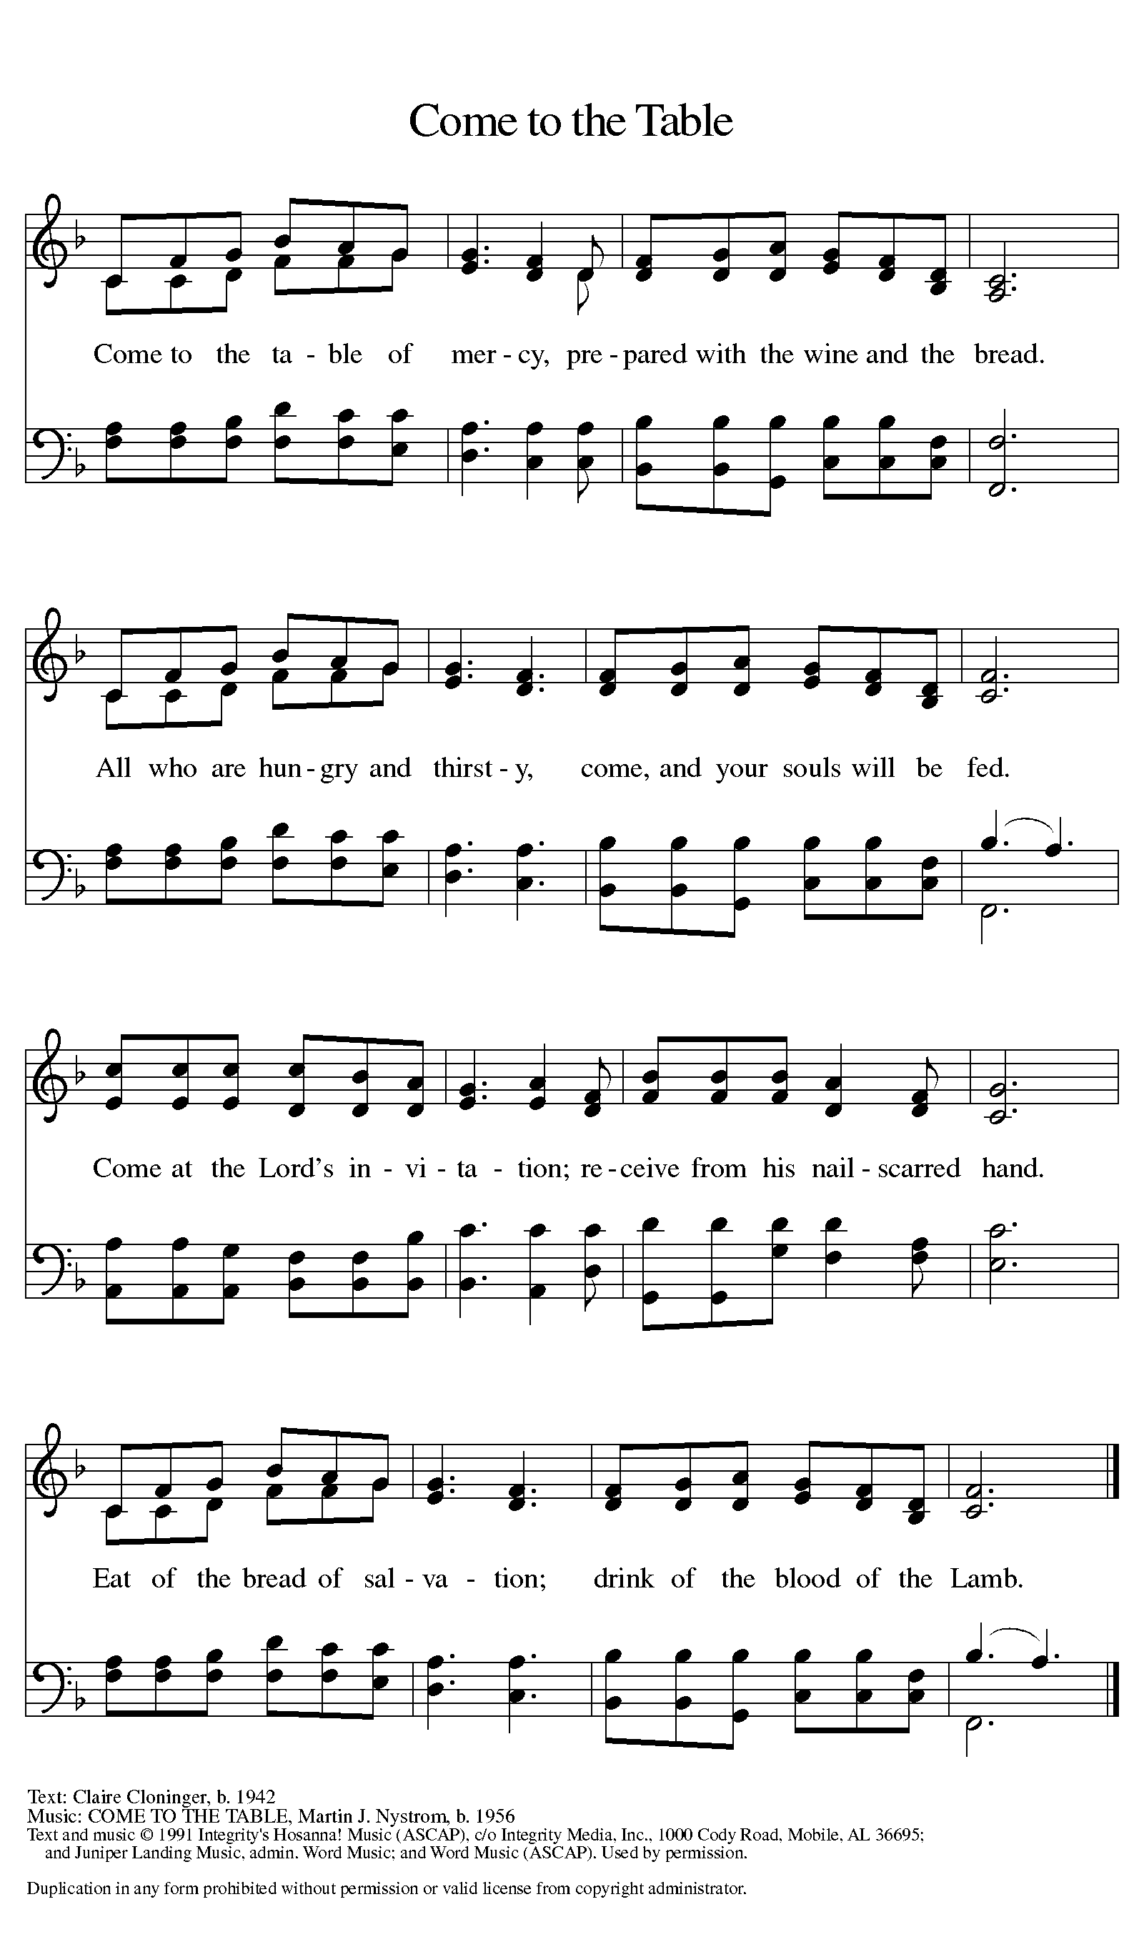

Distribution - Please come forward to receive
Communion Anthem: This is Jesus
P: Now may the body and blood of our Lord and Savior Jesus Christ strengthen you and keep you in His grace….. Jesus Loves You!
C: Thank You Jesus!
Prayer After Communion
Compassionate God, you have fed us with the bread of heaven. Sustain us in our Lenten pilgrimage: may our fasting be hunger for justice, our alms, a making of peace, and our prayer, the song of grateful hearts; through Christ our Lord. Amen.
Sending
Blessing
P: May God who has called us forth from the dust of the earth, and claimed us as children of the light, strengthen you on your journey into life renewed. The Lord bless you and keep you. The Lord’s face shine upon you with grace and mercy. The Lord look upon you with favor and give you ☩ peace.
C: Amen
Sending Hymn: Lift High the Cross ELW 660
Refrain
Lift high the cross, the love of Christ proclaim
till all the world adore his sacred name.
1 Come, Christians, follow where our captain trod,
our king victorious, Christ, the Son of God. Refrain

2 All newborn servants of the Crucified
bear on their brows the seal of him who died. Refrain
3 O Lord, once lifted on the glorious tree,
as thou hast promised, draw us all to thee. Refrain
4 So shall our song of triumph ever be:
praise to the Crucified for victory! Refrain

Dismissal
P: Marked with the cross of Christ, go forth to love and serve the Lord.
C: By the Light of the Cross, We Will! Thanks be to God!
Postlude: All Hail King Jesus W&P 3
Unless otherwise noted, materials used in this bulletin are:
From Sundays and Seasons.com. Copyright 2015 Augsburg Fortress. All rights reserved. Reprinted by permission under Augsburg Fortress Liturgies Annual License #SAS028635. Music is reprinted under OneLicense.Net #A712074 and/or Augsburg Fortress #SBL12176H. Scripture, unless otherwise noted, is from the New Revised Standard Version Bible, Copyright © 1989, Division of Christian Education of the National Council of the Churches of Christ in the United States of America. Used by permission. All rights reserved.
REMEMBRANCE
Olavus Petri, priest, died 1552; Laurentius Petri, Bishop of Uppsala, died 1573; renewers of the church
These two brothers studied with Luther at the University of Wittenberg and then returned to their native Sweden to introduce the Lutheran reforms. Olavus published a catechism and hymnal; Laurentius was a professor who defended the office of bishop and later became one.
From sundaysandseasons.com. PL

