St. Timothy Lutheran Church
Sunday, October 13th, 2024
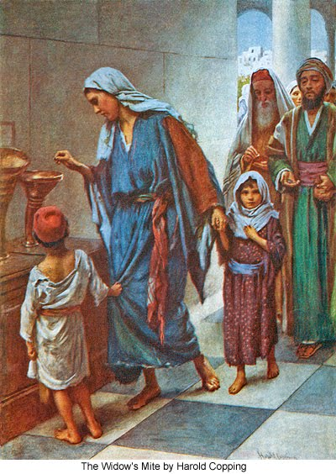
"Equip people to grow as Disciples faithfully serving our community"

We are glad to have you worship with us. All are welcome at communion. If you need gluten-free – please tell Pastor Joanie when you go up for communion. If you have any questions – just ask the Welcomer at the back of the sanctuary.

Please note** if you use a pew envelope for your offering – please write your name on the envelope so that the financial secretaries can post it as a gift from you. Thank You!
St Timothy Worship Planning Team
The Reverend Joan E. Holden 850-774-7730
Eric Mortensen, Director of Music
Parish Deacon, Frank Hofstetter

The Altar Flowers are given by Dick Kleinsmith in honor of his wife Donna’s birthday

This Week at St. Timothy's
Monday, October 14th 10:30 am – Ruth Circle, 1 pm – Garden Club
Tuesday, October 15th 1 pm – WELCA, 2:30pm – Book Study
Wednesday, October 16th 10am OT BS, 2 pm – Worship Meeting
Thursday, October 17th 9:30am – Prayer Group, 11am – Miniatures, 4:30pm – Choir, 5:15pm – Chimes, Council Retreat
Friday, October 18th No Classes, Council Retreat
Saturday, October 19th 4pm – Worship
Sunday, October 20th 9am – Worship, Children’s SS, 10:30am Adult SS, 11-11:30am – DriveUp Communion, 11:45 am – Council Meeting

Rooted in the past and growing into the future, the church must always be reformed in order to live out the love of Christ in an ever-changing world. We celebrate the good news of God’s grace, that Jesus Christ sets us free every day to do this life-transforming work. Trusting in the freedom given to us in baptism, we pray for the church, that Christians will unite more fully in worship and mission.
(from Sundays and Seasons for Reformation Weekend)

“Shout to the Lord” is the last pre-service hymn the choir sings, it is Hymn #821 and everyone is welcome to sing with the choir.
Welcome and Congregational News

Preparation Hymn: All That We Have W&P 5
Confession and Forgiveness
(Stand)
P – In the name of the Father, and of the Son, (+) and of the Holy Spirit.
C – Amen
P – Almighty God, to whom all hearts are open, all desires known, and from whom no secrets are hid; Cleanse the thoughts of our hearts by the inspiration of your Holy Spirit, that we may perfectly love you and worthily magnify your holy name, through Jesus Christ our Lord.
C – Amen
P - If we say we have no sin, we deceive ourselves, and the truth is not in us, But if we confess our sins, God who is faithful and just will forgive our sins and cleanse us from all unrighteousness.
(stand, sit or kneel as you are able)
P– Most Merciful God,
C – Have mercy on us. We confess to you all our sins and that in these continuing times of uncertainty and fear, we have trouble trusting you and feeling your presence. Forgive us our sins, our doubts, our fears and lack of patience with others. Strengthen our faith and help us to let your hope and light shine through us in these troubling times. We ask for mercy, wisdom and guidance, through Jesus Christ, our Savior and Lord. Amen.
P - Almighty God, in his mercy, has given his Son to die for us and for his sake, forgives us all our sins. Because we are saved by the actions and faithfulness of Christ, I therefore declare to you the entire forgiveness of all your sins, in the name of the Father, and of the + Son, and of the Holy Spirit.
C – Amen
Gathering Hymn: Founded on Faith ACS 1048
1 Founded on faith, the church—alive by grace—
proclaims the gospel here and ev'ry place.
The word of God resounds through time and space:
Alleluia!
2 Your cross, O Christ, renews our life each day.
Baptized in you, we learn and teach and pray.
Fed by your love, with thankful hearts, we say:
Alleluia!
3 Equipped by prayer, we live the Spirit's call.
Empow'red to serve with gifts, both great and small,
we bring the living hope of God to all.
Alleluia!
4 Growing in grace for God's created earth,
we yearn for justice, peace, and human worth;
a world restored; a faithful, caring church.
Alleluia!
5 Founded on faith, called forth, empow'red to serve,
we share God's endless love without reserve.
Then let us shout aloud the living Word!
Alleluia!
P - The grace of our Lord Jesus Christ, the love of God and the communion of the Holy Spirit be with you all.
C - And also with you.

Prayer of the Day
Generous God, your Son gave his life so that we can come to peace with you. Send your Spirit to guide us in everything we do and in all the choices we make about our time, our talent and our treasure.
Empower us to bear the name of Jesus Christ, our Savior and Lord.
Amen.
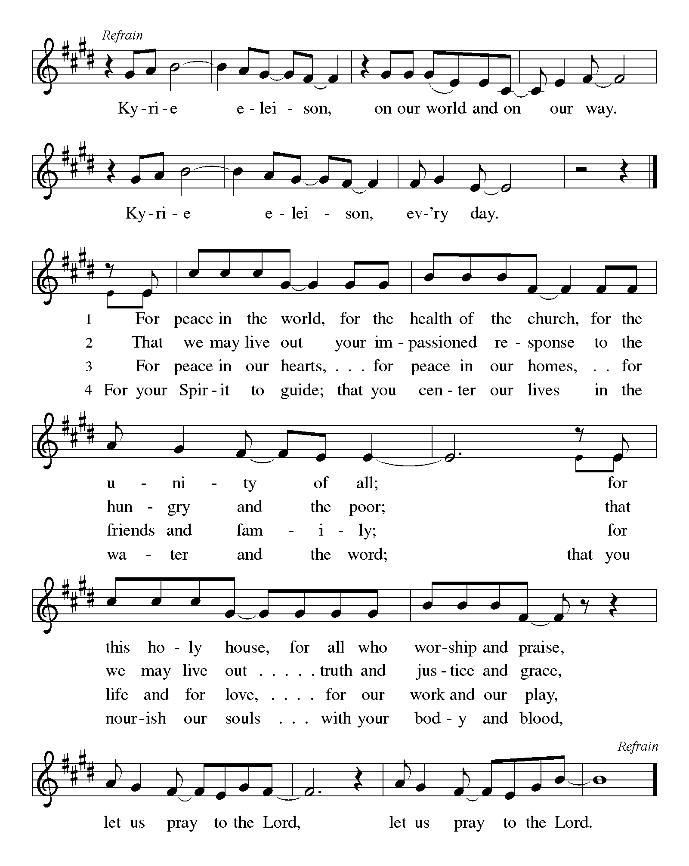

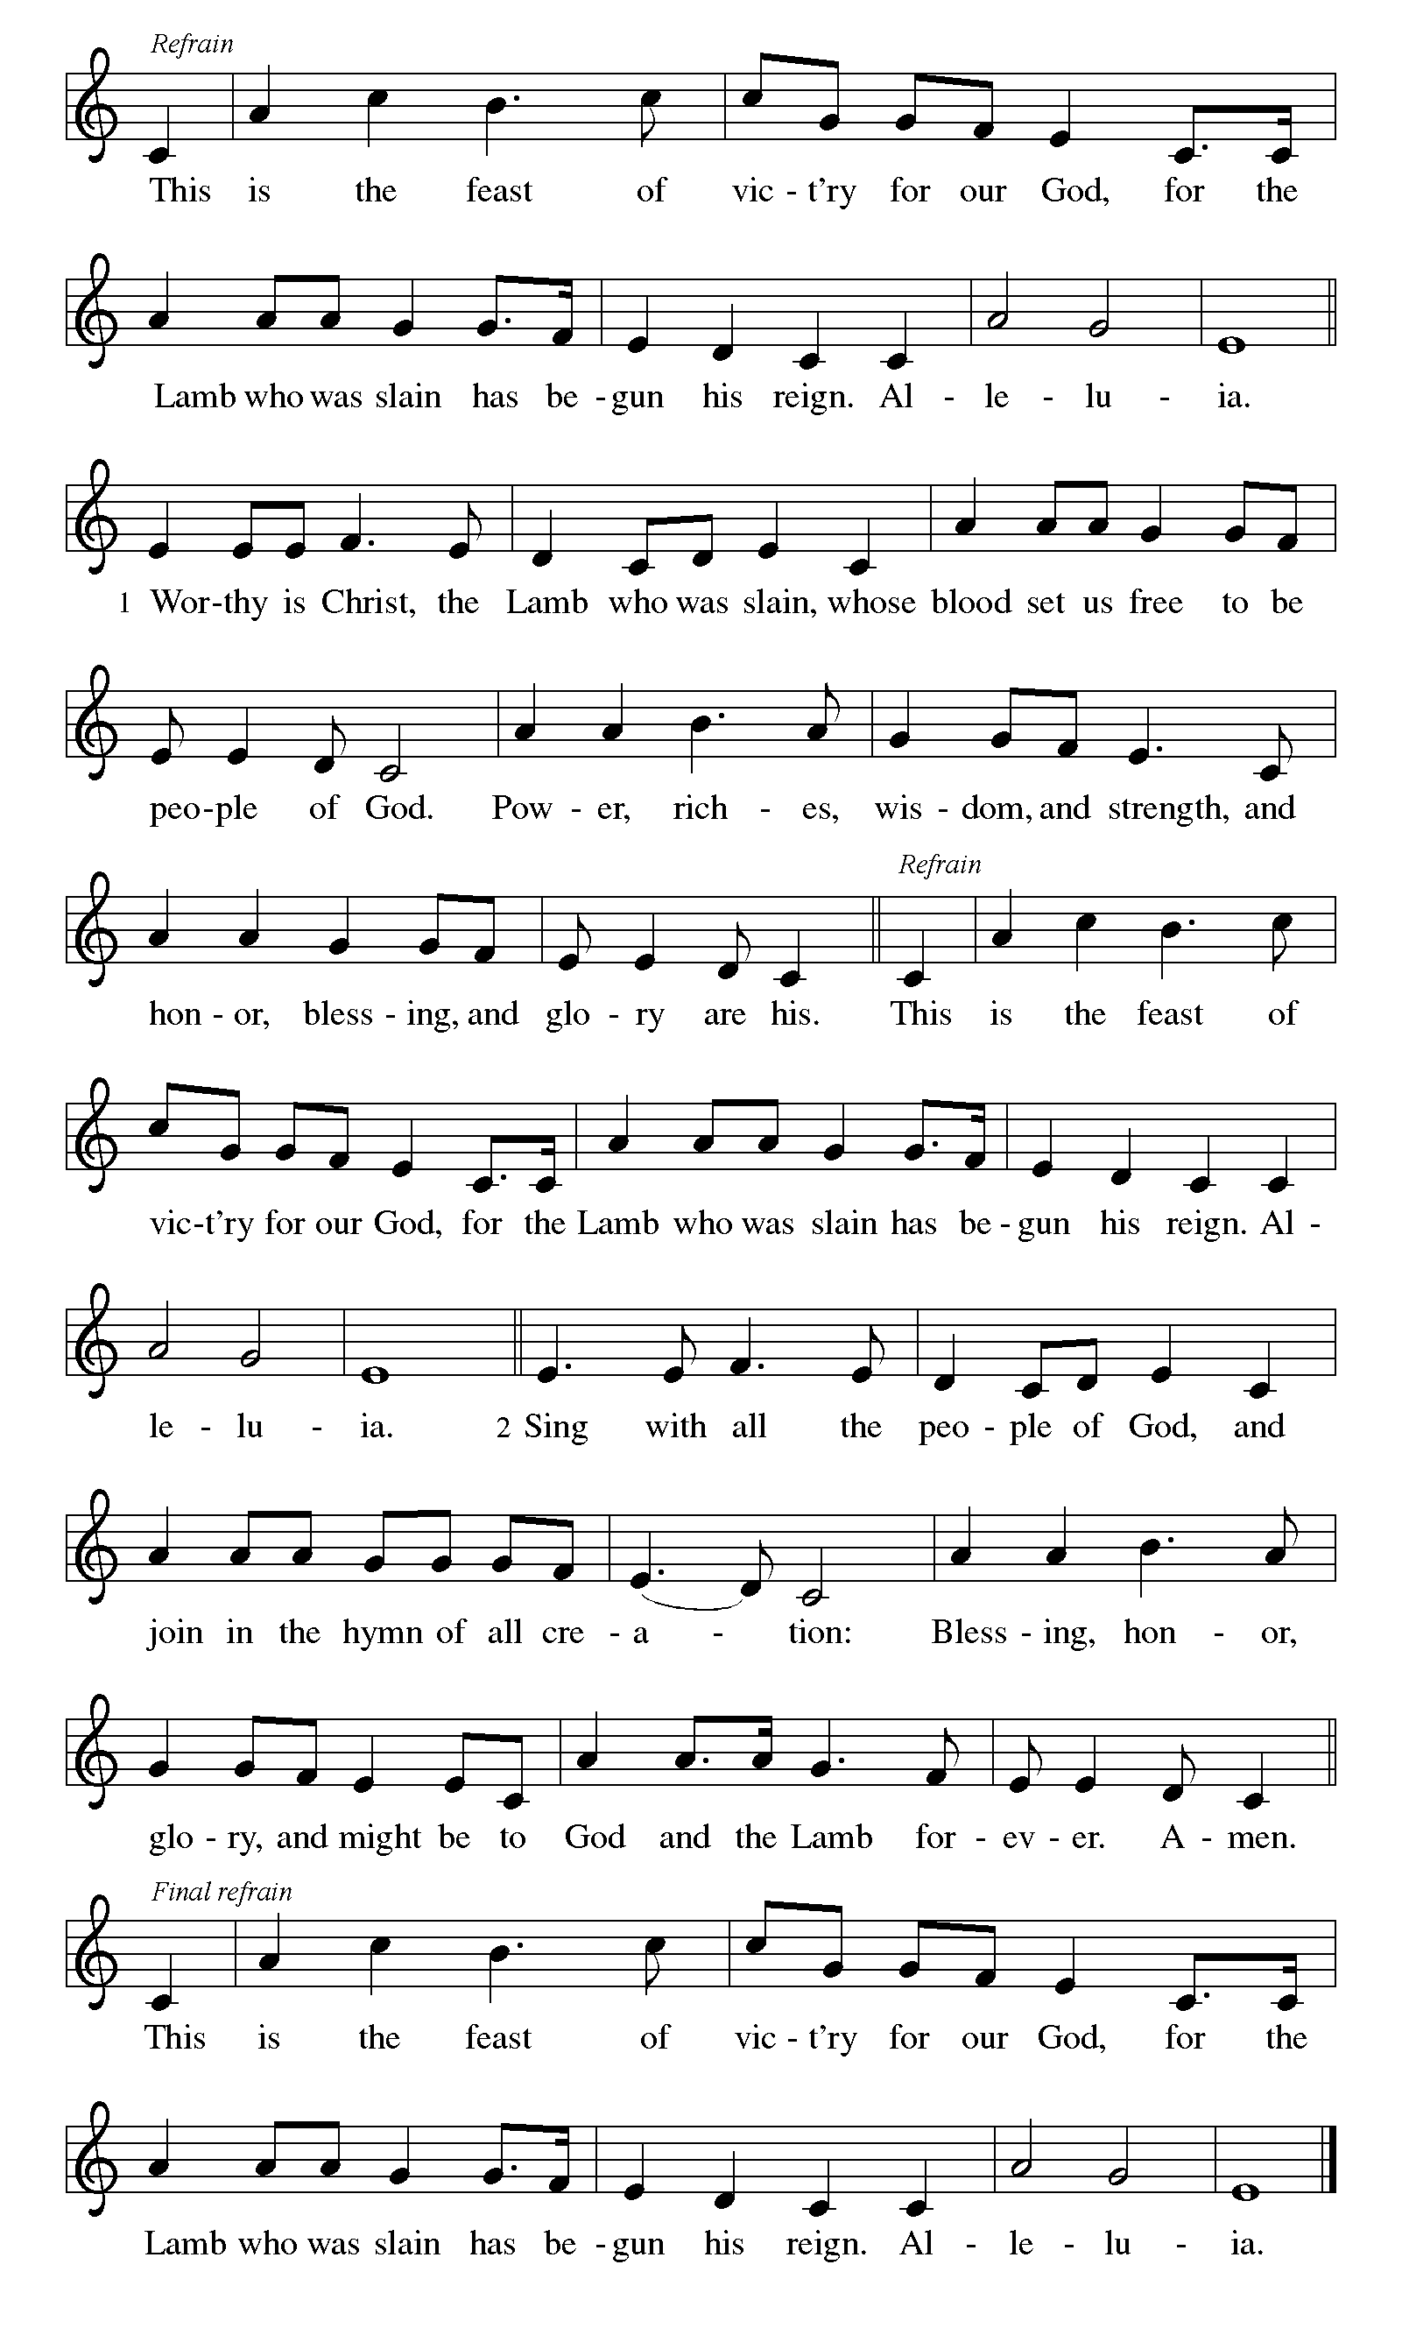
P – The Lord be with you.
C – And also with you. (be seated)

First Lesson: 1 Kings 17:8-16

⁸Then the word of the LORD came to him, saying, ⁹Go now to Zarephath, which belongs to Sidon, and live there; for I have commanded a widow there to feed you. ¹⁰So he set out and went to Zarephath. When he came to the gate of the town, a widow was there gathering sticks; he called to her and said, "Bring me a little water in a vessel, so that I may drink." ¹¹As she was going to bring it, he called to her and said, "Bring me a morsel of bread in your hand." ¹²But she said, "As the LORD your God lives, I have nothing baked, only a handful of meal in a jar, and a little oil in a jug; I am now gathering a couple of sticks, so that I may go home and prepare it for myself and my son, that we may eat it, and die." ¹³Elijah said to her, "Do not be afraid; go and do as you have said; but first make me a little cake of it and bring it to me, and afterwards make something for yourself and your son. ¹⁴For thus says the LORD the God of Israel: The jar of meal will not be emptied and the jug of oil will not fail until the day that the LORD sends rain on the earth." ¹⁵She went and did as Elijah said, so that she as well as he and her household ate for many days. ¹⁶The jar of meal was not emptied, neither did the jug of oil fail, according to the word of the LORD that he spoke by Elijah.

A – Word of God!

C – Words of Life!

Psalm 23

¹The LORD is my shepherd, I shall not want.
²He makes me lie down in green pastures;

he leads me beside still waters;
³he restores my soul. He leads me in right paths for his name's sake.
⁴Even though I walk through the darkest valley, I fear no evil; for you are with me; your rod and your staff — they comfort me.
⁵You prepare a table before me in the presence of my enemies;
you anoint my head with oil; my cup overflows.
⁶Surely goodness and mercy shall follow me all the days of my life, and I shall dwell in the house of the LORD my whole life long.

Second Lesson: 2 Corinthians 8:7-15

⁷Now as you excel in everything — in faith, in speech, in knowledge, in utmost eagerness, and in our love for you — so we want you to excel also in this generous undertaking.
⁸I do not say this as a command, but I am testing the genuineness of your love against the earnestness of others. ⁹For you know the generous act of our Lord Jesus Christ, that though he was rich, yet for your sakes he became poor, so that by his poverty you might become rich. ¹⁰And in this matter I am giving my advice: it is appropriate for you who began last year not only to do something but even to desire to do something — ¹¹now finish doing it, so that your eagerness may be matched by completing it according to your means. ¹²For if the eagerness is there, the gift is acceptable according to what one has — not according to what one does not have. ¹³I do not mean that there should be relief for others and pressure on you, but it is a question of a fair balance between ¹⁴your present abundance and their need, so that their abundance may be for your need, in order that there may be a fair balance. ¹⁵As it is written,
"The one who had much did not have too much,
and the one who had little did not have too little."

A – Word of God!

C – Words of Life!

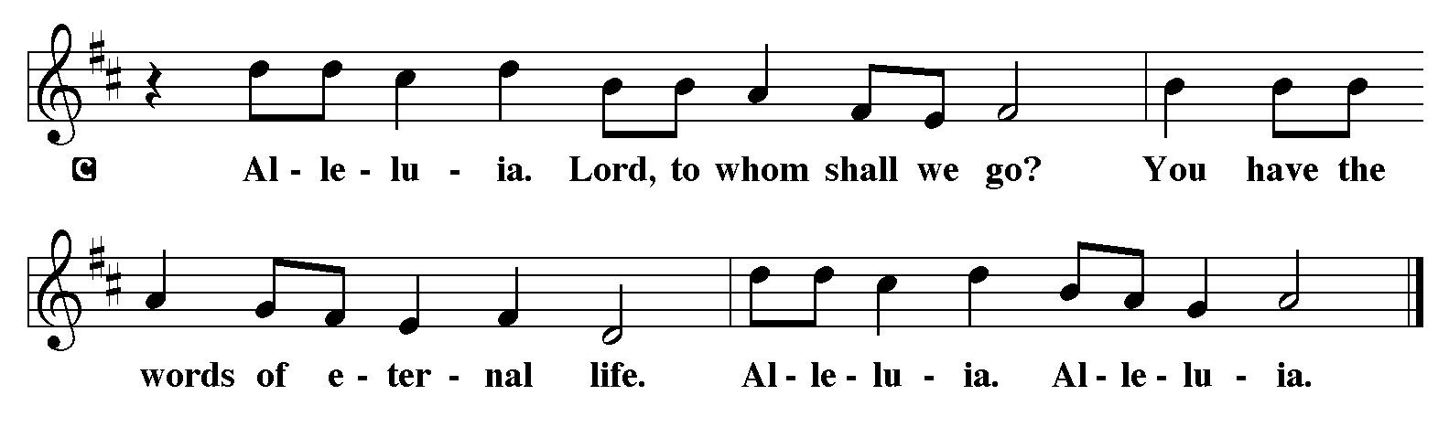
P - The Holy Gospel according to Mark, Chapter 12
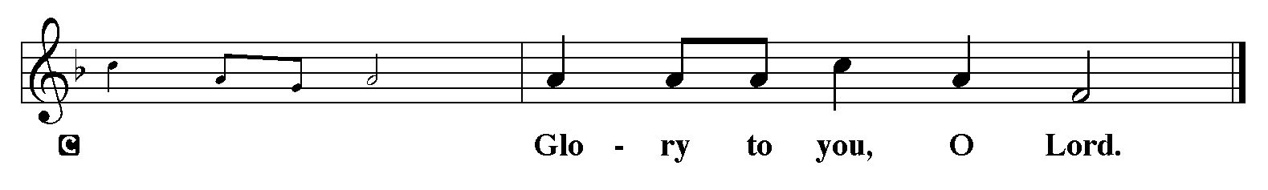

Gospel: Mark 12:41-44

⁴¹He sat down opposite the treasury, and watched the crowd putting money into the treasury. Many rich people put in large sums. ⁴²A poor widow came and put in two small copper coins, which are worth a penny. ⁴³Then he called his disciples and said to them, "Truly I tell you, this poor widow has put in more than all those who are contributing to the treasury. ⁴⁴For all of them have contributed out of their abundance; but she out of her poverty has put in everything she had, all she had to live on."

P - The Gospel of the Lord.
C - Praise to you, O Christ. (Sit)

Children’s Time

Message

Hymn of the Day: What Have We to Offer W&P 156
1 What have we to offer? What have we to share?
Coins from the coffer, hearts filled with care.
God will not falter; so let us dare
lay it at the altar there.
2 What have we to offer? What have we to bring?
Love, ripe with laughter; hope that we can sing;
dreams of what we’re after; promises of when.
Lay it at the altar then.
3 What have we to offer? What have we to give?
Eyes that are wide open; lies that we won’t live;
truth that must be spoken; justice somehow.
Lay it at the altar now.
4 What have we to offer? What have we to give?
Lives we will live.

The Apostles’ Creed
I believe in God, the Father almighty,
creator of heaven and earth.
I believe in Jesus Christ, God’s only Son, our Lord,
who was conceived by the Holy Spirit,
born of the virgin Mary,
suffered under Pontius Pilate,
was crucified, died, and was buried;
he descended to the dead.
On the third day he rose again;
he ascended into heaven,
he is seated at the right hand of the Father,
and he will come to judge the living and the dead.
I believe in the Holy Spirit,
the holy catholic church,
the communion of saints,
the forgiveness of sins,
the resurrection of the body,
and the life everlasting. Amen.
Lord, listen to your children praying,
Lord, send your Spirit in this place;
Lord, listen to your children praying,
send us love, send us pow'r, send us grace.
Prayers of the People please stand, sit, or kneel as you are able
Made children and heirs of God’s promise, we pray for the church, the world, and everyone in need. A brief silence.
We pray for the church and its ministry. Bless all your children and encourage them in their faith journeys. Sustain all members of the body of Christ in lives of prayer, service, and worship. Lord, in your mercy, hear our prayer.
We pray for those in authority and soon to be in authority this election year. Give them wise minds and compassionate hearts. Strengthen in them a desire to protect the vulnerable and care for those underserved. Lord, in your mercy, hear our prayer.
We pray for those who are struggling with cancer, dementia, or any other disease, especially everyone on our prayer list and everyone we name softly out loud or silently in our hearts at this time……. Provide them with peace and resilience for the days ahead. Sustain caregivers with energy and patience. Lord, in your mercy, hear our prayer.
We pray for this congregation, give us servant hearts and hands and help us to allow your Holy Spirit to guide us in every decision we make as individuals and as a congregation during this time of gifts discernment and throughout the year. Lord, in your mercy, hear our prayer.
At this time anyone can lift up prayers:
Lord, in your mercy, hear our prayer.
We give thanks for all your saints, those we have loved and known and those from every time and place. Continue to guide us by their example and reassure us of your promised salvation. Lord, in your mercy, hear our prayer.
Receive these prayers, O God, and those in our hearts known only to you; through Jesus Christ our Lord. Amen.

The Peace
P – The Peace of the Lord be with you always.
C – And also with you.

The Offering is Brought to the Altar
Offering Prayer

We lift our voices, we lift our hands, we lift our lives up to you; we are an Offering. Lord, use our voices, Lord, use our hands, Lord, use our lives, they are yours: we are an offering. All that we have, all that we are, all that we hope to be, we give to you, we give to you. We lift our voices, we lift our hands, we lift our lives up to you; we are an offering, we are an offering.

Jesus’ Words of Promise and Gift of Life
P: Dear Lord, Jesus Christ:
in the night in which you were betrayed,
You took bread, broke it and gave thanks,
then you gave it to your disciples saying:
take and eat, this is my body I am giving for you.
Do this in remembrance of me.
Again, after supper, Dear Lord Jesus,
You took the cup, gave thanks
and gave it for everyone to drink saying:
this cup is the new covenant in my blood,
I am shedding for you and for all people for the forgiveness of sin.
Do this for the remembrance of me. Amen.

Our Lord's Prayer
Our Father in heaven, hallowed be your name, your kingdom come, your will be done, on earth as in heaven. Give us today our daily bread. Forgive us our sins as we forgive those who sin against us. Save us from the time of trial and deliver us from evil. For the kingdom, the power, and the glory are yours, now and forever. Amen.
Invitation to Communion
P: Come to this Table where God really does come to us!
C: Thank You Jesus!

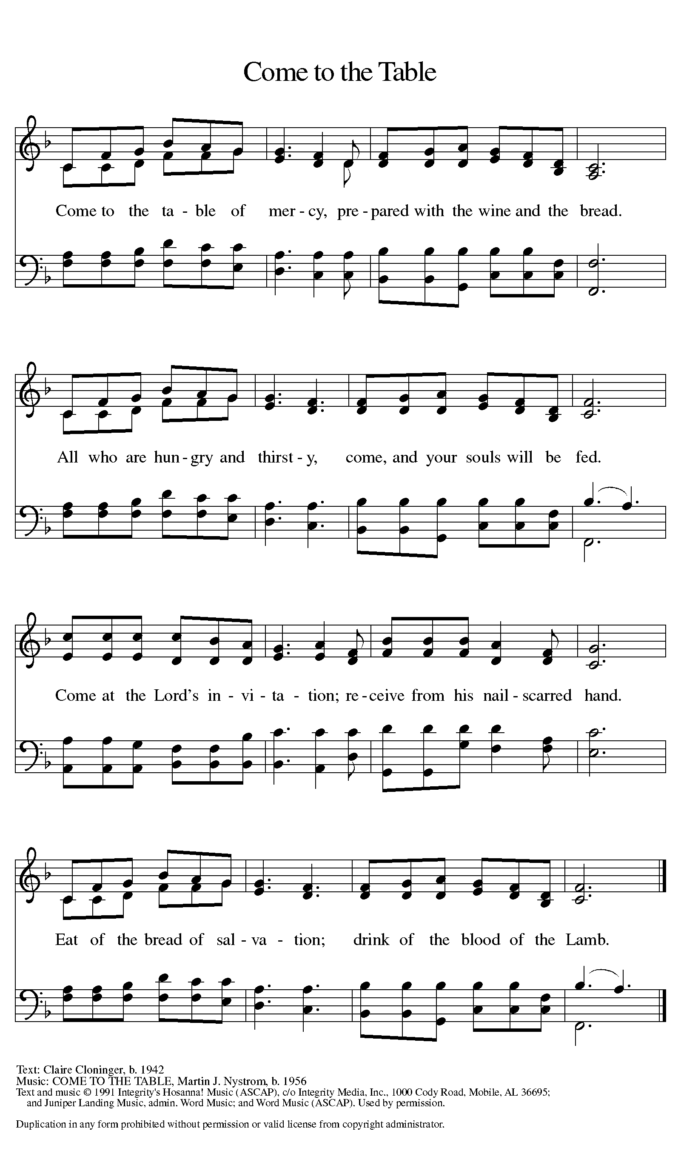

Distribution - Please come forward to receive
Communion Anthems: Blessing, Honor and Glory W&P 21

P – Now may the body and blood of our Lord and Savior, Jesus Christ strengthen you and keep you in His grace … Jesus Loves You!
C – Thank You Jesus!
Communion Prayer
Holy God, you welcome us to this meal and feed us with dignity at your table. Send us now to welcome others and to be at peace with one another, through Jesus Christ our Lord. Amen.
Blessing

P: God all mighty, God most merciful ☩ bless you, keep you, and give you peace.
C: Amen

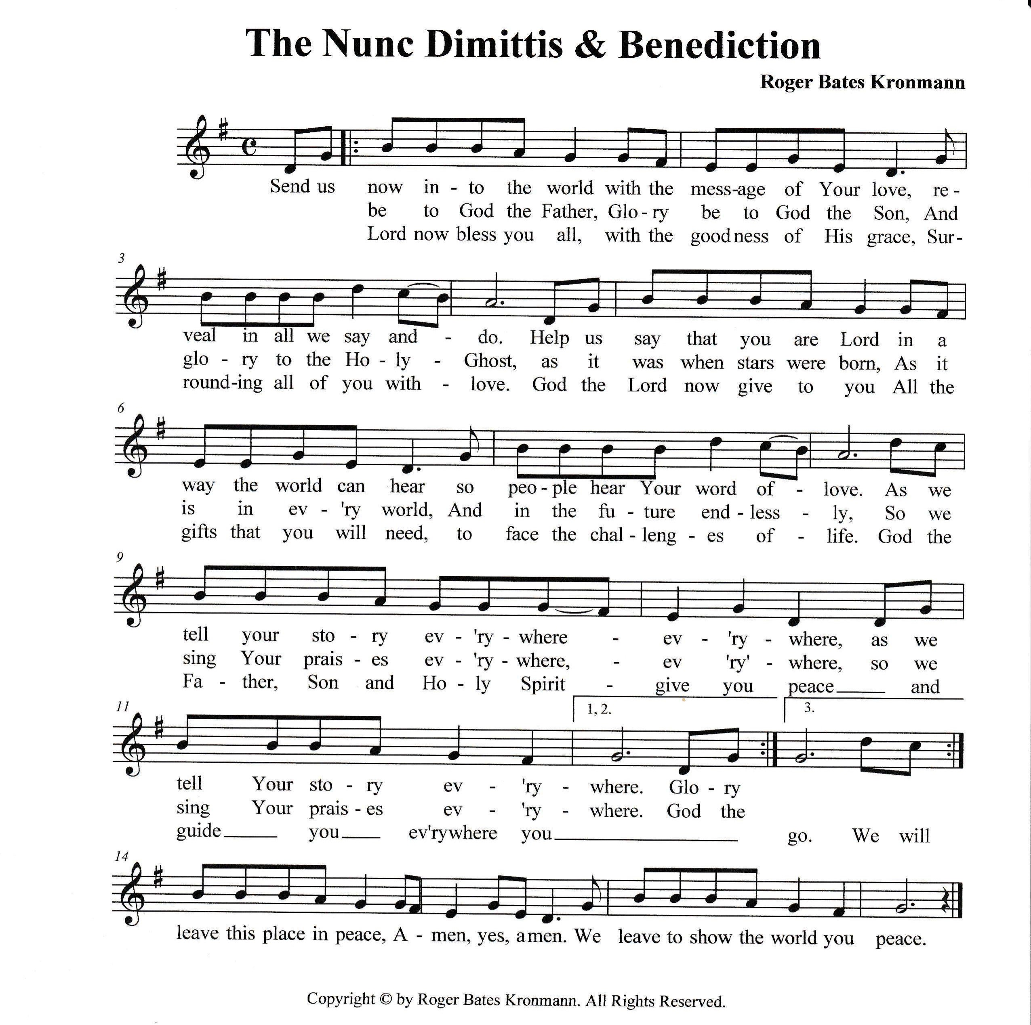

Sending Hymn: What is This Place ELW 524

1 What is this place where we are meeting? Only a house, the earth its floor. Walls and a roof sheltering people, windows for light, an open door. Yet it becomes a body that lives when we are gathered here,

and know our God is near.

2 Words from afar, stars that are falling, sparks that are sown in us like seed: names for our God, dreams, signs, and wonders sent from the past are all we need. We in this place remember and speak again what we have heard: God's free redeeming word.

3 And we accept bread at this table, broken and shared, a living sign.

Here in this world, dying and living, we are each other's bread and wine.

This is the place where we can receive what we need to increase:

our justice and God's peace.
A - Go in peace. Proclaim the Good News!
C - By the Grace of God we will – Allelulia!
Postlude: All Hail King Jesus W&P 3

Unless otherwise noted, materials used in this bulletin are:
From Sundays and Seasons.com. Copyright 2015 Augsburg Fortress. All rights reserved. Reprinted by permission under Augsburg Fortress Liturgies Annual License #SAS028635. Music is reprinted under OneLicense.Net #A712074 and/or Augsburg Fortress #SBL12176H. Scripture, unless otherwise noted, is from the New Revised Standard Version Bible, Copyright © 1989, Division of Christian Education of the National Council of the Churches of Christ in the United States of America. Used by permission. All rights reserved.

Announcements for October 12th and 13th

ATTENDANCE
Saturday, October 5th, 4pm 26
Sunday, October 6th, 9am 37
Drive-Up Communion 2
65

Gospel of Mary Magdalene - First Witness of the Resurrection.
Class began on Tuesday, October 1^{st.} Still time to join. I have the books, so please get with me to get yours. Classes are Tuesday at 2:30pm. ZOOM links available
-PJ

KITCHEN REFRIGERATOR
This is considered a public use kitchen and needs to be kept clean and cleaned out. PERSONAL ITEMS SHOULD BE LABELED WITH YOUR NAME AND DATE AND PLACED IN THE FRIDGE NEXT TO PASTOR JOANIE’S OFFICE. Items shouldn’t be left there longer than one week.

WE ARE BEGINNING TO COLLECT ITEMS FOR THE THANKSGIVING FOOD BOXES. PLEASE SEE SEPARATE LIST.

MINI GRANNY’S ATTIC


CALLING ALL BAKERS!!!!
We need cookies, cakes, cupcakes, brownies, candy, breads, etc. for our Bake Sale on
Friday, October 25th.
- You may package your goodies, or we will do that for you.
- Please mark if the goodies are gluten free
and/or sugar free.
- Please note if there are nuts in the baked
goods.
- Please bring the items to the church either Thursday, October 24th or early Friday, October 25th.
Thanks so much for your help and support.
Questions? Call Eileen at 352-419-6610 or Lynn at 352-382-0435.
