St Timothy Lutheran Church
Sunday, April 20, 2025
Easter Sunday

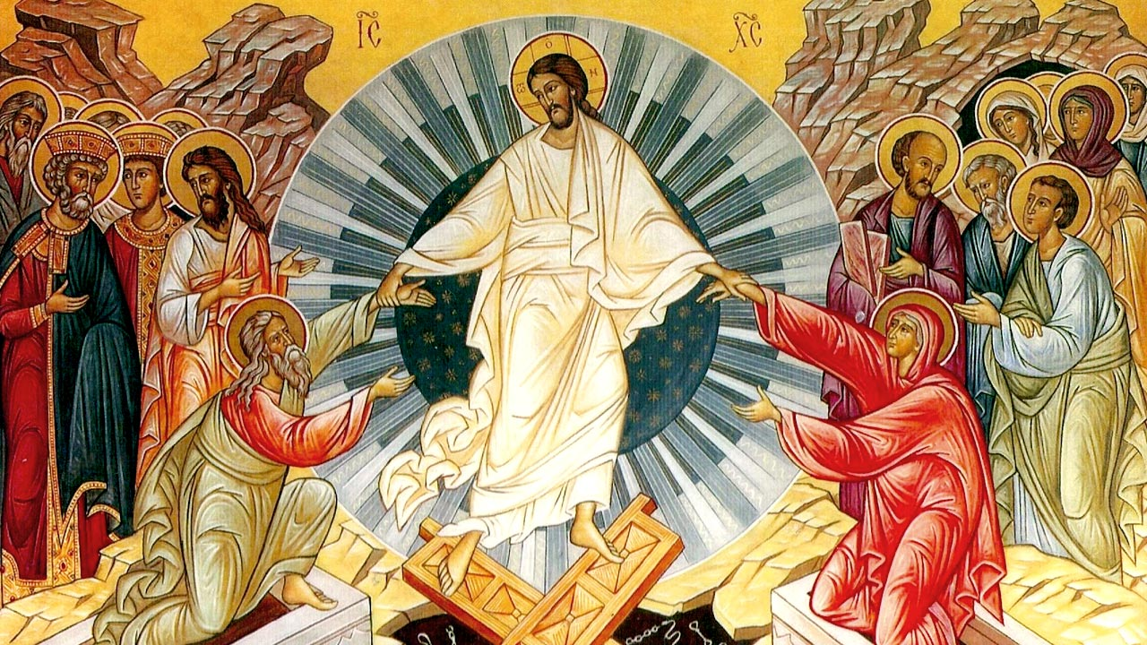

Alleluia, Christ is Risen Today!

"Equip people to grow as Disciples faithfully serving our community"

We are glad to have you worship with us. All are welcome at communion. If you need gluten-free – please let us know when you go up for communion. If you have any questions – just ask the Welcomer at the back of the sanctuary.

Please note** if you use a pew envelope for your offering – please write your name on the envelope so that the financial secretaries can post it as a gift from you. Thank You!

St Timothy’s is served by The Reverend Lynn Bechdolt
Director of Music Eric Mortensen
And Parish Deacon Frank Hofstetter

We begin worship this joyous Easter morning with Affirmation of Our Baptism into the Life, Death, and Resurrection of our Lord and Savior Jesus Christ. It is important for us to remember that in Christ we are made new every day and we are Joint Heirs in the Kingdom with Christ, God the Son.
Since this is Jesus’ House and Table and not ours – all are Welcome to Join With Christ at His Table. Both wheat and gluten-free wafers are served by the Pastor, just let us know at the Table if you need gluten-free. Also, grape juice and water are available for those who prefer one of these instead of the wine – just let the communion assistant know your preference.
Come to this Table Where God Comes to Us!

Many Thanks to Everyone Who
Brought Flowers for
Our Easter Services
-
Thanks to You – Our Church
Is
Especially Beautiful this Easter!

Unless otherwise noted, service materials used in this bulletin are:
"Reprinted from the 1995 Moravian Book of Worship with permission of the Interprovincial Board of Communication, Moravian Church in North America."
Music is reprinted under OneLicense.Net #A712074 and/or Augsburg Fortress #SBL12176H. Scripture, unless otherwise noted, is from the New Revised Standard Version Bible, Copyright © 1989, Division of Christian Education of the National Council of the Churches of Christ in the United States of America. Used by permission. All rights reserved.

Welcome!
Preparation Hymn: Chimes: All Creatures of Our God and King
The Day of Resurrection
Confession and Forgiveness
P – In the name of the Father, and of the Son, (+) and of the Holy Spirit.
C – Amen

P – Almighty God, to whom all hearts are open, all desires known, and from whom no secrets are hid; Cleanse the thoughts of our hearts by the inspiration of your Holy Spirit, that we may perfectly love you and worthily magnify your holy name, through Jesus Christ our Lord.
C – Amen

P - If we say we have no sin, we deceive ourselves, and the truth is not in us, But if we confess our sins, God who is faithful and just will forgive our sins and cleanse us from all unrighteousness.

P – Most Merciful God,
C – We confess that we are in bondage to sin and cannot free ourselves. We have sinned against you in thought, word, and deed, by what we have done and by what we have left undone. We have not loved you with our whole heart; we have not loved our neighbors as ourselves. For the sake of your Son, Jesus Christ, have mercy on us. Forgive us, renew us and lead us, so that we may delight in your will and walk in your ways, to the glory of your holy name. Amen
P – Almighty God, in his mercy, has given his Son to die for us and for his sake, forgives us all our sins. As a called and ordained minister of the Church of Christ, and by his authority, I therefore declare to you the entire forgiveness of all your sins, in the name of the Father, and of the + Son, and of the Holy Spirit.
C – Amen

Affirmation of Baptism
In the early church, baptism took place once a year –
at sunrise on Easter.
It is appropriate today, Easter morning, that we affirm our baptism.

P - Dear friends, we give thanks for the gift of baptism as we come before God to make public affirmation of baptism into Christ.

P - Let us pray.
Merciful God, we thank you that you have made us your own by water and the Word in baptism. You have called us to yourself, enlightened us with the gifts of your Spirit, and nourished us in the community of faith. Uphold us and all your servants in the gifts and promises of baptism, and unite the hearts of all whom you have brought to new birth. We ask this in the name of Christ.
C - Amen.

Profession of Faith by The Congregation
P - I ask you to profess your faith in Christ Jesus, reject sin, and confess the faith of the church.
Do you renounce the devil and all the forces that defy God,
the powers of this world that rebel against God,
and the ways of sin that draw you from God?
C - I renounce them.
Do you believe in God the Father?
I believe in God, the Father almighty,
creator of heaven and earth.

Do you believe in Jesus Christ, the Son of God?
I believe in Jesus Christ, God’s only Son, our Lord,
who was conceived by the Holy Spirit,
born of the virgin Mary,
suffered under Pontius Pilate,
was crucified, died, and was buried;
he descended to the dead.*
On the third day he rose again;
he ascended into heaven,
he is seated at the right hand of the Father,
and he will come to judge the living and the dead.
Do you believe in God the Holy Spirit?
I believe in the Holy Spirit,
the holy catholic church,
the communion of saints,
the forgiveness of sins,
the resurrection of the body,
and the life everlasting.
You have made public profession of your faith. Do you intend to continue in the covenant God made with you in holy baptism:
to live among God’s faithful people,
to hear the word of God and share in the Lord’s supper,
to proclaim the good news of God in Christ through word and deed,
to serve all people, following the example of Jesus,
and to strive for justice and peace in all the earth?
C- I do, and I ask God to help and guide me.
People of God, do you promise to support and pray for one another in your life in Christ?
C - We do, and we ask God to help and guide us.

P - We give you thanks, O God, that through water and the Holy Spirit you give us new birth, cleanse us from sin, and raise us to eternal life. Stir up in your people the gift of your Holy Spirit: the spirit of wisdom and understanding, the spirit of counsel and might, the spirit of knowledge and the fear of the Lord, the spirit of joy in your presence both now and forever.
C - Amen.

Reminder of Baptism During the Gathering Hymn
Gathering Hymn: Jesus Christ is Risen Today ELW 365
1 Jesus Christ is ris'n today, Alleluia!
our triumphant holy day, Alleluia!
who did once upon the cross, Alleluia!
suffer to redeem our loss. Alleluia!
2 Hymns of praise then let us sing, Alleluia!
unto Christ, our heav'nly king, Alleluia!
who endured the cross and grave, Alleluia!
sinners to redeem and save. Alleluia!
3 But the pains which he endured, Alleluia!
our salvation have procured; Alleluia!
now above the sky he's king, Alleluia!
where the angels ever sing. Alleluia!
4 Sing we to our God above, Alleluia!
praise eternal as his love; Alleluia!
praise him, all you heav'nly host, Alleluia!
Father, Son, and Holy Ghost. Alleluia!

P - The grace of our Lord Jesus Christ, the love of God and the communion of the Holy Spirit be with you all.
C - And also with you.

Prayer of the Day
O God, you gave your only Son to suffer death on the cross for our redemption, and by his glorious resurrection you delivered us from the power of death. Make us die every day to sin, that we may live with him forever in the joy of the resurrection, through your Son, Jesus Christ our Lord, who lives and reigns with you and the Holy Spirit, one God, now and forever. Amen.

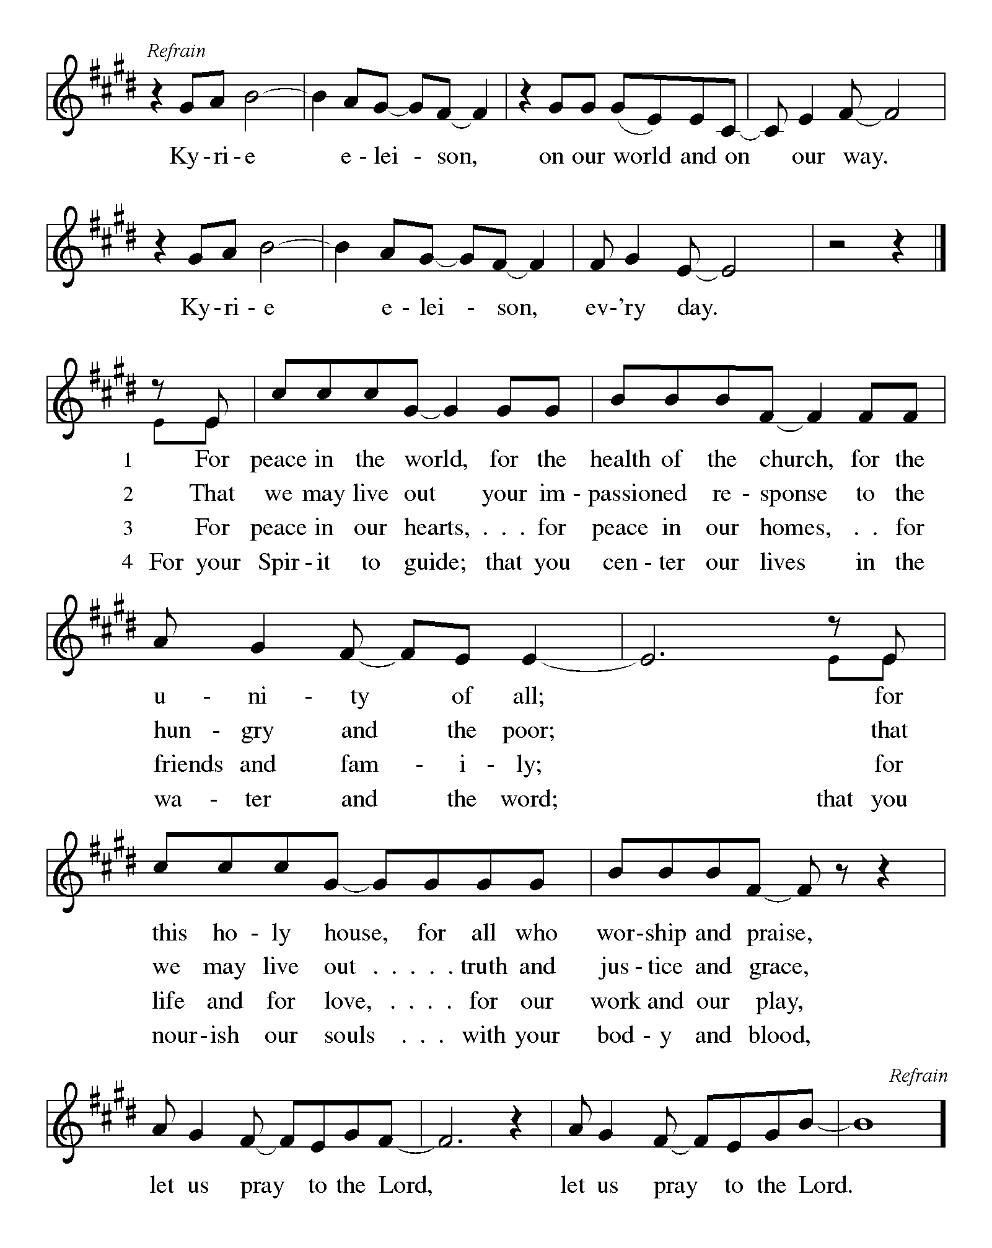

P – The Lord be with you!
C – And also with you! (be seated)

First Lesson: Isaiah 65:17-25
¹⁷I am about to create new heavens
and a new earth;
the former things shall not be remembered
or come to mind.
¹⁸But be glad and rejoice forever
in what I am creating;
for I am about to create Jerusalem as a joy,
and its people as a delight.
¹⁹I will rejoice in Jerusalem, and delight in my people;
no more shall the sound of weeping be heard in it,
or the cry of distress.
²⁰No more shall there be in it
an infant that lives but a few days,
or an old person who does not live out a lifetime;
for one who dies at a hundred years will be considered a youth,
and one who falls short of a hundred will be considered accursed.
²¹They shall build houses and inhabit them;
they shall plant vineyards and eat their fruit.
²²They shall not build and another inhabit;
they shall not plant and another eat;
for like the days of a tree shall the days of my people be,
and my chosen shall long enjoy the work of their hands.
²³They shall not labor in vain, or bear children for calamity;
for they shall be offspring blessed by the Lord—
and their descendants as well.
²⁴Before they call I will answer,
while they are yet speaking I will hear.
²⁵The wolf and the lamb shall feed together,
the lion shall eat straw like the ox;
but the serpent—its food shall be dust!
They shall not hurt or destroy
on all my holy mountain,
says the Lord.

A – Words of God!

C – Words of Life!

Psalm 118:1-2, 14-24
¹Give thanks to the Lord, for the Lord is good;
God’s mercy endures forever.
²Let Israel now declare,
“God’s mercy endures forever.”
¹⁴The Lord is my strength and my song,
and has become my salvation.
¹⁵Shouts of rejoicing and salvation echo in the tents of the righteous:
“The right hand of the Lord acts valiantly!
¹⁶The right hand of the Lord is exalted!
The right hand of the Lord acts valiantly!”
¹⁷I shall not die, but live,
and declare the works of the Lord.
¹⁸The Lord indeed punished me sorely,
but did not hand me over to death.
¹⁹Open for me the gates of righteousness;
I will enter them and give thanks to the Lord.
²⁰“This is the gate of the Lord;
here the righteous may enter.”
²¹I give thanks to you, for you have answered me
and you have become my salvation.
²²The stone that the builders rejected
has become the chief cornerstone.
²³By the Lord has this been done;
it is marvelous in our eyes.
²⁴This is the day that the Lord has made;
let us rejoice and be glad in it.

Second Lesson: Acts 10:34-43
³⁴Peter began to speak to [the people]: “I truly understand that God shows no partiality, ³⁵but in every nation anyone who fears him and does what is right is acceptable to him. ³⁶You know the message he sent to the people of Israel, preaching peace by Jesus Christ—he is Lord of all. ³⁷That message spread throughout Judea, beginning in Galilee after the baptism that John announced: ³⁸how God anointed Jesus of Nazareth with the Holy Spirit and with power; how he went about doing good and healing all who were oppressed by the devil, for God was with him. ³⁹We are witnesses to all that he did both in Judea and in Jerusalem. They put him to death by hanging him on a tree; ⁴⁰but God raised him on the third day and allowed him to appear, ⁴¹not to all the people but to us who were chosen by God as witnesses, and who ate and drank with him after he rose from the dead. ⁴²He commanded us to preach to the people and to testify that he is the one ordained by God as judge of the living and the dead. ⁴³All the prophets testify about him that everyone who believes in him receives forgiveness of sins through his name.”
A – Words of God!
C – Words of Life! (Stand)
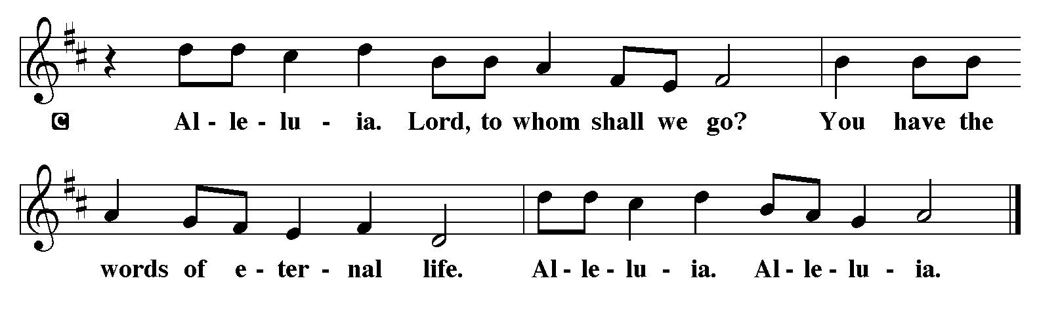
P - The Holy Gospel according to John, the 20th chapter

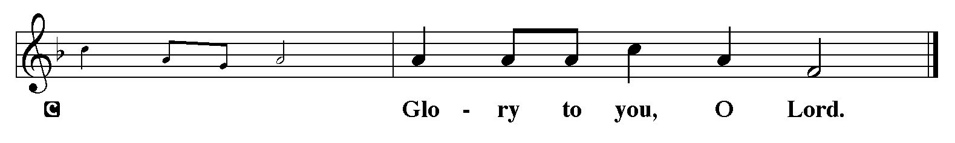

Gospel: John 20:1-18
¹Early on the first day of the week, while it was still dark, Mary Magdalene came to the tomb and saw that the stone had been removed from the tomb. ²So she ran and went to Simon Peter and the other disciple, the one whom Jesus loved, and said to them, “They have taken the Lord out of the tomb, and we do not know where they have laid him.” ³Then Peter and the other disciple set out and went toward the tomb. ⁴The two were running together, but the other disciple outran Peter and reached the tomb first. ⁵He bent down to look in and saw the linen wrappings lying there, but he did not go in. ⁶Then Simon Peter came, following him, and went into the tomb. He saw the linen wrappings lying there, ⁷and the cloth that had been on Jesus’ head, not lying with the linen wrappings but rolled up in a place by itself. ⁸Then the other disciple, who reached the tomb first, also went in, and he saw and believed; ⁹for as yet they did not understand the scripture, that he must rise from the dead. ¹⁰Then the disciples returned to their homes. ¹¹But Mary stood weeping outside the tomb. As she wept, she bent over to look into the tomb; ¹²and she saw two angels in white, sitting where the body of Jesus had been lying, one at the head and the other at the feet. ¹³They said to her, “Woman, why are you weeping?” She said to them, “They have taken away my Lord, and I do not know where they have laid him.” ¹⁴When she had said this, she turned around and saw Jesus standing there, but she did not know that it was Jesus. ¹⁵Jesus said to her, “Woman, why are you weeping? Whom are you looking for?” Supposing him to be the gardener, she said to him, “Sir, if you have carried him away, tell me where you have laid him, and I will take him away.” ¹⁶Jesus said to her, “Mary!” She turned and said to him in Hebrew, “Rabbouni!” (which means Teacher). ¹⁷Jesus said to her, “Do not hold on to me, because I have not yet ascended to the Father. But go to my brothers and say to them, ‘I am ascending to my Father and your Father, to my God and your God.’ ” ¹⁸Mary Magdalene went and announced to the disciples, “I have seen the Lord”; and she told them that he had said these things to her.
P - The Gospel of the Lord.
C – Praise to you, O Christ!
The Message
Hymn of the Day: Hallelujah! Jesus Lives!
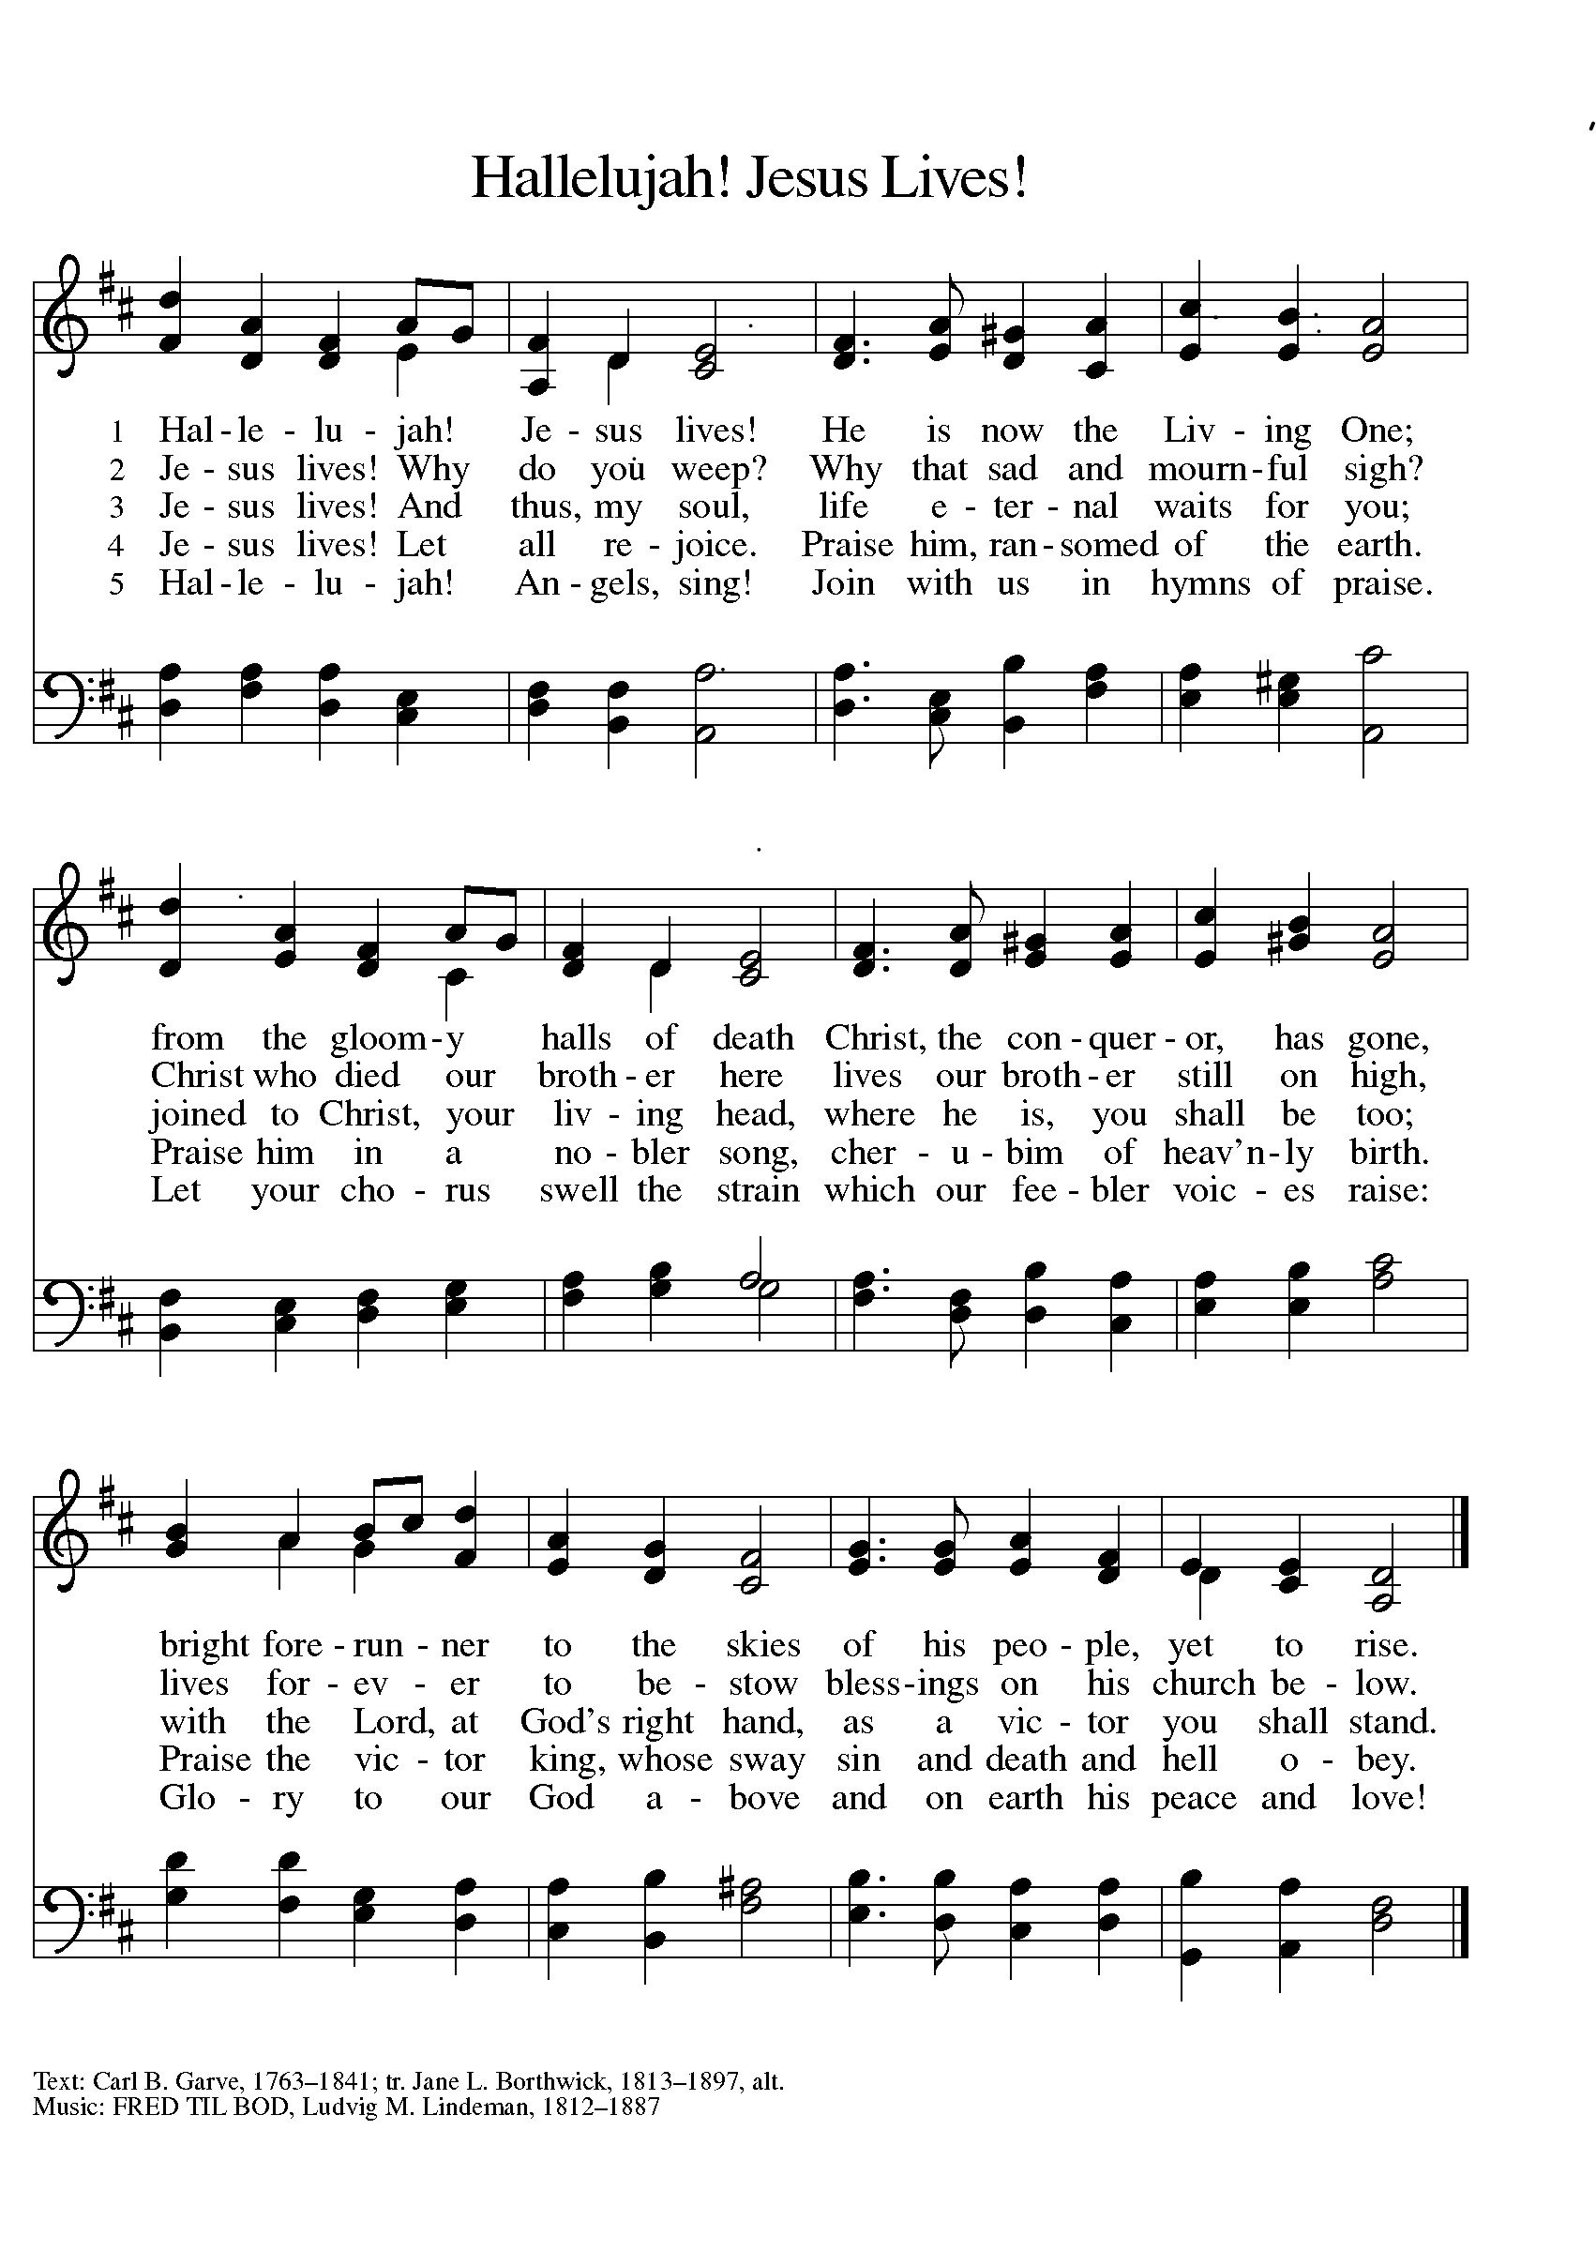

The Prayers of the People (please stand, sit, or kneel as you are able)
On this day of rejoicing, we pray for the life of the church, the world, and everyone in any need. A brief silence.
You give life to your church by joining the baptized to the body of Christ. Bless the newly baptized as we proclaim the one whose death and resurrection makes us one in you. Lord, in your mercy, hear our prayer.
You give life to creation by renewing the earth in every season. Curb our exploitation of natural resources, and cause us to preserve the health of plant and animal habitats. Lord, in your mercy, hear our prayer.
You give life to the world by laying a cornerstone among the nations. Rebuild the powers and principalities around us in ways that protect the vulnerable, end the violence, and raise up the lowly. Lord, in your mercy, hear our prayer.
You give life to those in need by the anointing of your Holy Spirit. Comfort those who suffer, encourage those who care for the sick, bind up the brokenhearted, protect our children, and wipe away the tears of all who mourn. We pray especially for everyone we remember on our prayer list, the homebound, those in hospitals, nursing homes, hospice care, assisted living, and rehab facilities, our veterans and their families, the military - active duty and civilian - serving here and abroad, and all of those we name softly out loud or in our hearts at this time. . . Lord, in your mercy, hear our prayer.
You give life to this community of faith by infusing us with love for one another. Inspire us to reach out to our neighbors in meaningful ways and bring the joys of community to a wider family of people. Lord, in your mercy, hear our prayer.
You give life to your saints by setting a banquet table of rich food. Feed us with the bread of life and bring us with all your saints to the feast that has no end. Lord, in your mercy, hear our prayer.
Into your hands, O God, we commend ourselves and all for whom we pray, trusting in Jesus Christ, the spring of new and everlasting life.
Amen.
The Peace
P – The Peace of the Lord be with you always.
C – And also with you.
The Offering is Brought to the Altar
Offering Prayer

We lift our voices, we lift our hands, we lift our lives up to you; we are an Offering. Lord, use our voices, Lord, use our hands, Lord, use our lives, they are yours: we are an offering. All that we have, all that we are, all that we hope to be, we give to you, we give to you. We lift our voices, we lift our hands, we lift our lives up to you; we are an offering, we are an offering.
P – The Lord be with You
C – And also with you.
P – Lift up your hearts
C – We lift them to the Lord.
P – Let us give thanks to the Lord, our God
C – It is right to give Him our thanks and praise.
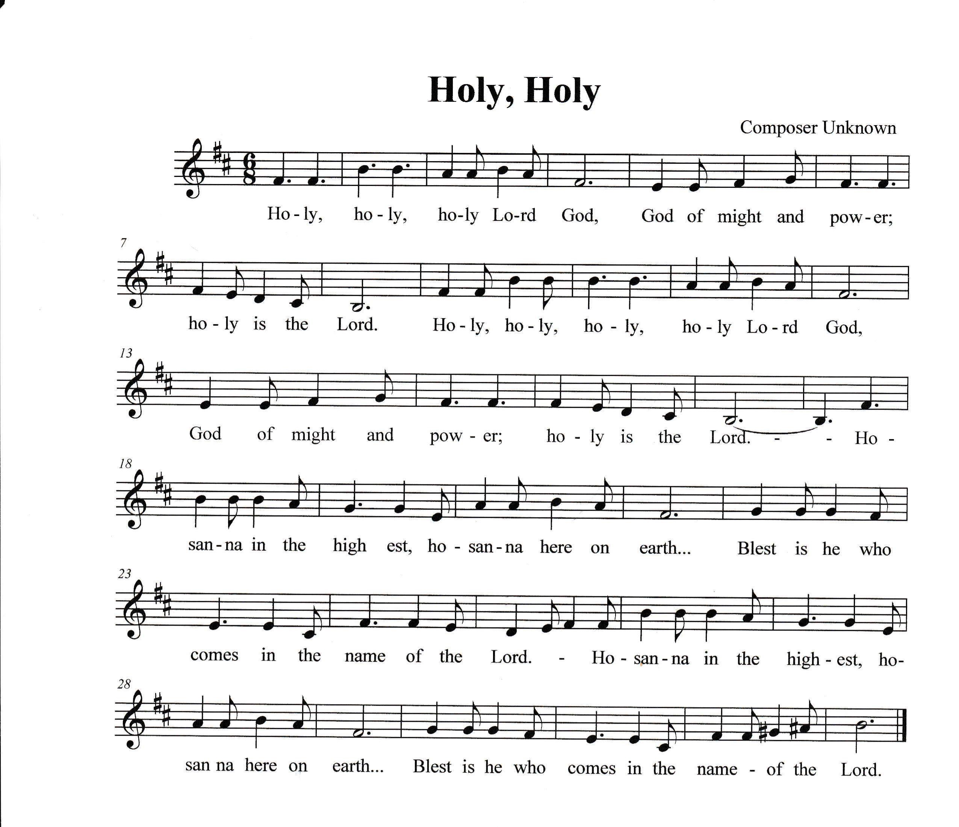

The Meal
Blessed are you, O Lord our God King of the Universe, Father of our Lord Jesus Christ. From the foundation of the world you chose us to be your children. You have liberated us from the power of darkness and brought us into the kingdom of your dear Son, the very image and reflection of your glory. In him we have received redemption and the forgiveness of sins.

In the night in which he was betrayed, our Lord Jesus took bread, and gave thanks (Prayer); then broke it, and gave it to his disciples, saying: Take and eat; this is my body, given for you. Do this for the remembrance of me.

Again, after supper, he took the cup, gave thanks (Prayer); and gave it for all to drink, saying: This cup is the new covenant in my blood, shed for you and for all people for the forgiveness of sin. Do this for the remembrance of me.

For as often as we eat of this bread and drink from this cup, we proclaim the Lord’s death until he comes.

Remembering, therefore, his death, resurrection, and ascension, we await his coming in glory.

Pour out upon us the Spirit of your love, O Lord, and unite the wills of all who share this heavenly food, the body and blood of Jesus Christ, our Lord; to whom, with you and the Holy Spirit, be all honor and glory, now and forever.
Amen.

Our Lord's Prayer
Our Father in heaven, hallowed be your name, your kingdom come, your will be done, on earth as in heaven. Give us today our daily bread. Forgive us our sins as we forgive those who sin against us. Save us from the time of trial and deliver us from evil. For the kingdom, the power, and the glory are yours, now and forever. Amen.
P – Come to this Table where God comes to us!
C – Thank You Jesus! (be seated)

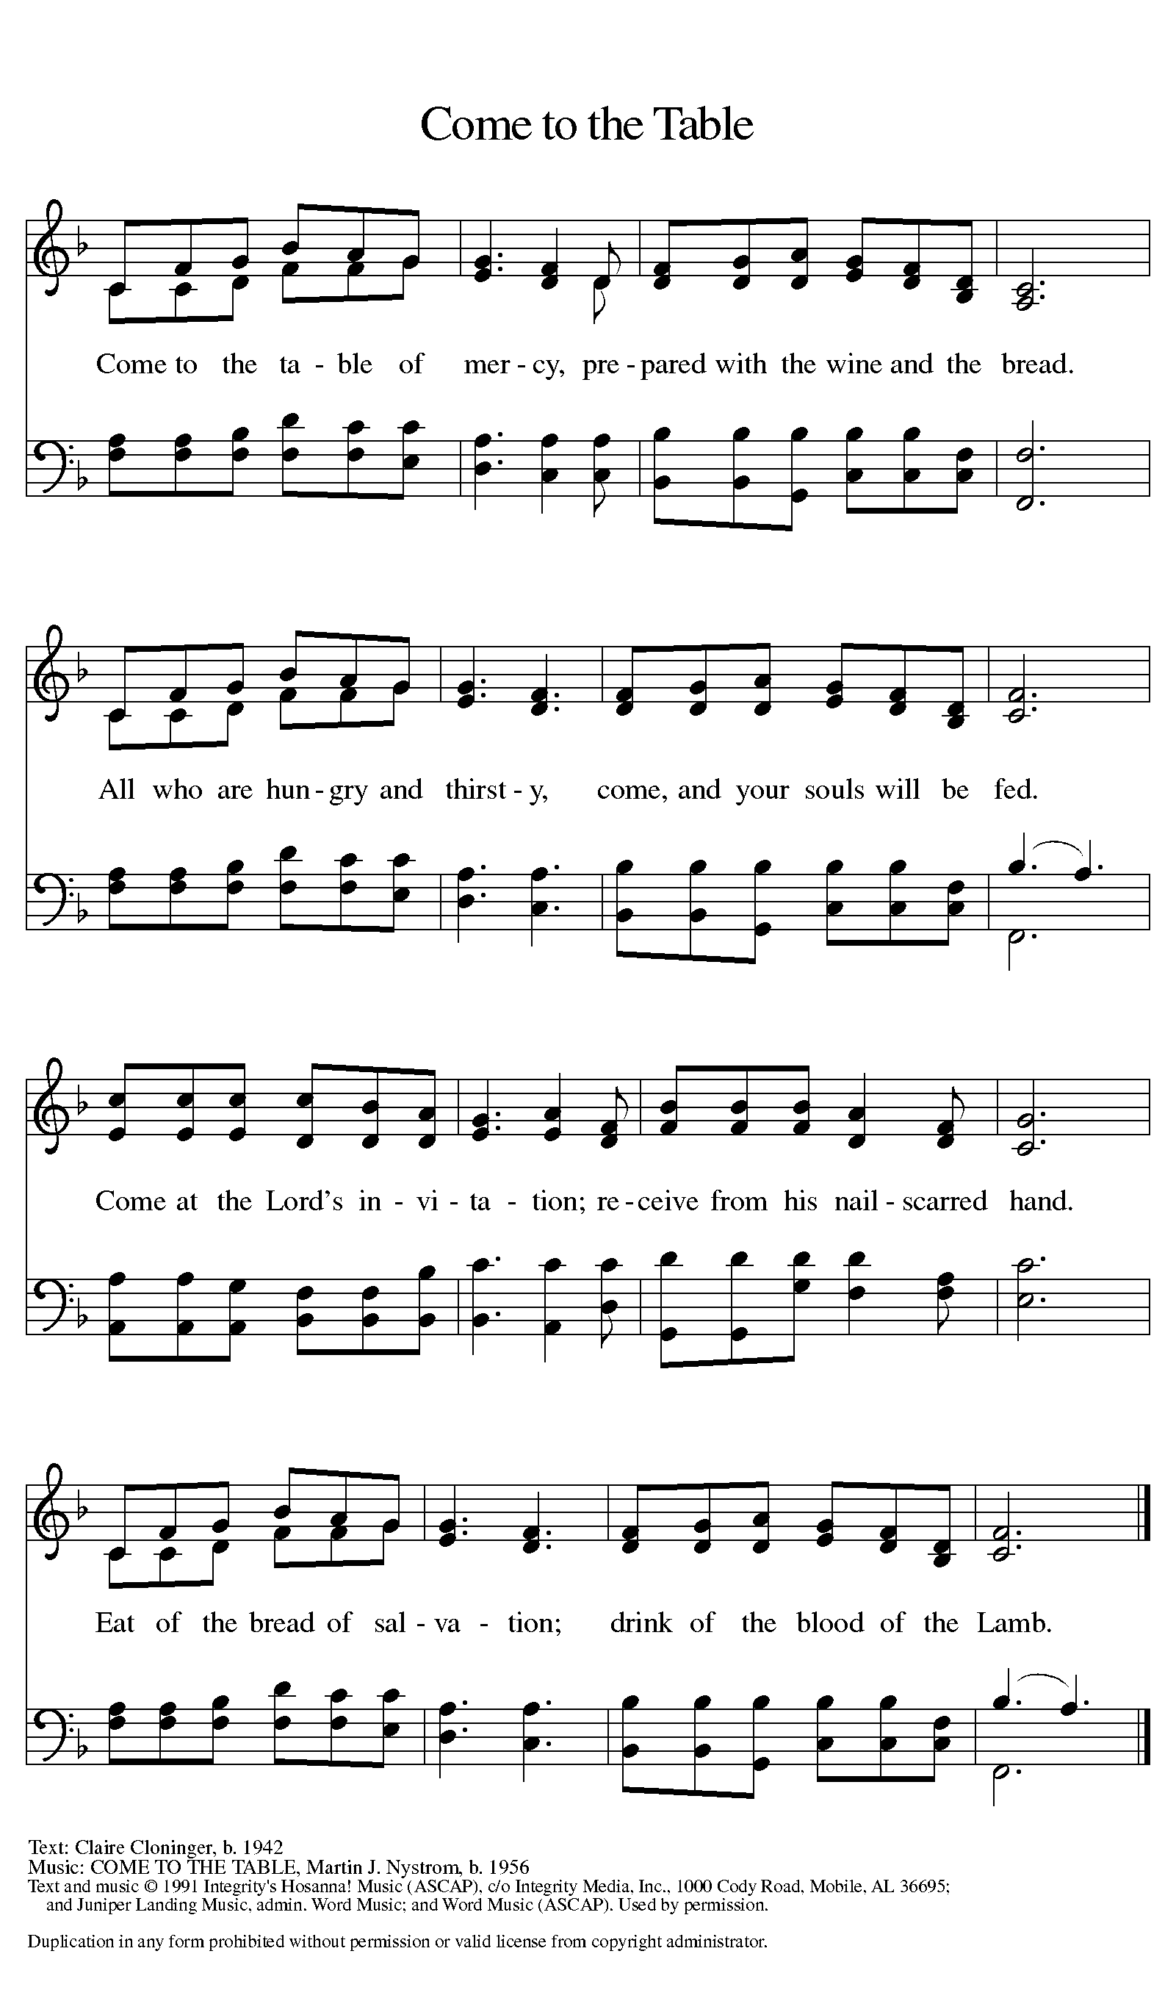

Distribution of Communion – Come Forward to Receive

Communion Anthem: What Feast of Love ELW 487

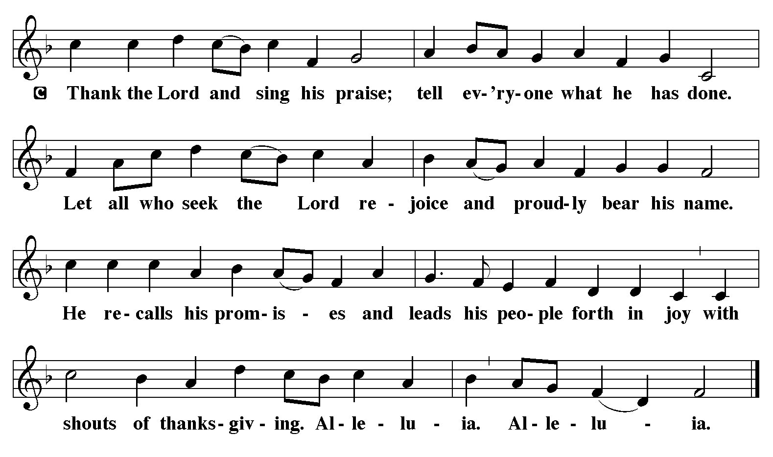

P – Now may the body and blood of our Lord and Savior Jesus Christ strengthen you and keep you in His grace….. Jesus Loves You!
C – Thank You Jesus!
Communion Prayer
We give you thanks, O God, that you make your home with us, bringing heaven to earth in this holy meal. Fill us with your Spirit as we go from here, that we may wipe away tears, tend to those in mourning and pain, seek the healing of the nations, and bring to earth the presence of your Son, Jesus Christ, our Savior and Lord.
Amen.
P - Almighty God, Father, + Son, and Holy Spirit, bless you now and forever.
C - Amen.

Sending Hymn: Alleluia, Jesus Is Risen ELW 377
1 Alleluia! Jesus is risen!
Trumpets resounding in glorious light!
Splendor, the Lamb, heaven forever!
Oh, what a miracle God has in sight!
Refrain
Jesus is risen and we shall arise.
Give God the glory! Alleluia!
2 Walking the way, Christ in the center
telling the story to open our eyes;
breaking our bread, giving us glory:
Jesus our blessing, our constant surprise. Refrain
3 Jesus the vine, we are the branches;
life in the Spirit the fruit of the tree;
heaven to earth, Christ to the people,
gift of the future now flowing to me. Refrain
4 Weeping, be gone; sorrow, be silent:
death put asunder, and Easter is bright.
Cherubim sing: O grave, be open!
Clothe us in wonder, adorn us in light. Refrain
5 City of God, Easter forever,
golden Jerusalem, Jesus the Lamb,
river of life, saints and archangels,
sing with creation to God the I AM! Refrain
P- Alleluia. Go in peace. Proclaim the Good News!
C- Thanks be to God. Alleluia.

Postlude: This is the Day W&P 141

