St Timothy Lutheran Church
Saturday, April 19th, 2025, 4 PM Worship
Easter Vigil

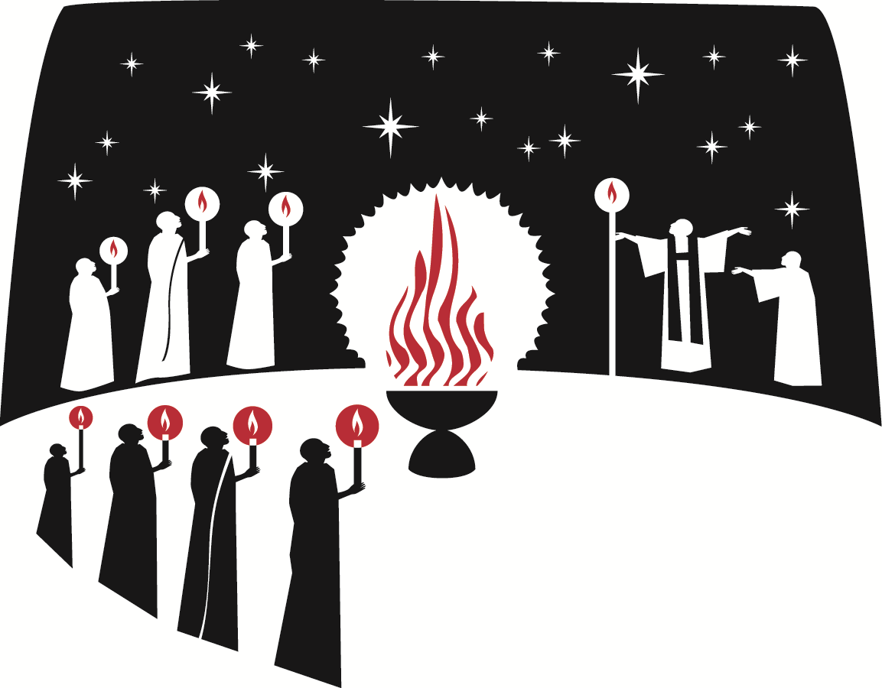

"Equip people to grow as Disciples faithfully serving our community"

Please note** if you use a pew envelope for your offering – please write your name on the envelope so that the financial secretaries can post it as a gift from you. Thank You!
Welcome
Gathering Hymn – Jesu, Jesu, Fill Us with Your Love

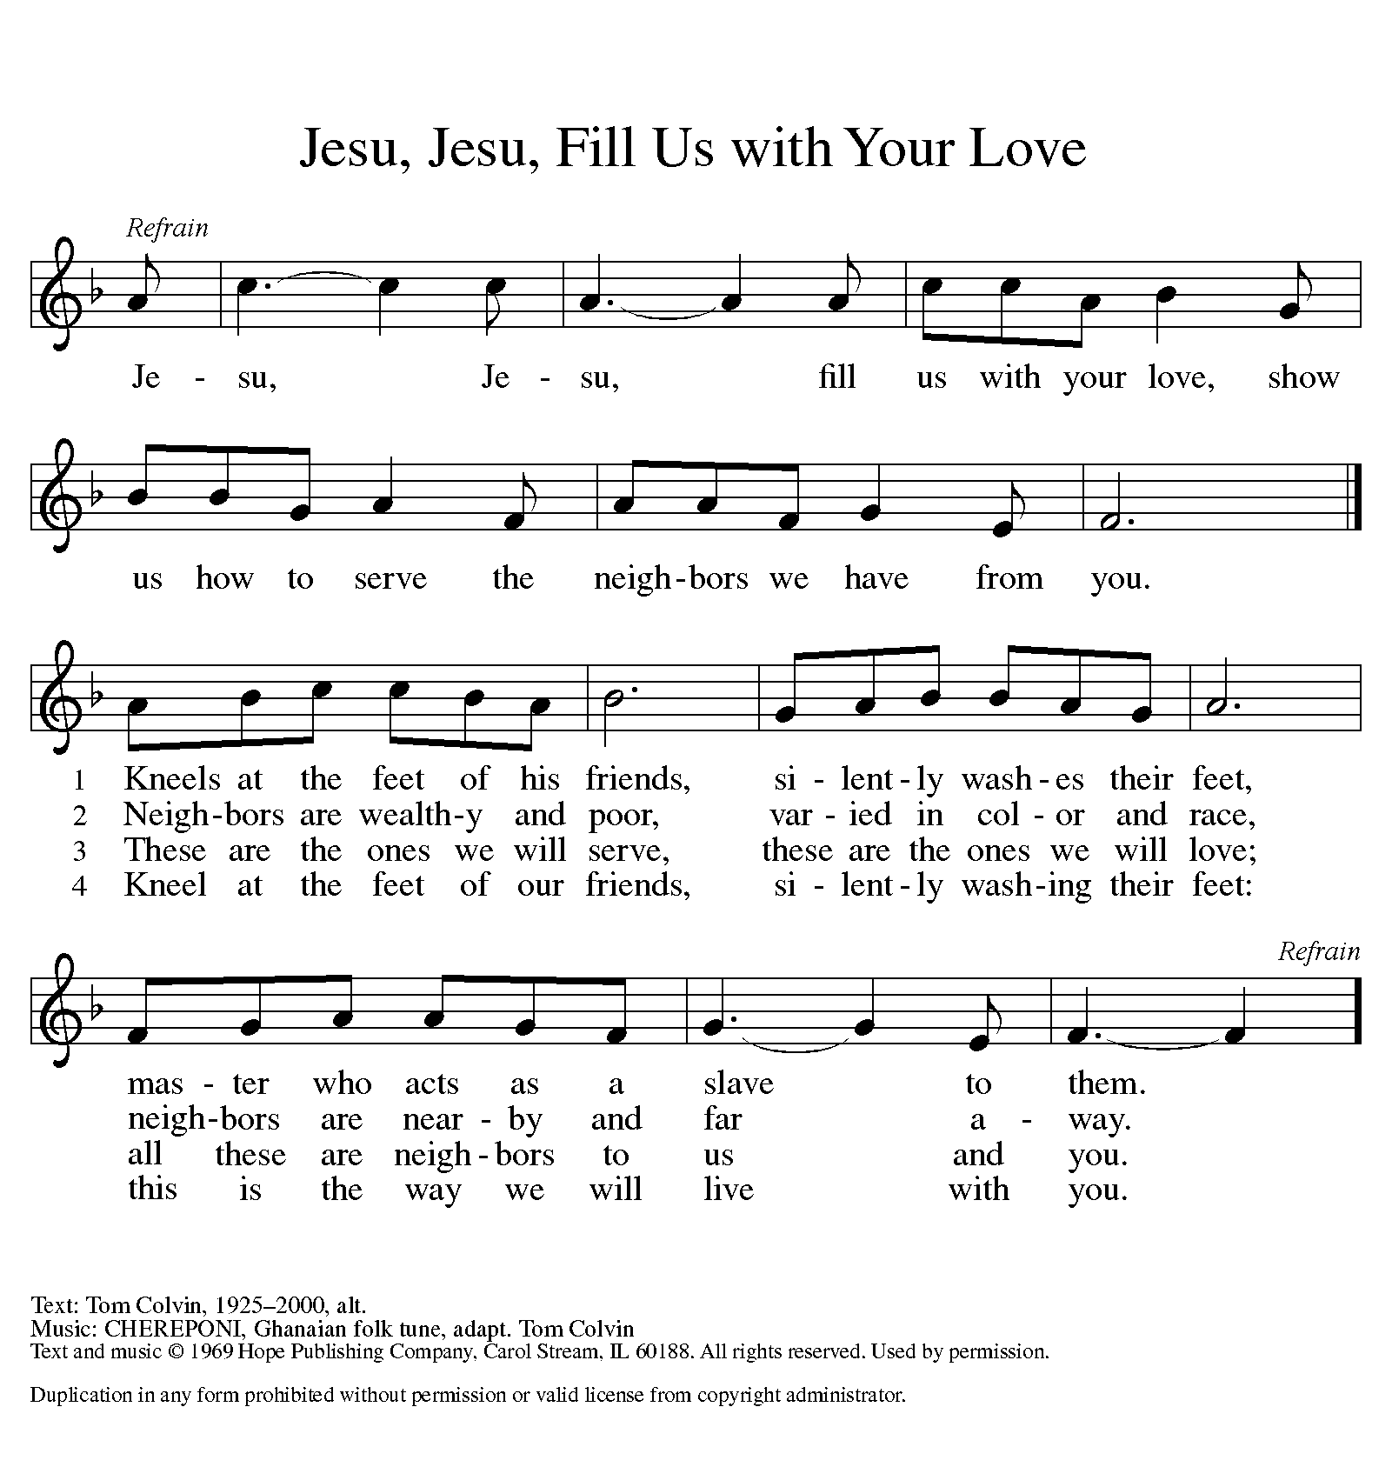

Please stand as you are able
Litany
P: Lord, we have experienced the darkness and the shadows of our sin. On Good Friday, it seemed that, with the cruel death of our Lord Jesus, the darkness might overcome us.
C: Shine through the darkness and grant us your strength, your hope and your forgiving love.
P: Lord, you know us as well as you knew your first disciples. Yet in love you gave yourself to them. Do likewise for us.
C: Lord, we call to you from the depths of our sin.
P: Then hear his words: "I am the Light of the World. The light is among you still. Trust the light so that you may become children of light. No follower of mine shall wander in the dark; he shall have the light of life" (John 8:12, 23:35-36, 46)
C: We know that you are our light and salvation; therefore we will not fear, but we will worship you in the spirit of love, celebrating the Resurrection joy with the light of Easter dawn.
A Service of Light
The Blessing of the Paschal Candle
P: The Easter Candle represents our risen Lord shining in the light and splendor of his resurrection. He is the new "Pillar of Fire" leading redeemed Israel out of the bondage of sin into the promise of eternal life. It is for this reason that it burns from Easter to Ascension Day, symbol of the great forty days of Christ's presence among his followers after his resurrection. The candle is prescribed with a cross, together with the first and last letters of the Greek alphabet, which teaches us that Christ is the first and last, "the beginning and the end."
The Lighting of the Paschal Candle
P: Christ yesterday and today, the beginning and the end, the Alpha and the Omega; to him belong time and the eternal ages; to him be glory and dominion forever. Amen
Through his holy and glorious wounds may Christ the Lord protect and preserve us. Amen.
May the light of Christ gloriously arisen destroy the darkness of our hearts and minds.
P: The Lord be with you! C: And with your spirit.
Prayer of the Day
Eternal giver of life and light, this holy night shines with the radiance of the risen Christ. Renew your church with the Spirit given us in baptism, that we may worship you in sincerity and truth and may shine as a light in the world, through your Son, Jesus Christ our Lord, who lives and reigns with you and the Holy Spirit, one God, now and forever. Amen.
The Spreading of the Light
(The pastor lights her candle from the Paschal Candle. The light is then passed to the congregation until the Light of Christ is spread to everyone in the house.)
P: The Light of Christ illumines all people! And helping one's neighbor light their candle is a good lesson of one's duty of apostolate: each Christian must assist in the spreading of Christ's life and light.
(The pastor goes into the midst of the congregation and pauses in three different locations with this announcement and response of the people.)
P: The Light of Christ.
C: Thanks be to God.
P: The Light of Christ.
C: Thanks be to God.
P: The Light of Christ.
C: Thanks be to God. You May Be Seated
(The people extinguish their candles and are seated.)

First Lesson: Romans 6:3-11
³Do you not know that all of us who have been baptized into Christ Jesus were baptized into his death? ⁴Therefore we have been buried with him by baptism into death, so that, just as Christ was raised from the dead by the glory of the Father, so we too might walk in newness of life.
⁵For if we have been united with him in a death like his, we will certainly be united with him in a resurrection like his. ⁶We know that our old self was crucified with him so that the body of sin might be destroyed, and we might no longer be enslaved to sin. ⁷For whoever has died is freed from sin. ⁸But if we have died with Christ, we believe that we will also live with him. ⁹We know that Christ, being raised from the dead, will never die again; death no longer has dominion over him. ¹⁰The death he died, he died to sin, once for all; but the life he lives, he lives to God. ¹¹So you also must consider yourselves dead to sin and alive to God in Christ Jesus.

Gospel: John 20:1-18
Early on the first day of the week, while it was still dark, Mary Magdalene came to the tomb and saw that the stone had been removed from the tomb. ²So she ran and went to Simon Peter and the other disciple, the one whom Jesus loved, and said to them, ‘They have taken the Lord out of the tomb, and we do not know where they have laid him.’ ³Then Peter and the other disciple set out and went towards the tomb. ⁴The two were running together, but the other disciple outran Peter and reached the tomb first. ⁵He bent down to look in and saw the linen wrappings lying there, but he did not go in. ⁶Then Simon Peter came, following him, and went into the tomb. He saw the linen wrappings lying there, ⁷and the cloth that had been on Jesus’ head, not lying with the linen wrappings but rolled up in a place by itself. ⁸Then the other disciple, who reached the tomb first, also went in, and he saw and believed; ⁹for as yet they did not understand the scripture, that he must rise from the dead. ¹⁰Then the disciples returned to their homes.
11 But Mary stood weeping outside the tomb. As she wept, she bent over to look into the tomb; ¹²and she saw two angels in white, sitting where the body of Jesus had been lying, one at the head and the other at the feet. ¹³They said to her, ‘Woman, why are you weeping?’ She said to them, ‘They have taken away my Lord, and I do not know where they have laid him.’ ¹⁴When she had said this, she turned round and saw Jesus standing there, but she did not know that it was Jesus. ¹⁵Jesus said to her, ‘Woman, why are you weeping? For whom are you looking?’ Supposing him to be the gardener, she said to him, ‘Sir, if you have carried him away, tell me where you have laid him, and I will take him away.’ ¹⁶Jesus said to her, ‘Mary!’ She turned and said to him in Hebrew, ‘Rabbouni!’ (which means Teacher). ¹⁷Jesus said to her, ‘Do not hold on to me, because I have not yet ascended to the Father. But go to my brothers and say to them, “I am ascending to my Father and your Father, to my God and your God.” ’ ¹⁸Mary Magdalene went and announced to the disciples, ‘I have seen the Lord’; and she told them that he had said these things to her.
Message
Hymn of the Day Christ Has Arisen, Alleluia 364
1 Christ has arisen, alleluia.
Rejoice and praise him, alleluia.
For our redeemer burst from the tomb,
even from death, dispelling its gloom.
Refrain
Let us sing praise to him with endless joy.
Death's fearful sting he has come to destroy.
Our sin forgiving, alleluia!
Jesus is living, alleluia!
2 For three long days the grave did its worst
until its strength by God was dispersed.
He who gives life did death undergo,
and in its conquest his might did show. Refrain
3 The angel said to them, "Do not fear.
You look for Jesus who is not here.
See for yourselves the tomb is all bare.
Only the graveclothes are lying there." Refrain
4 "Go spread the news: he's not in the grave.
He has arisen this world to save.
Jesus' redeeming labors are done.
Even the battle with sin is won." Refrain
5 Christ has arisen to set us free.
Alleluia, to him praises be.
Jesus is living! Let us all sing;
he reigns triumphant, heavenly king. Refrain
P: The peace of Christ be with you all,
C: And also with you.

We Share God’s Peace

Offering is Brought to the Altar

Offering Prayer

We lift our voices, we lift our hands, we lift our lives up to you; we are an Offering. Lord, use our voices, Lord, use our hands, Lord, use our lives, they are yours: we are an offering. All that we have, all that we are, all that we hope to be, we give to you, we give to you. We lift our voices, we lift our hands, we lift our lives up to you; we are an offering, we are an offering.

The Meal
Jesus’ Words of Promise and Gift of Life
Dear Lord, Jesus Christ:
in the night in which you were betrayed,
You took bread, broke it and gave thanks,
then you gave it to your disciples saying:
take and eat, this is my body I am giving for you.
Do this in remembrance of me.
Again, after supper, Dear Lord Jesus Christ,
You took the cup, gave thanks
and gave it for everyone to drink saying:
this cup is the new covenant in my blood,
I am shedding for you and for all people for the forgiveness of sin.
Do this for the remembrance of me.
Amen.
Lord's Prayer
Our Father in heaven, hallowed be your name, your kingdom come, your will be done, on earth as in heaven. Give us today our daily bread. Forgive us our sins as we forgive those who sin against us. Save us from the time of trial and deliver us from evil. For the kingdom, the power, and the glory are yours, now and forever. Amen.
Invitation to Communion
P: Come to this table where God really does come to us!
C: Thank You Jesus!
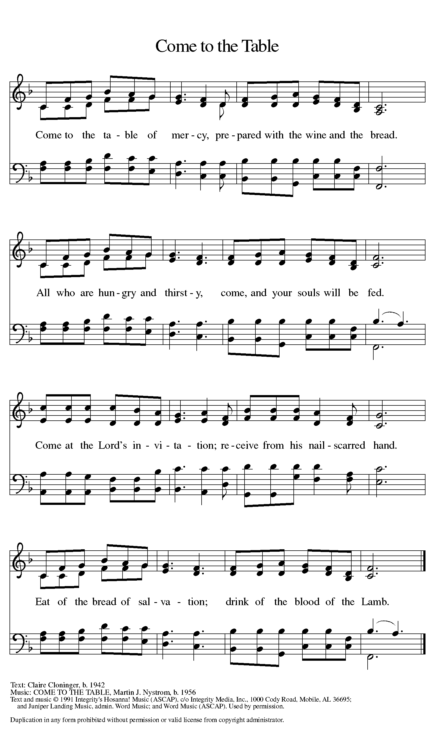

Distribution – Come Forward to Receive
Communion Special Music – You Are Mine ELW 581

P: Now may the body and blood of our Lord and Savior Jesus Christ strengthen you and keep you in His grace…. Jesus Loves You!
C: Amen!
Prayer after Communion
We give you thanks, O God, that you make your home with us, bringing heaven to earth in this holy meal. Fill us with your Spirit as we go from here, that we will wipe away tears, tend to those in mourning and pain, seek the healing of the nations, and bring to earth the presence of your Son, Jesus Christ, our Savior and Lord. Amen.
Blessing
P: God Almighty send you light and truth to keep you all the days of your life. The hand of God protect you; the holy angels accompany you; and the blessing of almighty God, the Father, the ☩ Son, and the Holy Spirit, be with you now and forever.
C: Amen.

Sending Hymn Christ the Lord is Risen Today, Alleluia ELW 369
1 Christ the Lord is ris'n today; Alleluia!
Christians, hasten on your way; Alleluia!
offer praise with love replete, Alleluia!
at the paschal victim's feet. Alleluia!
2 For the sheep the Lamb has bled, Alleluia!
sinless in the sinner's stead. Alleluia!
Christ the Lord is ris'n on high; Alleluia!
now he lives, no more to die. Alleluia!
3 Christ, the victim undefiled, Alleluia!
God and sinners reconciled, Alleluia!
when contending death and life, Alleluia!
met in strange and awesome strife. Alleluia!
4 Christians, on this holy day, Alleluia!
all your grateful homage pay; Alleluia!
Christ the Lord is ris'n on high; Alleluia!
now he lives, no more to die. Alleluia!
P: Alleluia. The Tomb is Empty! Share the good news!
C: Best News Ever! Alleluia!

