St Timothy Lutheran Church
Sunday, April 20, 2025
Easter Sunrise Service



"Equip people to grow as Disciples faithfully serving our community"
We are glad to have you worship with us. All are welcome at communion. If you need gluten-free – please let us know when you go up for communion. If you have any questions – just ask the Welcomer at the back of the sanctuary.

Please note** if you use a pew envelope for your offering – please write your name on the envelope so that the financial secretaries can post it as a gift from you. Thank You!
Welcome
P: The Lord is risen!
C: The Lord is risen indeed!
P: Sing this aloud, proclaim it to the ends of the earth:
C: The Lord has set His people free.
Jesus Christ is Risen Today ELW 355
1 Jesus Christ is ris'n today, Alleluia!
our triumphant holy day, Alleluia!
who did once upon the cross, Alleluia!
suffer to redeem our loss. Alleluia!
2 Hymns of praise then let us sing, Alleluia!
unto Christ, our heav'nly king, Alleluia!
who endured the cross and grave, Alleluia!
sinners to redeem and save. Alleluia!
3 But the pains which he endured, Alleluia!
our salvation have procured; Alleluia!
now above the sky he's king, Alleluia!
where the angels ever sing. Alleluia!
4 Sing we to our God above, Alleluia!
praise eternal as his love; Alleluia!
praise him, all you heav'nly host, Alleluia!
Father, Son, and Holy Ghost. Alleluia!
P: Praise the God and Father of our Lord Jesus Christ! By God’s great mercy we are given new birth into a living hope through the resurrection of Jesus Christ from the dead, and into an inheritance that is imperishable, undefiled, and unfading.
C: Praise, honor, glory, and power to the One seated on the throne, and to the Lamb, forever and ever!

P: Jesus was handed over to death for our sins,
C: And was raised to life for our justification.
P: Then what can separate us from the love of Christ? Can affliction or hardships? Can persecution, hunger, nakedness, peril, or sword?
C: No, in all these things we are more than conquerors through Christ, who loved us.
P: For we are convinced that neither death, nor life, nor angels, nor rulers, nor things present, nor things to come,
C: Nor powers, nor heights, nor depths, nor anything else in all creation, will be able to separate us from the love of God in Christ Jesus our Lord.
P: We have been buried with him by baptism into death, so that, just as Christ was raised from the dead by the glory of the Father, we too might walk in newness of life.
C: For if we have been united with him in a death like his, we will certainly be united with him in a resurrection like his.
P: We do not live to ourselves, and we do not die to ourselves. If we live, it is for the Lord that we live; and if we die, it is for the Lord that we die.
C: So whether we live or die, we belong to the Lord, for Christ died, rose from death, and lives again in order to be Lord of the living and of the dead.
P: We do not want you to be in any doubt about those who have died, or to grieve over them as others do who have no hope.
C: For since we believe that Jesus died and rose again, even so, through Jesus, God will bring with him those who have died.
P: What we are saying, brothers and sisters, is this: flesh and blood cannot inherit the kingdom of God.
C: Nor does the perishable inherit the imperishable.
P: What is sown as perishable,
C: Is raised imperishable;
P: What is sown in dishonor,
C: Is raised in glory;

P: What is sown in weakness,
C: Is raised in power;
P: What is sown a physical body,
C: Is raised a spiritual body.
P: Then the saying that is written will be fulfilled: Death has been swallowed up in victory.
C: Thanks be to God, who gives us the victory through our Lord Jesus Christ.

Isaiah 65:17-25
¹⁷I am about to create new heavens and a new earth; the former things shall not be remembered or come to mind. ¹⁸But be glad and rejoice forever in what I am creating; for I am about to create Jerusalem as a joy, and its people as a delight. ¹⁹I will rejoice in Jerusalem, and delight in my people; no more shall the sound of weeping be heard in it, or the cry of distress. ²⁰No more shall there be in it an infant that lives but a few days, or an old person who does not live out a lifetime; for one who dies at a hundred years will be considered a youth, and one who falls short of a hundred will be considered accursed. ²¹They shall build houses and inhabit them; they shall plant vineyards and eat their fruit. ²²They shall not build and another inhabit; they shall not plant and another eat; for like the days of a tree shall the days of my people be, and my chosen shall long enjoy the work of their hands. ²³They shall not labor in vain, or bear children for calamity; for they shall be offspring blessed by the Lord— and their descendants as well. ²⁴Before they call I will answer, while they are yet speaking I will hear. ²⁵The wolf and the lamb shall feed together, the lion shall eat straw like the ox; but the serpent—its food shall be dust! They shall not hurt or destroy on all my holy mountain,
A: Words of God!
C: Words of Life!

P: The Holy Gospel according to John, the 20th chapter
C: Glory to you O Lord.

Gospel: John 20:1-18
¹Early on the first day of the week, while it was still dark, Mary Magdalene came to the tomb and saw that the stone had been removed from the tomb. ²So she ran and went to Simon Peter and the other disciple, the one whom Jesus loved, and said to them, “They have taken the Lord out of the tomb, and we do not know where they have laid him.” ³Then Peter and the other disciple set out and went toward the tomb. ⁴The two were running together, but the other disciple outran Peter and reached the tomb first. ⁵He bent down to look in and saw the linen wrappings lying there, but he did not go in. ⁶Then Simon Peter came, following him, and went into the tomb. He saw the linen wrappings lying there, ⁷and the cloth that had been on Jesus’ head, not lying with the linen wrappings but rolled up in a place by itself. ⁸Then the other disciple, who reached the tomb first, also went in, and he saw and believed; ⁹for as yet they did not understand the scripture, that he must rise from the dead. ¹⁰Then the disciples returned to their homes. ¹¹But Mary stood weeping outside the tomb. As she wept, she bent over to look into the tomb; ¹²and she saw two angels in white, sitting where the body of Jesus had been lying, one at the head and the other at the feet. ¹³They said to her, “Woman, why are you weeping?” She said to them, “They have taken away my Lord, and I do not know where they have laid him.” ¹⁴When she had said this, she turned around and saw Jesus standing there, but she did not know that it was Jesus. ¹⁵Jesus said to her, “Woman, why are you weeping? Whom are you looking for?” Supposing him to be the gardener, she said to him, “Sir, if you have carried him away, tell me where you have laid him, and I will take him away.” ¹⁶Jesus said to her, “Mary!” She turned and said to him in Hebrew, “Rabbouni!” (which means Teacher). ¹⁷Jesus said to her, “Do not hold on to me, because I have not yet ascended to the Father. But go to my brothers and say to them, ‘I am ascending to my Father and your Father, to my God and your God.’ ” ¹⁸Mary Magdalene went and announced to the disciples, “I have seen the Lord”; and she told them that he had said these things to her.

P: The Gospel of Our Lord!
C: Praise to you O Christ!
Easter Meditation
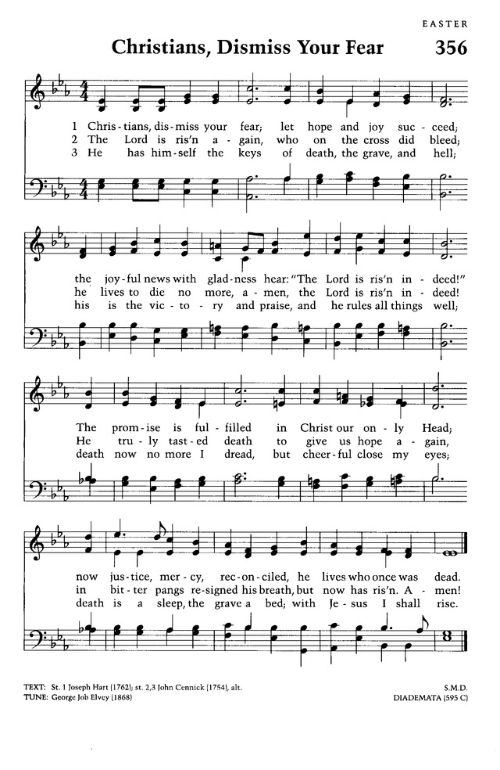

Apostles’ Creed
I believe in God, the Father almighty,
creator of heaven and earth.
I believe in Jesus Christ, God’s only Son, our Lord,
who was conceived by the Holy Spirit,
born of the virgin Mary,
suffered under Pontius Pilate,
was crucified, died, and was buried;
he descended to the dead.
On the third day he rose again;
he ascended into heaven,
he is seated at the right hand of the Father,
and he will come to judge the living and the dead.
I believe in the Holy Spirit,
the holy catholic church,
the communion of saints,
the forgiveness of sins,
the resurrection of the body,
and the life everlasting. Amen.

Prayer of the Day
God of mercy, we no longer look for Jesus among the dead, for he is alive and has become the Lord of life. Increase in our minds and hearts the risen life we share with Christ, and help us to grow as your people toward the fullness of eternal life with you, through Jesus Christ, our Savior and Lord, who lives and reigns with you and the Holy Spirit, one God, now and forever. C: Amen.
P: The Peace of Christ Be With You All!
C: And also with you!
We Share the Peace of Christ!
Offering is Brought to the Altar

Offering Prayer

We lift our voices, we lift our hands, we lift our lives up to you; we are an Offering. Lord, use our voices, Lord, use our hands, Lord, use our lives, they are yours: we are an offering. All that we have, all that we are, all that we hope to be, we give to you, we give to you. We lift our voices, we lift our hands, we lift our lives up to you; we are an offering, we are an offering.
The Meal
Blessed are you, O Lord our God King of the Universe, Father of our Lord Jesus Christ. From the foundation of the world you chose us to be your children. You have liberated us from the power of darkness and brought us into the kingdom of your dear Son, the very image and reflection of your glory. In him we have received redemption and the forgiveness of sins.

In the night in which he was betrayed, our Lord Jesus took bread, and gave thanks (Prayer); then broke it, and gave it to his disciples, saying: Take and eat; this is my body, given for you. Do this for the remembrance of me.

Again, after supper, he took the cup, gave thanks (Prayer); and gave it for all to drink, saying: This cup is the new covenant in my blood, shed for you and for all people for the forgiveness of sin. Do this for the remembrance of me.

For as often as we eat of this bread and drink from this cup, we proclaim the Lord’s death until he comes.

Remembering, therefore, his death, resurrection, and ascension, we await his coming in glory.

Pour out upon us the Spirit of your love, O Lord, and unite the wills of all who share this heavenly food, the body and blood of Jesus Christ, our Lord; to whom, with you and the Holy Spirit, be all honor and glory, now and forever.
Amen.
The Lord’s Prayer
Our Father in heaven, hallowed be your name, your kingdom come, your will be done, on earth as in heaven. Give us today our daily bread. Forgive us our sins as we forgive those who sin against us. Save us from the time of trial and deliver us from evil. For the kingdom, the power, and the glory are yours, now and forever. Amen.
P: Come to this Table where God comes to us!
C: Thank You Jesus!

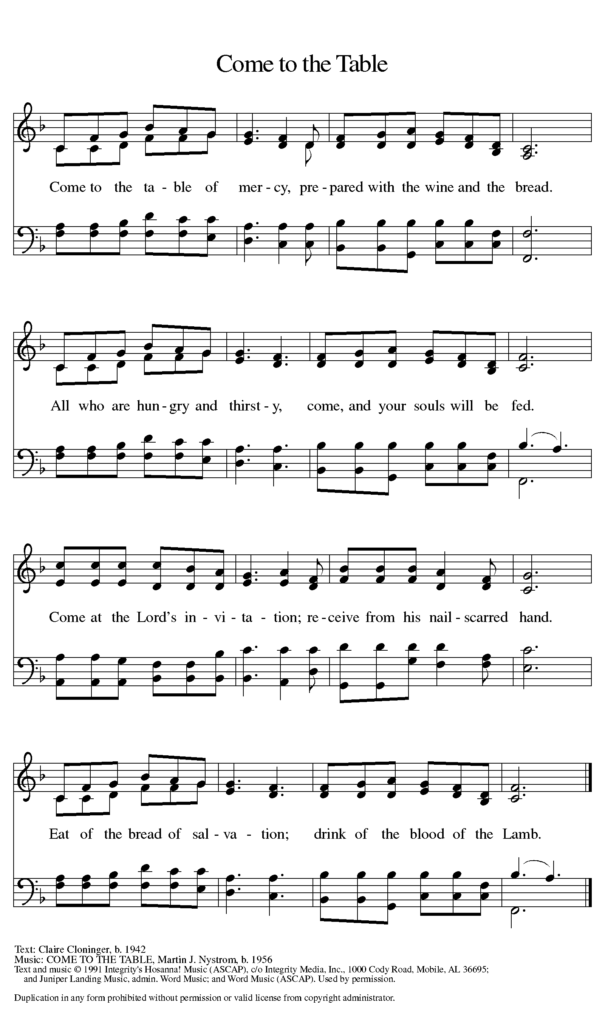

Distribution – Come Forward to Receive

Communion Hymn: What Feast of Love ELW 487
1 What feast of love is offered here, what banquet come from heaven?
What food of everlasting life, what gracious gift is given?
This, this is Christ the king, the bread come down from heaven.
Oh, taste and see and sing! How sweet the manna given!

2 What light of truth is offered here, what covenant from heaven?
What hope of everlasting life, what wondrous word is given?
This, this is Christ the king, the sun come down from heaven.
Oh, see and hear and sing! The Word of God is given!

3 What wine of love is offered here, what crimson drink from heaven?
What stream of everlasting life, what precious blood is given?
This, this is Christ the king, the sweetest wine of heaven.
Oh, taste and see and sing! The Son of God is given!
P: Now may the Body and Blood of our Lord, and Savior, Jesus Christ strengthen you and keep you in His grace…. Jesus Loves You!
C: Thank You Jesus!

Prayer After Communion
Living God, you have greeted us in our brokenness and nourished us with the body of Christ, broken for us. Risen to new life with you, send us now to bear your healing love into the wounded world, in the name of our risen Savior and Lord.
Amen.

P: The Lord bless you and keep you; The Lord make his face shine upon you and be gracious unto you; The Lord lift up his countenance upon you and give you peace!
C: Amen.
Sending Hymn: Alleluia, Jesus Is Risen ELW 377
1 Alleluia! Jesus is risen!
Trumpets resounding in glorious light!
Splendor, the Lamb, heaven forever!
Oh, what a miracle God has in sight!
Refrain
Jesus is risen and we shall arise.
Give God the glory! Alleluia!
2 Walking the way, Christ in the center
telling the story to open our eyes;
breaking our bread, giving us glory:
Jesus our blessing, our constant surprise. Refrain
3 Jesus the vine, we are the branches;
life in the Spirit the fruit of the tree;
heaven to earth, Christ to the people,
gift of the future now flowing to me. Refrain
4 Weeping, be gone; sorrow, be silent:
death put asunder, and Easter is bright.
Cherubim sing: O grave, be open!
Clothe us in wonder, adorn us in light. Refrain
5 City of God, Easter forever,
golden Jerusalem, Jesus the Lamb,
river of life, saints and archangels,
sing with creation to God the I AM! Refrain

P: Tell the world, Death is No More! Christ Lives!
C: And, so do we Hallelujah! God is With Us!
Postlude: This is the Day W&P 141

St Timothy’s is served by The Reverend Lynn Bechdolt
Director of Music Eric Mortensen
And Parish Deacon Frank Hofstetter

Unless otherwise noted, service materials used in this bulletin are:
"Reprinted from the 1995 Moravian Book of Worship with permission of the Interprovincial Board of Communication, Moravian Church in North America."
Music is reprinted under OneLicense.Net #A712074 and/or Augsburg Fortress #SBL12176H. Scripture, unless otherwise noted, is from the New Revised Standard Version Bible, Copyright © 1989, Division of Christian Education of the National Council of the Churches of Christ in the United States of America. Used by permission. All rights reserved.

Many Thanks to Everyone Who
Brought in Flowers for
Our Easter Services
-
Thanks to You – Our Church
Is
Especially Beautiful this Easter!

