St Timothy Lutheran Church
Sunday, April 13, 2025, 9 am Service
Palm Sunday



"Equip people to grow as Disciples faithfully serving our community"

We are glad to have you worship with us. All are welcome at communion. If you need gluten-free – please let us know when you go up for communion. If you have any questions – just ask the Welcomer at the back of the sanctuary.

Please note** if you use a pew envelope for your offering – please write your name on the envelope so that the financial secretaries can post it as a gift from you. Thank You!
St Timothy Worship Planning Team
Pastor Lynn Bechdolt
Eric Mortensen, Director of Music
Parish Deacon, Frank Hofstetter

The Altar Palms are given to the Glory of God!

This Week at St. Timothy's
Monday, April 14th 10:30am – Ruth Circle, 1pm – Garden Club
Tuesday, April 15th 1pm - WELCA
Wednesday, April 16th
Thursday, April 17th NO Prayer Group, 11:00 am - Miniatures, 7 pm – Maundy Thursday Service
Friday, April 18th 7 pm – Good Friday Tenebrae Service
Saturday, April 19th 4 pm – Easter Vigil
Sunday, April 20th EASTER - 7 am – Sunrise Service, 8am – Breakfast, 9:30am - Traditional Easter Service, 11-11:30am – Drive-Up Communion

Rooted in the past and growing into the future, the church must always be reformed in order to live out the love of Christ in an ever-changing world. We celebrate the good news of God’s grace, that Jesus Christ sets us free every day to do this life-transforming work. Trusting in the freedom given to us in baptism, we pray for the church, that Christians will unite more fully in worship and mission.
(from Sundays and Seasons for Reformation Weekend)

Gathering
Congregation gathers outside and receives Palm branches for processing
P - The Holy Spirit calls us together as the people of God.
P - Blessed is the one who comes in the name of the Lord.
C - Hosanna in the highest!
P - The holy gospel according to Luke, the 19th chapter
C - Glory to you, O Lord.

P - reads Luke 19:28-40
²⁸After he had said this, [Jesus] went on ahead, going up to Jerusalem.
²⁹When he had come near Bethphage and Bethany, at the place called the Mount of Olives, he sent two of the disciples, ³⁰saying, “Go into the village ahead of you, and as you enter it you will find tied there a colt that has never been ridden. Untie it and bring it here. ³¹If anyone asks you, ‘Why are you untying it?’ just say this, ‘The Lord needs it.’ ” ³²So those who were sent departed and found it as he had told them. ³³As they were untying the colt, its owners asked them, “Why are you untying the colt?” ³⁴They said, “The Lord needs it.” ³⁵Then they brought it to Jesus; and after throwing their cloaks on the colt, they set Jesus on it. ³⁶As he rode along, people kept spreading their cloaks on the road. ³⁷As he was now approaching the path down from the Mount of Olives, the whole multitude of the disciples began to praise God joyfully with a loud voice for all the deeds of power that they had seen, ³⁸saying,
“Blessed is the king
who comes in the name of the Lord!
Peace in heaven,
and glory in the highest heaven!”
³⁹Some of the Pharisees in the crowd said to him, “Teacher, order your disciples to stop.” ⁴⁰He answered, “I tell you, if these were silent, the stones would shout out.”
P - The gospel of the Lord.
C - Praise to you, O Christ.
P - Let us pray
We praise you, O God, for redeeming the world through our Savior Jesus Christ. Today he entered the holy city in triumph and was proclaimed messiah and king by those who spread garments and branches along his way. Bless these branches and those who carry them. Grant us grace to follow our Lord in the way of the cross, so that, joined to his death and resurrection, we enter into life with you; through the same Jesus Christ, who lives and reigns with you and the Holy Spirit, one God, now and forever.
C - Amen
Procession
A - Let us go forth in peace.
C - in the name of Christ. Amen.
Gathering Hymn: All Glory, Laud and Honor ELW 344

Refrain
All glory, laud, and honor to you, redeemer, king,
to whom the lips of children made sweet hosannas ring.
1 You are the king of Israel and David's royal Son,
now in the Lord's name coming, our King and Blessed One. Refrain
2 The company of angels are praising you on high;
creation and all mortals in chorus make reply. Refrain
3 The multitude of pilgrims with palms before you went;
our praise and prayer and anthems before you we present. Refrain
4 To you, before your passion, they sang their hymns of praise.
To you, now high exalted, our melody we raise. Refrain
5 Their praises you accepted; accept the prayers we bring,
great author of all goodness, O good and gracious King. Refrain

Confession and Forgiveness
P – In the name of the Father, and of the Son, (+) and of the Holy Spirit.
C – Amen
P – Almighty God, to whom all hearts are open, all desires known, and from whom no secrets are hid; Cleanse the thoughts of our hearts by the inspiration of your Holy Spirit, that we may perfectly love you and worthily magnify your holy name, through Jesus Christ our Lord.
C – Amen
P - If we say we have no sin, we deceive ourselves, and the truth is not in us, But if we confess our sins, God who is faithful and just will forgive our sins and cleanse us from all unrighteousness.
(Stand, Sit or Kneel) (Silence for reflection and self-examination)
P – Most Merciful God,
C – Have mercy on us. We confess to you all our sins and that in these times of continuing uncertainty and fear, we have trouble trusting you and feeling your presence. Forgive us our sins, our doubts, our fears and lack of patience with others. Strengthen our faith and help us to let your hope and light shine through us in these challenging times. We ask for mercy, wisdom and guidance, through Jesus Christ, our Savior and Lord. Amen.
P – Almighty God, in his mercy, has given his Son to die for us and for his sake, forgives us all our sins. As a called and ordained minister of the Church of Christ, and by his authority, I therefore declare to you the entire forgiveness of all your sins, in the name of the Father, and of the + Son, and of the Holy Spirit.
C – Amen
P - The grace of our Lord Jesus Christ, the love of God and the communion of the Holy Spirit be with you all.
C - And also with you.

Prayer of the Day
Everlasting God, in your endless love for the human race you sent our Lord Jesus Christ to take on our nature and to suffer death on the cross. In your mercy enable us to share in his obedience to your will and in the glorious victory of his resurrection, who lives and reigns with you and the Holy Spirit, one God, now and forever.

Amen.

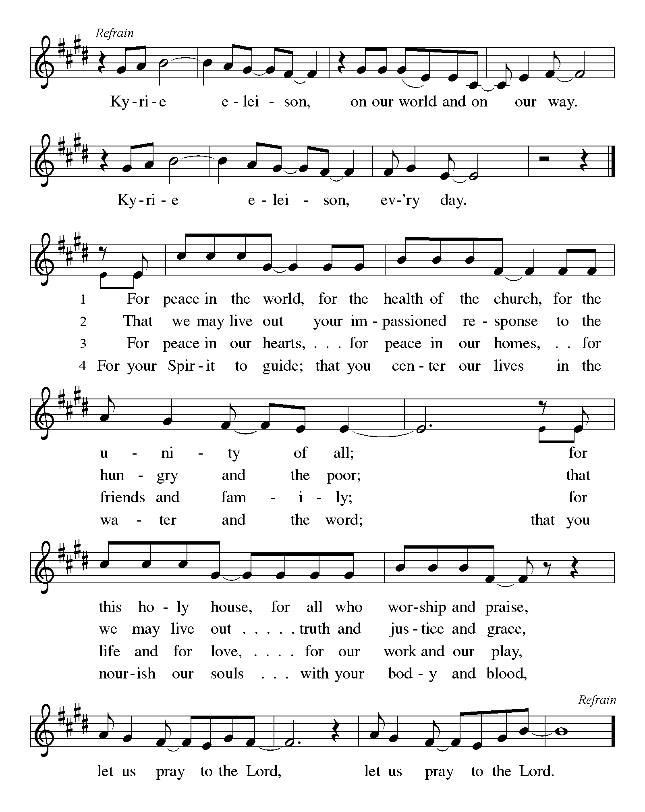

First Lesson: Zechariah 9:9-11
⁹Rejoice greatly, O daughter Zion!
Shout aloud, O daughter Jerusalem!
Lo, your king comes to you; triumphant and victorious is he,
humble and riding on a donkey, on a colt, the foal of a donkey.
¹⁰He will cut off the chariot from Ephraim
and the war-horse from Jerusalem;
and the battle bow shall be cut off,
and he shall command peace to the nations;
his dominion shall be from sea to sea,
and from the River to the ends of the earth.
¹¹As for you also, because of the blood of my covenant with you,
I will set your prisoners free from the waterless pit.

A – Words of God!
C – Words of Life!

Psalm 31:9-16
⁹ Have mercy on me, O Lord, for I am in trouble;
my eye is consumed with sorrow, and also my throat and my belly.
¹⁰ For my life is wasted with grief, and my years with sighing;
my strength fails me because of affliction, and my bones are consumed.
¹¹ I am the scorn of all my enemies, a disgrace to my neighbors, a dismay to my acquaintances;
when they see me in the street they avoid me.
¹² Like the dead I am forgotten, out of mind;
I am as useless as a broken pot.
¹³ For I have heard the whispering of the crowd; fear is all around;
they put their heads together against me; they plot to take my life.
¹⁴ But as for me, I have trusted in you, O Lord.
I have said, “You are my God.
¹⁵ My times are in your hand;
rescue me from the hand of my enemies, and from those who persecute me.
¹⁶ Let your face shine upon your servant;
save me in your steadfast love.”

Second Lesson: Philippians 2:5-11
⁵ Let the same mind be in you that was in Christ Jesus,
⁶ who, though he was in the form of God,
did not regard equality with God
as something to be exploited,
⁷ but emptied himself,
taking the form of a slave,
being born in human likeness.
And being found in human form,
⁸ he humbled himself
and became obedient to the point of death—
even death on a cross.
⁹ Therefore God also highly exalted him
and gave him the name
that is above every name,
¹⁰ so that at the name of Jesus
every knee should bend,
in heaven and on earth and under the earth,
¹¹ and every tongue should confess
that Jesus Christ is Lord,
to the glory of God the Father.

A – Words of God!
C – Words of Life! (Stand)
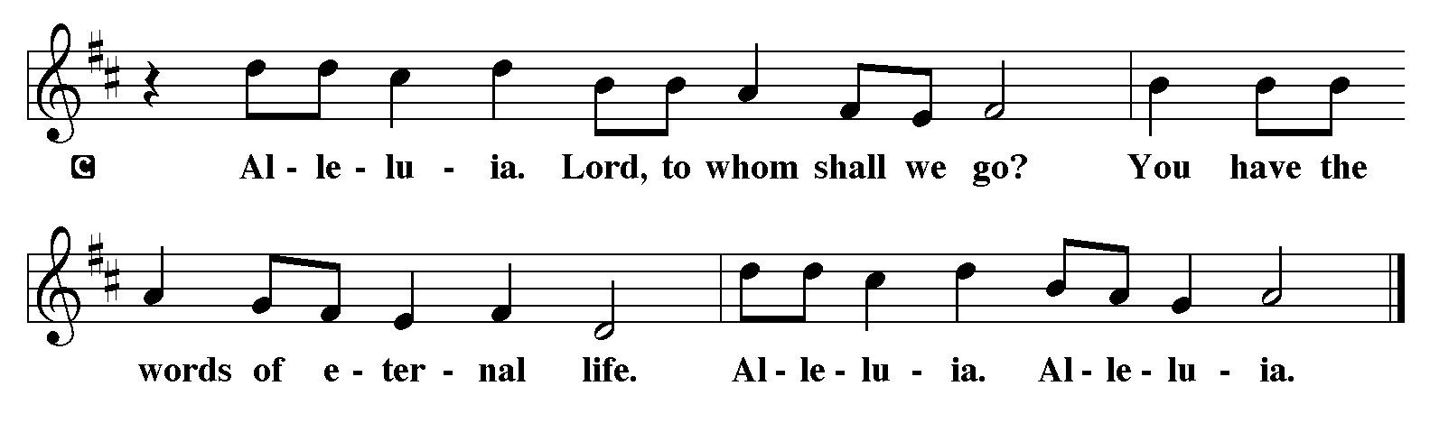
P - The Holy Gospel according to John, Chapter 12
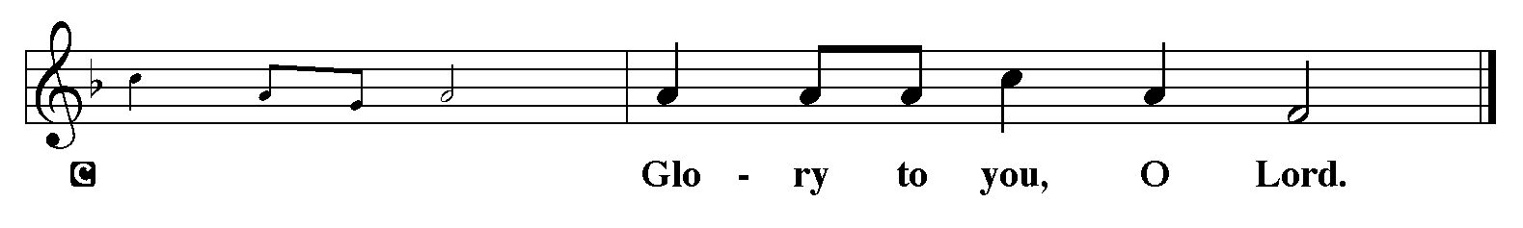

The Gospel: John 12:12-19
¹²The next day the great crowd that had come to the festival heard that Jesus was coming to Jerusalem. ¹³So they took branches of palm trees and went out to meet him, shouting,
"Hosanna!
Blessed is the one who comes in the name of the Lord —
the King of Israel!"
¹⁴Jesus found a young donkey and sat on it; as it is written:
¹⁵"Do not be afraid, daughter of Zion.
Look, your king is coming,
sitting on a donkey's colt!"
¹⁶His disciples did not understand these things at first; but when Jesus was glorified, then they remembered that these things had been written of him and had been done to him. ¹⁷So the crowd that had been with him when he called Lazarus out of the tomb and raised him from the dead continued to testify. ¹⁸It was also because they heard that he had performed this sign that the crowd went to meet him. ¹⁹The Pharisees then said to one another, "You see, you can do nothing. Look, the world has gone after him!"
P - The Gospel of the Lord.
C - Praise to you, O Christ. (Sit)
Message

Hymn of the Day: Ride On, Ride On in Majesty! ELW 346
- Ride on, ride on in majesty! Hear all the
tribes hosanna cry; O Savior meek, your road pursue,
with palms and scattered garments strewed.
- Ride on, ride on in majesty! In lowly
pomp ride on to die. O Christ, your triumphs now begin
o'er captive death and conquered sin.
- Ride on, ride on in majesty! The hosts of
angels in the sky look down with sad and wond'ring
eyes to see the approaching sacrifice.
- Ride on, ride on in majesty! In lowly
pomp ride on to die, bow your meek head to mortal
pain, then take, O Christ, your pow'r and reign!

Apostles’ Creed
I believe in God, the Father almighty,
creator of heaven and earth.
I believe in Jesus Christ, God’s only Son, our Lord,
who was conceived by the Holy Spirit,
born of the virgin Mary,
suffered under Pontius Pilate,
was crucified, died, and was buried;
he descended to the dead.
On the third day he rose again;
he ascended into heaven,
he is seated at the right hand of the Father,
and he will come to judge the living and the dead.
I believe in the Holy Spirit,
the holy catholic church,
the communion of saints,
the forgiveness of sins,
the resurrection of the body,
and the life everlasting. Amen.

Lord, listen to your children praying,
Lord, send your Spirit in this place;
Lord, listen to your children praying,
send us love, send us pow'r, send us grace.
Prayers of the People please stand, sit, or kneel as you are able
Relying on the promises of God, we pray boldly for the church, the world, and everyone in need. A brief silence.
In Jesus you came among us as a suffering servant. Give your church humility. Redeem your people from pride and the certainty that we can always know your will. Heal us and empower us to confess Christ crucified. Hear us, O God. Your mercy is great.
Jesus entered Jerusalem knowing His fate because He thinks we are worth living and dying for. Give us courage and guidance to live for Him serving His world. Hear us, O God. Your mercy is great.
Your mercy endures forever. Deliver everyone who cries to you, especially those who are suffering from Covid or its impact, those who are hungry or homeless and those who are struggling with difficult choices. Give life in places where death seems triumphant; give healing to those who are sick and comfort to those who mourn, especially everyone on our prayer list and everyone we name softly out loud or silently in our hearts at this time…... Hear us, O God. Your mercy is great.
By grace we are saved. Fill this congregation to overflowing with that grace so that we will show mercy to others. Nourish any in our midst who are hungry, especially children, and bless our ministries of feeding and shelter. Give us patience and courage when the way seems long. Hear us, O God. Your mercy is great.
Anyone can lift up prayers at this time – Hear us, O God. Your mercy is great.
We entrust ourselves and all our prayers to you, O faithful God, through Jesus Christ our Lord.
Amen.
The Peace
P – The Peace of the Lord be with you always.
C – And also with you.

The Offering is Brought to the Altar
Offering Prayer

We lift our voices, we lift our hands, we lift our lives up to you; we are an Offering. Lord, use our voices, Lord, use our hands, Lord, use our lives, they are yours: we are an offering. All that we have, all that we are, all that we hope to be, we give to you, we give to you. We lift our voices, we lift our hands, we lift our lives up to you; we are an offering, we are an offering.

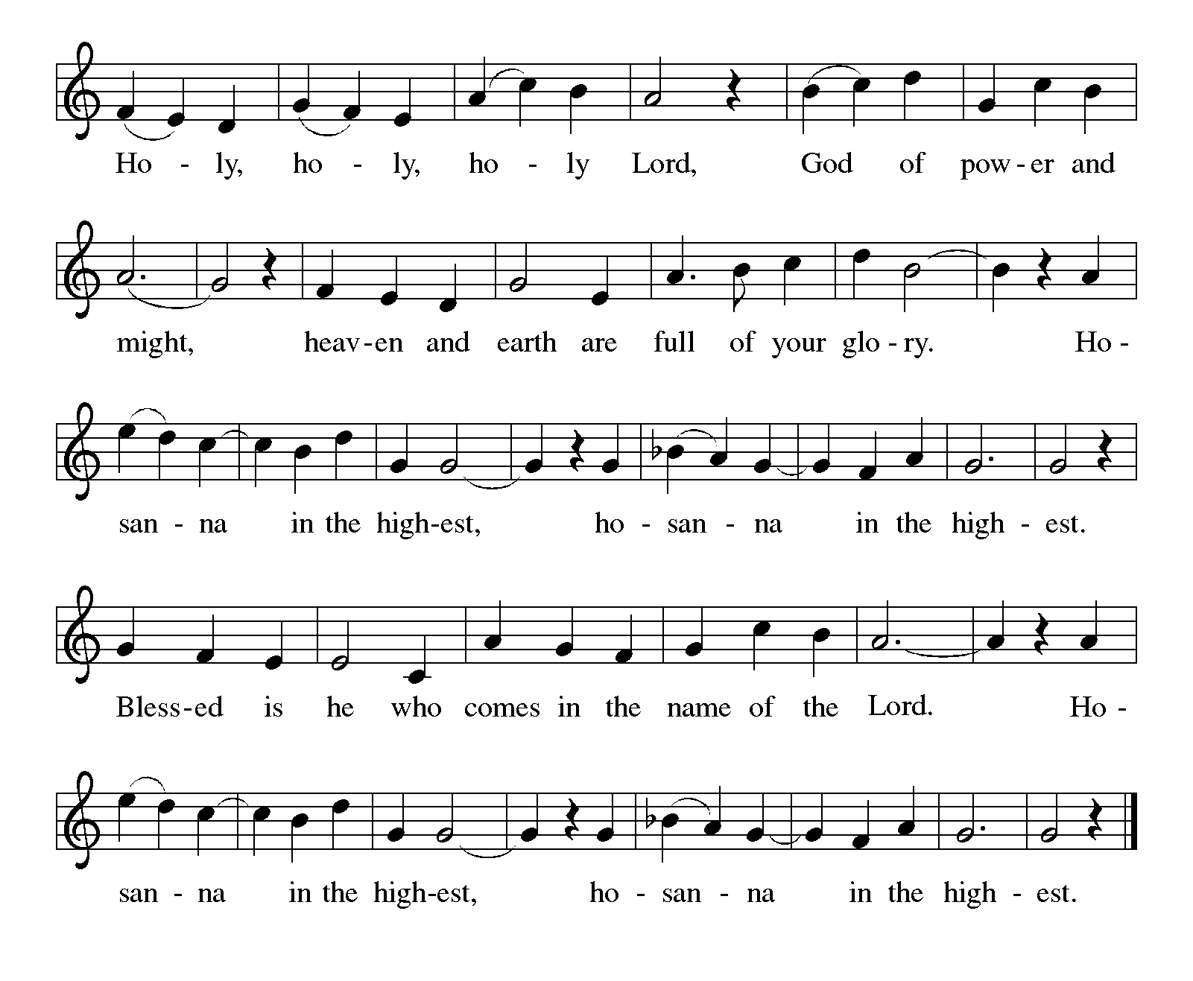
Jesus’ Words of Promise and Gift of Life
Dear Lord, Jesus Christ:
in the night in which you were betrayed,
You took bread, broke it and gave thanks,
then you gave it to your disciples saying:
take and eat, this is my body I am giving for you.
Do this in remembrance of me.
Again, after supper, Dear Lord Jesus,
You took the cup, gave thanks
and gave it for everyone to drink saying:
this cup is the new covenant in my blood,
I am shedding for you and for all people for the forgiveness of sin.
Do this for the remembrance of me. Amen.

Our Lord's Prayer
Our Father in heaven, hallowed be your name, your kingdom come, your will be done, on earth as in heaven. Give us today our daily bread. Forgive us our sins as we forgive those who sin against us. Save us from the time of trial and deliver us from evil. For the kingdom, the power, and the glory are yours, now and forever. Amen.
P – Come to this Table where God really does come to us!
C – Thank You Jesus!

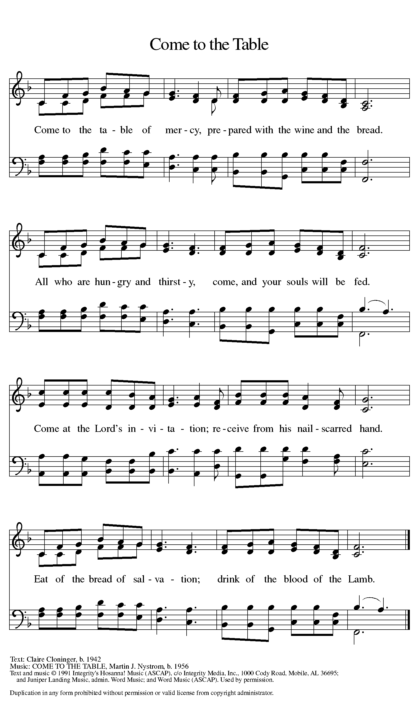

Distribution Anthem of Communion – Come Forward to Receive
Communion Anthem: This Is Jesus
Prayer After Communion
Compassionate God, you have fed us with the bread of heaven. Sustain us in our Lenten pilgrimage: may our fasting be hunger for justice, our alms, a making of peace, and our prayer, the song of grateful hearts; through Christ our Lord. Amen.
P – Now may the body and blood of our Lord and Savior Jesus Christ strengthen you and keep you in His grace….. Jesus Loves You!
C – Thank You Jesus!
The Blessing
P – May God who has called us forth from the dust of the earth, and claimed us as children of the light, strengthen you on your journey into life renewed. The Lord bless you and keep you. The Lord’s face shine upon you with grace and mercy. The Lord look upon you with favor and give you ☩ peace.
C - Amen.

Sending Hymn: Lift High the Cross ELW 660
Refrain
Lift high the cross, the love of Christ proclaim
till all the world adore his sacred name.
1 Come, Christians, follow where our captain trod,
our king victorious, Christ, the Son of God. Refrain

2 All newborn servants of the Crucified
bear on their brows the seal of him who died. Refrain
3 O Lord, once lifted on the glorious tree,
as thou hast promised, draw us all to thee. Refrain
4 So shall our song of triumph ever be:
praise to the Crucified for victory! Refrain
P - Marked with the cross of Christ, go forth to love and serve the Lord.
C - By the Light of the Cross, We Will! Hallelujah!

Postlude: All Hail King Jesus W&P 3
Unless otherwise noted, materials used in this bulletin are:
From Sundays and Seasons.com. Copyright 2015 Augsburg Fortress. All rights reserved. Reprinted by permission under Augsburg Fortress Liturgies Annual License #SAS028635. Music is reprinted under OneLicense.Net #A712074 and/or Augsburg Fortress #SBL12176H. Scripture, unless otherwise noted, is from the New Revised Standard Version Bible, Copyright © 1989, Division of Christian Education of the National Council of the Churches of Christ in the United States of America. Used by permission. All rights reserved.

REMEMBRANCE
Olavus Petri, priest, died 1552; Laurentius Petri, Bishop of Uppsala, died 1573; renewers of the church
These two brothers studied with Luther at the University of Wittenberg and then returned to their native Sweden to introduce the Lutheran reforms. Olavus published a catechism and hymnal; Laurentius was a professor who defended the office of bishop and later became one.
From sundaysandseasons.com.

Announcements for April 12th and 13th
Attendance
Lent Wednesday, April 2nd, 4pm 18
Saturday, April 5th, 4pm 30
Sunday, April 6th , 9am 44
Drive-Up Communion 2
94

HOLY WEEK SERVICES
Maundy Thursday, April 17th, 7pm
Good Friday, April 18th, 7pm Tenebrae Service
Easter Vigil, Saturday, April 19th, 4pm
Easter Sunday, April 20th, Sunrise Svc 7am
Breakfast
Traditional Service, 9:30am

EASTER ALTAR FLOWERS
Celebrate God’s diverse world! Since 2021 we’ve been asking folks to bring potted, flowering plants to decorate the church, instead of lilies. Let’s do it again this year! All kinds, all colors, all sizes are welcome. Bring them to the church on Saturday (the day before Easter). If you would like them back please put your name on them.
