St. Timothy Lutheran Church
Sunday, September 22nd, Pentecost Season

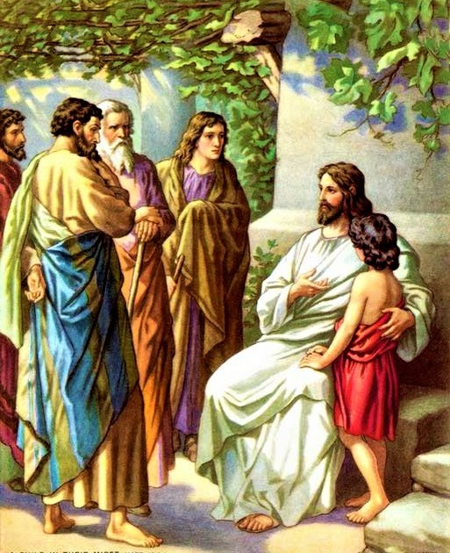
"Equip people to grow as Disciples faithfully serving our community"

We are glad to have you worship with us. All are welcome at communion. If you need gluten-free – please tell Pastor Joanie when you go up for communion. If you have any questions – just ask the Welcomer at the back of the sanctuary.

Please note** if you use a pew envelope for your offering – please write your name on the envelope so that the financial secretaries can post it as a gift from you. Thank You!
St Timothy Worship Planning Team
The Reverend Joan E. Holden 850-774-7730
Eric Mortensen, Director of Music
Parish Deacon, Frank Hofstetter

The Altar Flowers are given by Sue Gable, in memory of her parents

This Week at St. Timothy's
Monday, September 23rd PJ Off
Tuesday, September 24th 9-12 Food Pantry
Wednesday, September 25th 10am – OT BS
Thursday, September 26th 9:30am – Prayer Group, 11:00am – Miniatures, 1:30pm – Royal Dalton, 4:30pm – Choir, 5:15 pm – Chimes
Friday, September 27th 10am – NT BS, 11am – PJ Continuing Ed
Saturday, September 28th 4pm – Worship
Sunday, September 29th 9am – Worship, Children’s SS, 10:30am – Adult SS, 11-11:30am – Drive-Up Communion

Rooted in the past and growing into the future, the church must always be reformed in order to live out the love of Christ in an ever-changing world. We celebrate the good news of God’s grace, that Jesus Christ sets us free every day to do this life-transforming work. Trusting in the freedom given to us in baptism, we pray for the church, that Christians will unite more fully in worship and mission.
(from Sundays and Seasons for Reformation Weekend)
“Shout to the Lord” is the last pre-service hymn the choir sings, it is Hymn #821 and everyone is welcome to sing with the choir.
Welcome and Congregational News
Preparation Hymn: Bring Forth the Kingdom W&P 22

Confession and Forgiveness
(Stand)
P – In the name of the Father, and of the Son, (+) and of the Holy Spirit.
C – Amen
P – Almighty God, to whom all hearts are open, all desires known, and from whom no secrets are hid; Cleanse the thoughts of our hearts by the inspiration of your Holy Spirit, that we may perfectly love you and worthily magnify your holy name, through Jesus Christ our Lord.
C – Amen
P - If we say we have no sin, we deceive ourselves, and the truth is not in us, But if we confess our sins, God who is faithful and just will forgive our sins and cleanse us from all unrighteousness.
(stand, sit or kneel as you are able)
P– Most Merciful God,
C – Have mercy on us. We confess to you all our sins and that in these continuing times of uncertainty and fear, we have trouble trusting you and feeling your presence. Forgive us our sins, our doubts, our fears and lack of patience with others. Strengthen our faith and help us to let your hope and light shine through us in these troubling times. We ask for mercy, wisdom and guidance, through Jesus Christ, our Savior and Lord. Amen.
P - Almighty God, in his mercy, has given his Son to die for us and for his sake, forgives us all our sins. Because we are saved by the actions and faithfulness of Christ, I therefore declare to you the entire forgiveness of all your sins, in the name of the Father, and of the + Son, and of the Holy Spirit.
C – Amen

Gathering Hymn: God Is Here! ELW 526
1 God is here! As we your people meet to offer
praise and prayer, may we find in fuller measure
what it is in Christ we share. Here, as in the
world around us, all our varied skills and arts
wait the coming of the Spirit into open minds and hearts.

2 Here are symbols to remind us of our lifelong
need of grace; here are table, font, and pulpit;
here the cross has central place. Here in honesty
of preaching, here in silence, as in speech,
here, in newness and renewal, God the Spirit comes to each.

3 Here our children find a welcome in the Shepherd's
flock and fold; here as bread and wine are taken,
Christ sustains us as of old. Here the servants
of the Servant seek in worship to explore
what it means in daily living to believe and to adore.

4 Lord of all, of church and kingdom, in an age of
change and doubt, keep us faithful to the gospel;
help us work your purpose out. Here, in this day's
dedication, all we have to give, receive;
we, who cannot live without you, we adore you! We believe!
P - The grace of our Lord Jesus Christ, the love of God and the communion of the Holy Spirit be with you all.
C - And also with you.

Prayer of the Day
O God, our teacher and guide, you draw us to yourself and welcome us as beloved children. Help us to lay aside all envy and selfish ambition, so that we can walk in your ways of wisdom and understanding as servants of your Son, Jesus Christ, our Savior and Lord. Amen.
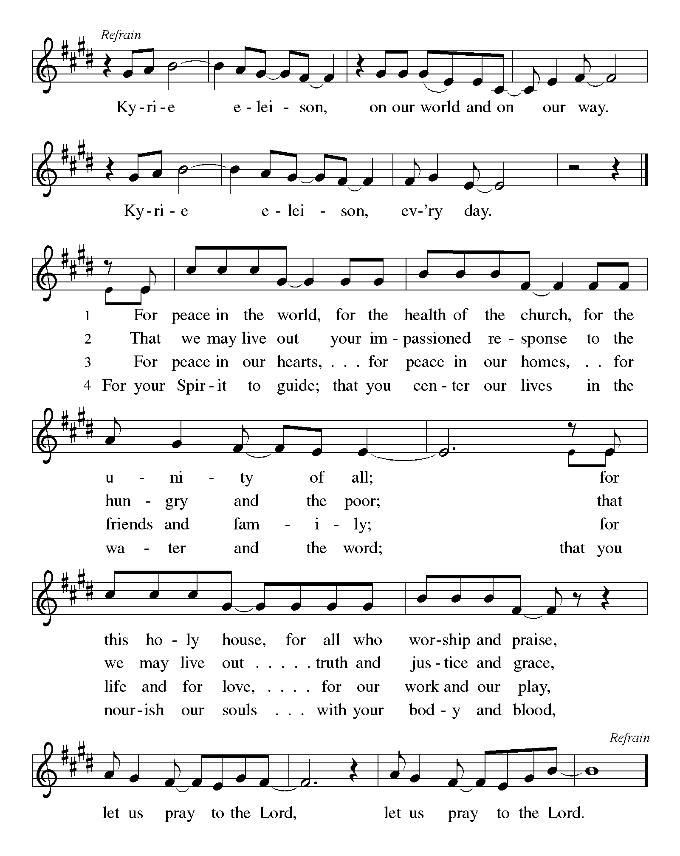

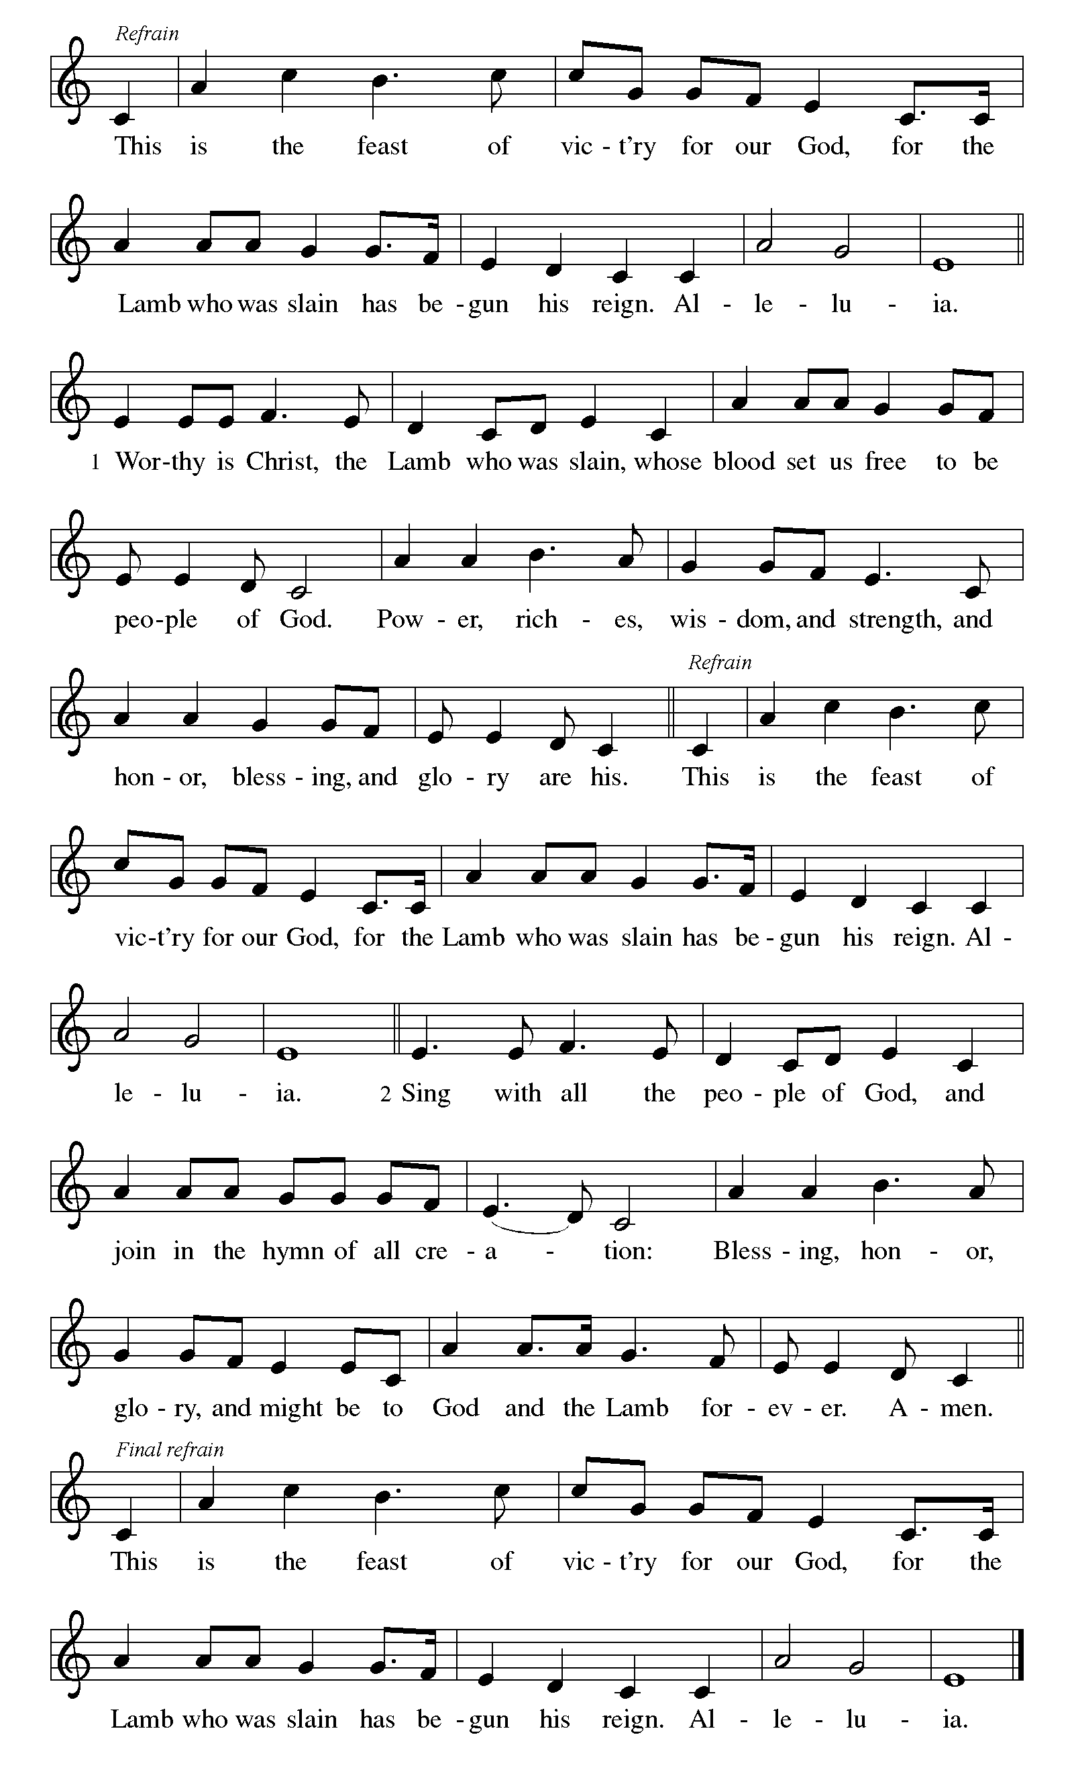

P – The Lord be with you.
C – And also with you. (be seated)

First Lesson: Jeremiah 11:18-20
Today’s reading tells of the suffering of the prophet Jeremiah, who announced God’s word to Judah but was met with intense opposition and persecution. Jeremiah continues to trust in God in the midst of his suffering.
¹⁸It was the Lord who made it known to me, and I knew;
then you showed me their evil deeds.
¹⁹But I was like a gentle lamb
led to the slaughter.
And I did not know it was against me
that they devised schemes, saying,
“Let us destroy the tree with its fruit,
let us cut him off from the land of the living,
so that his name will no longer be remembered!”
²⁰But you, O Lord of hosts, who judge righteously,
who try the heart and the mind,
let me see your retribution upon them,
for to you I have committed my cause.

A – Word of God!

C – Words of Life!

Psalm 54
¹Save me, O God, by your name;
in your might, defend my cause.
²Hear my prayer, O God;
give ear to the words of my mouth.
³For strangers have risen up against me, and the ruthless have sought my life,
those who have no regard for God.
⁴Behold, God is my helper;
it is the Lord who sustains my life.
⁵Render evil to those who spy on me;
in your faithfulness, destroy them.
⁶I will offer you a freewill sacrifice
and praise your name, O Lord, for it is good.
⁷For you have rescued me from every trouble,
and my eye looks down on my enemies.

Second Lesson: James 3:13—4:3, 7-8a
The wisdom God gives unites our hearts and minds. Instead of living to satisfy our own wants and desires, we manifest this wisdom in peace, gentleness, mercy, and impartiality toward others.
¹³Who is wise and understanding among you? Show by your good life that your works are done with gentleness born of wisdom. ¹⁴But if you have bitter envy and selfish ambition in your hearts, do not be boastful and false to the truth. ¹⁵Such wisdom does not come down from above, but is earthly, unspiritual, devilish. ¹⁶For where there is envy and selfish ambition, there will also be disorder and wickedness of every kind. ¹⁷But the wisdom from above is first pure, then peaceable, gentle, willing to yield, full of mercy and good fruits, without a trace of partiality or hypocrisy. ¹⁸And a harvest of righteousness is sown in peace for those who make peace.^{4:}
¹Those conflicts and disputes among you, where do they come from? Do they not come from your cravings that are at war within you? ²You want something and do not have it; so you commit murder. And you covet something and cannot obtain it; so you engage in disputes and conflicts. You do not have, because you do not ask. ³You ask and do not receive, because you ask wrongly, in order to spend what you get on your pleasures. ⁷Submit yourselves therefore to God. Resist the devil, and he will flee from you. ^{8a}Draw near to God, and he will draw near to you.

A – Word of God!

C – Words of Life!

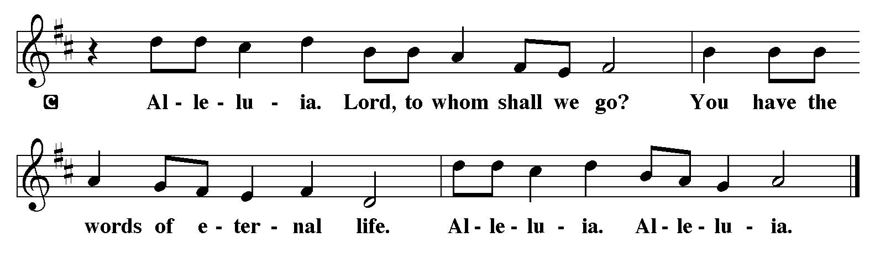
P - The Holy Gospel according to Mark, Chapter 9
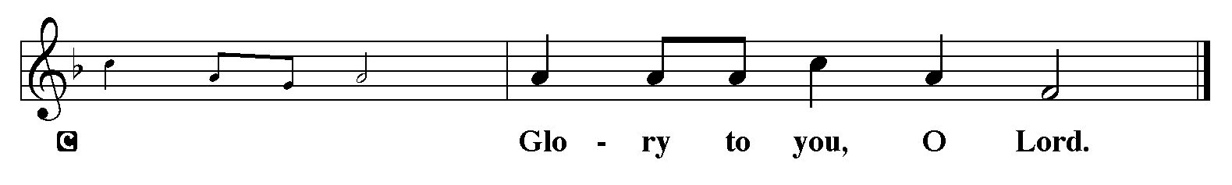

Gospel: Mark 9:30-37
Jesus’ teaching and action in this text are directed to the church whenever it is seduced by the world’s definition of greatness: prestige, power, influence, and money. The antidote to such a concern for greatness is servanthood.
³⁰[Jesus and the disciples went on] and passed through Galilee. He did not want anyone to know it;³¹for he was teaching his disciples, saying to them, “The Son of Man is to be betrayed into human hands, and they will kill him, and three days after being killed, he will rise again.” ³²But they did not understand what he was saying and were afraid to ask him.
³³Then they came to Capernaum; and when he was in the house he asked them, “What were you arguing about on the way?” ³⁴But they were silent, for on the way they had argued with one another who was the greatest. ³⁵He sat down, called the twelve, and said to them, “Whoever wants to be first must be last of all and servant of all.” ³⁶Then he took a little child and put it among them; and taking it in his arms, he said to them, ³⁷“Whoever welcomes one such child in my name welcomes me, and whoever welcomes me welcomes not me but the one who sent me.”

P - The Gospel of the Lord.
C - Praise to you, O Christ. (Sit)

Children’s Time

Message
Hymn of the Day: All Are Welcome (Let Us Build a House Where Love Can Dwell) ELW 641
Let us build a house where love can dwell and all can safely
live, a place where saints and children tell how
hearts learn to forgive. Built of hopes and dreams and
visions, rock of faith and vault of grace; here the love of
Christ shall end divisions:

Refrain
All are welcome, all are welcome,
all are welcome in this place.
Let us build a house where prophets speak, and words are strong and true, where all God's children dare to seek to
dream God's reign anew. Here the cross shall stand as
witness and as symbol of God's grace; here as one we
claim the faith of Jesus: Refrain
Let us build a house where love is found in water, wine and
wheat: a banquet hall on holy ground where
peace and justice meet. Here the love of God, through
Jesus, is revealed in time and space; as we share in
Christ the feast that frees us: Refrain
Let us build a house where hands will reach beyond the wood and
stone to heal and strengthen, serve and teach, and
live the Word they've known. Here the outcast and the
stranger bear the image of God's face; let us bring an
end to fear and danger: Refrain

Let us build a house where all are named, their songs and visions
heard and loved and treasured, taught and claimed as
words within the Word. Built of tears and cries and
laughter, prayers of faith and songs of grace, let this house proclaim from floor to rafter: Refrain
The Apostles’ Creed
I believe in God, the Father almighty,
creator of heaven and earth.
I believe in Jesus Christ, God’s only Son, our Lord,
who was conceived by the Holy Spirit,
born of the virgin Mary,
suffered under Pontius Pilate,
was crucified, died, and was buried;
he descended to the dead.
On the third day he rose again;
he ascended into heaven,
he is seated at the right hand of the Father,
and he will come to judge the living and the dead.
I believe in the Holy Spirit,
the holy catholic church,
the communion of saints,
the forgiveness of sins,
the resurrection of the body,
and the life everlasting. Amen.

Lord, listen to your children praying,
Lord, send your Spirit in this place;
Lord, listen to your children praying,
send us love, send us pow'r, send us grace.

Prayers of the People (please stand, sit or kneel as you are able )
Drawn together in the power of the Holy Spirit, we pray with confidence for the church, God’s good creation, and everyone in need.
A brief silence.
Loving God, you welcome everyone at your table of grace. Instill in your church a spirit of humility and curiosity, so that we embrace everyone who seeks you. We pray especially for ministries of hospitality and faith formation. Hear us, O God. Your mercy is great.
Creating God, you shape the world so there is more than enough for all. Curb our habits of overuse, and guide us toward more sustainable sources of energy, food, and water. Hear us, O God. Your mercy is great.
Gracious God, your peace brings justice and solidarity. Encourage peace among peoples, tribes, and nations; heal divisions in our country and local communities, that together we might cooperate for the good of all. Hear us, O God. Your mercy is great.
Faithful God, you draw near to you everyone who is in need. Bring healing and wholeness to everyone who suffers, especially everyone on our prayer list and everyone we name out loud or silently in our hearts….. Transform economic, political, and social systems that oppress vulnerable people, especially systems of structural racism and generational poverty. Hear us, O God. Your mercy is great.
Transforming God, you accompany everyone through changes and transitions. Help us to see where you are calling this community to new ways of living the gospel promise; assure us that even as change brings loss, it also brings hope and life. Hear us, O God. Your mercy is great.
Everyone is welcome to offer prayers at this time…..Hear us, O God. Your mercy is great.
Merciful God, you embrace us on our final pilgrimage from this life. Accompany everyone who has died, console those who mourn, and at the last, show us the way to eternal life in you. Hear us, O God. Your mercy is great.
We entrust these and all our prayers to you, holy God, in the name of your beloved child, Jesus Christ, our Savior.
Amen.

The Peace
P – The Peace of the Lord be with you always.
C – And also with you.
The Offering is Brought to the Altar
Offering Prayer

We lift our voices, we lift our hands, we lift our lives up to you; we are an Offering. Lord, use our voices, Lord, use our hands, Lord, use our lives, they are yours: we are an offering. All that we have, all that we are, all that we hope to be, we give to you, we give to you. We lift our voices, we lift our hands, we lift our lives up to you; we are an offering, we are an offering.
Jesus’ Words of Promise and Gift of Life
P: Dear Lord, Jesus Christ:
in the night in which you were betrayed,
You took bread, broke it and gave thanks,
then you gave it to your disciples saying:
take and eat, this is my body I am giving for you.
Do this in remembrance of me.
Again, after supper, Dear Lord Jesus,
You took the cup, gave thanks
and gave it for everyone to drink saying:
this cup is the new covenant in my blood,
I am shedding for you and for all people for the forgiveness of sin.
Do this for the remembrance of me. Amen.

Our Lord's Prayer
Our Father in heaven, hallowed be your name, your kingdom come, your will be done, on earth as in heaven. Give us today our daily bread. Forgive us our sins as we forgive those who sin against us. Save us from the time of trial and deliver us from evil. For the kingdom, the power, and the glory are yours, now and forever. Amen.
Invitation to Communion
P: Come to this Table where God really does come to us!
C: Thank You Jesus!

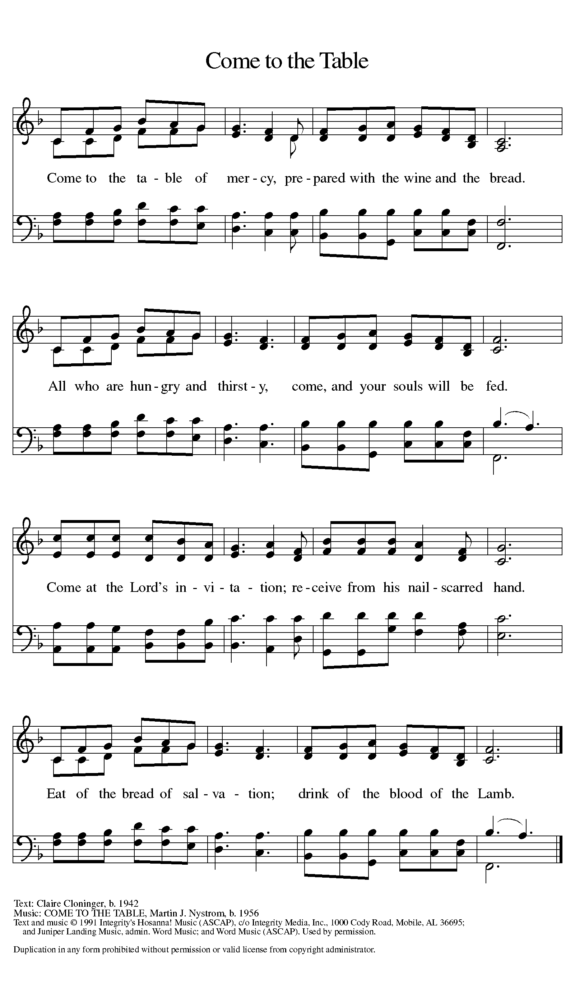

Distribution - Please come forward to receive
Communion Anthems: By Grace, We Have Been Saved W&P 25
I Received the Living God ELW 477

P – Now may the body and blood of our Lord and Savior, Jesus Christ strengthen you and keep you in His grace … Jesus Loves You!
C – Thank You Jesus!
Communion Prayer
Holy God, you welcome us to this meal and feed us with dignity at your table. Send us now to welcome others and to be at peace with one another, through Jesus Christ our Lord. Amen.
Blessing

P: God all mighty, God most merciful ☩ bless you, keep you, and give you peace.
C: Amen

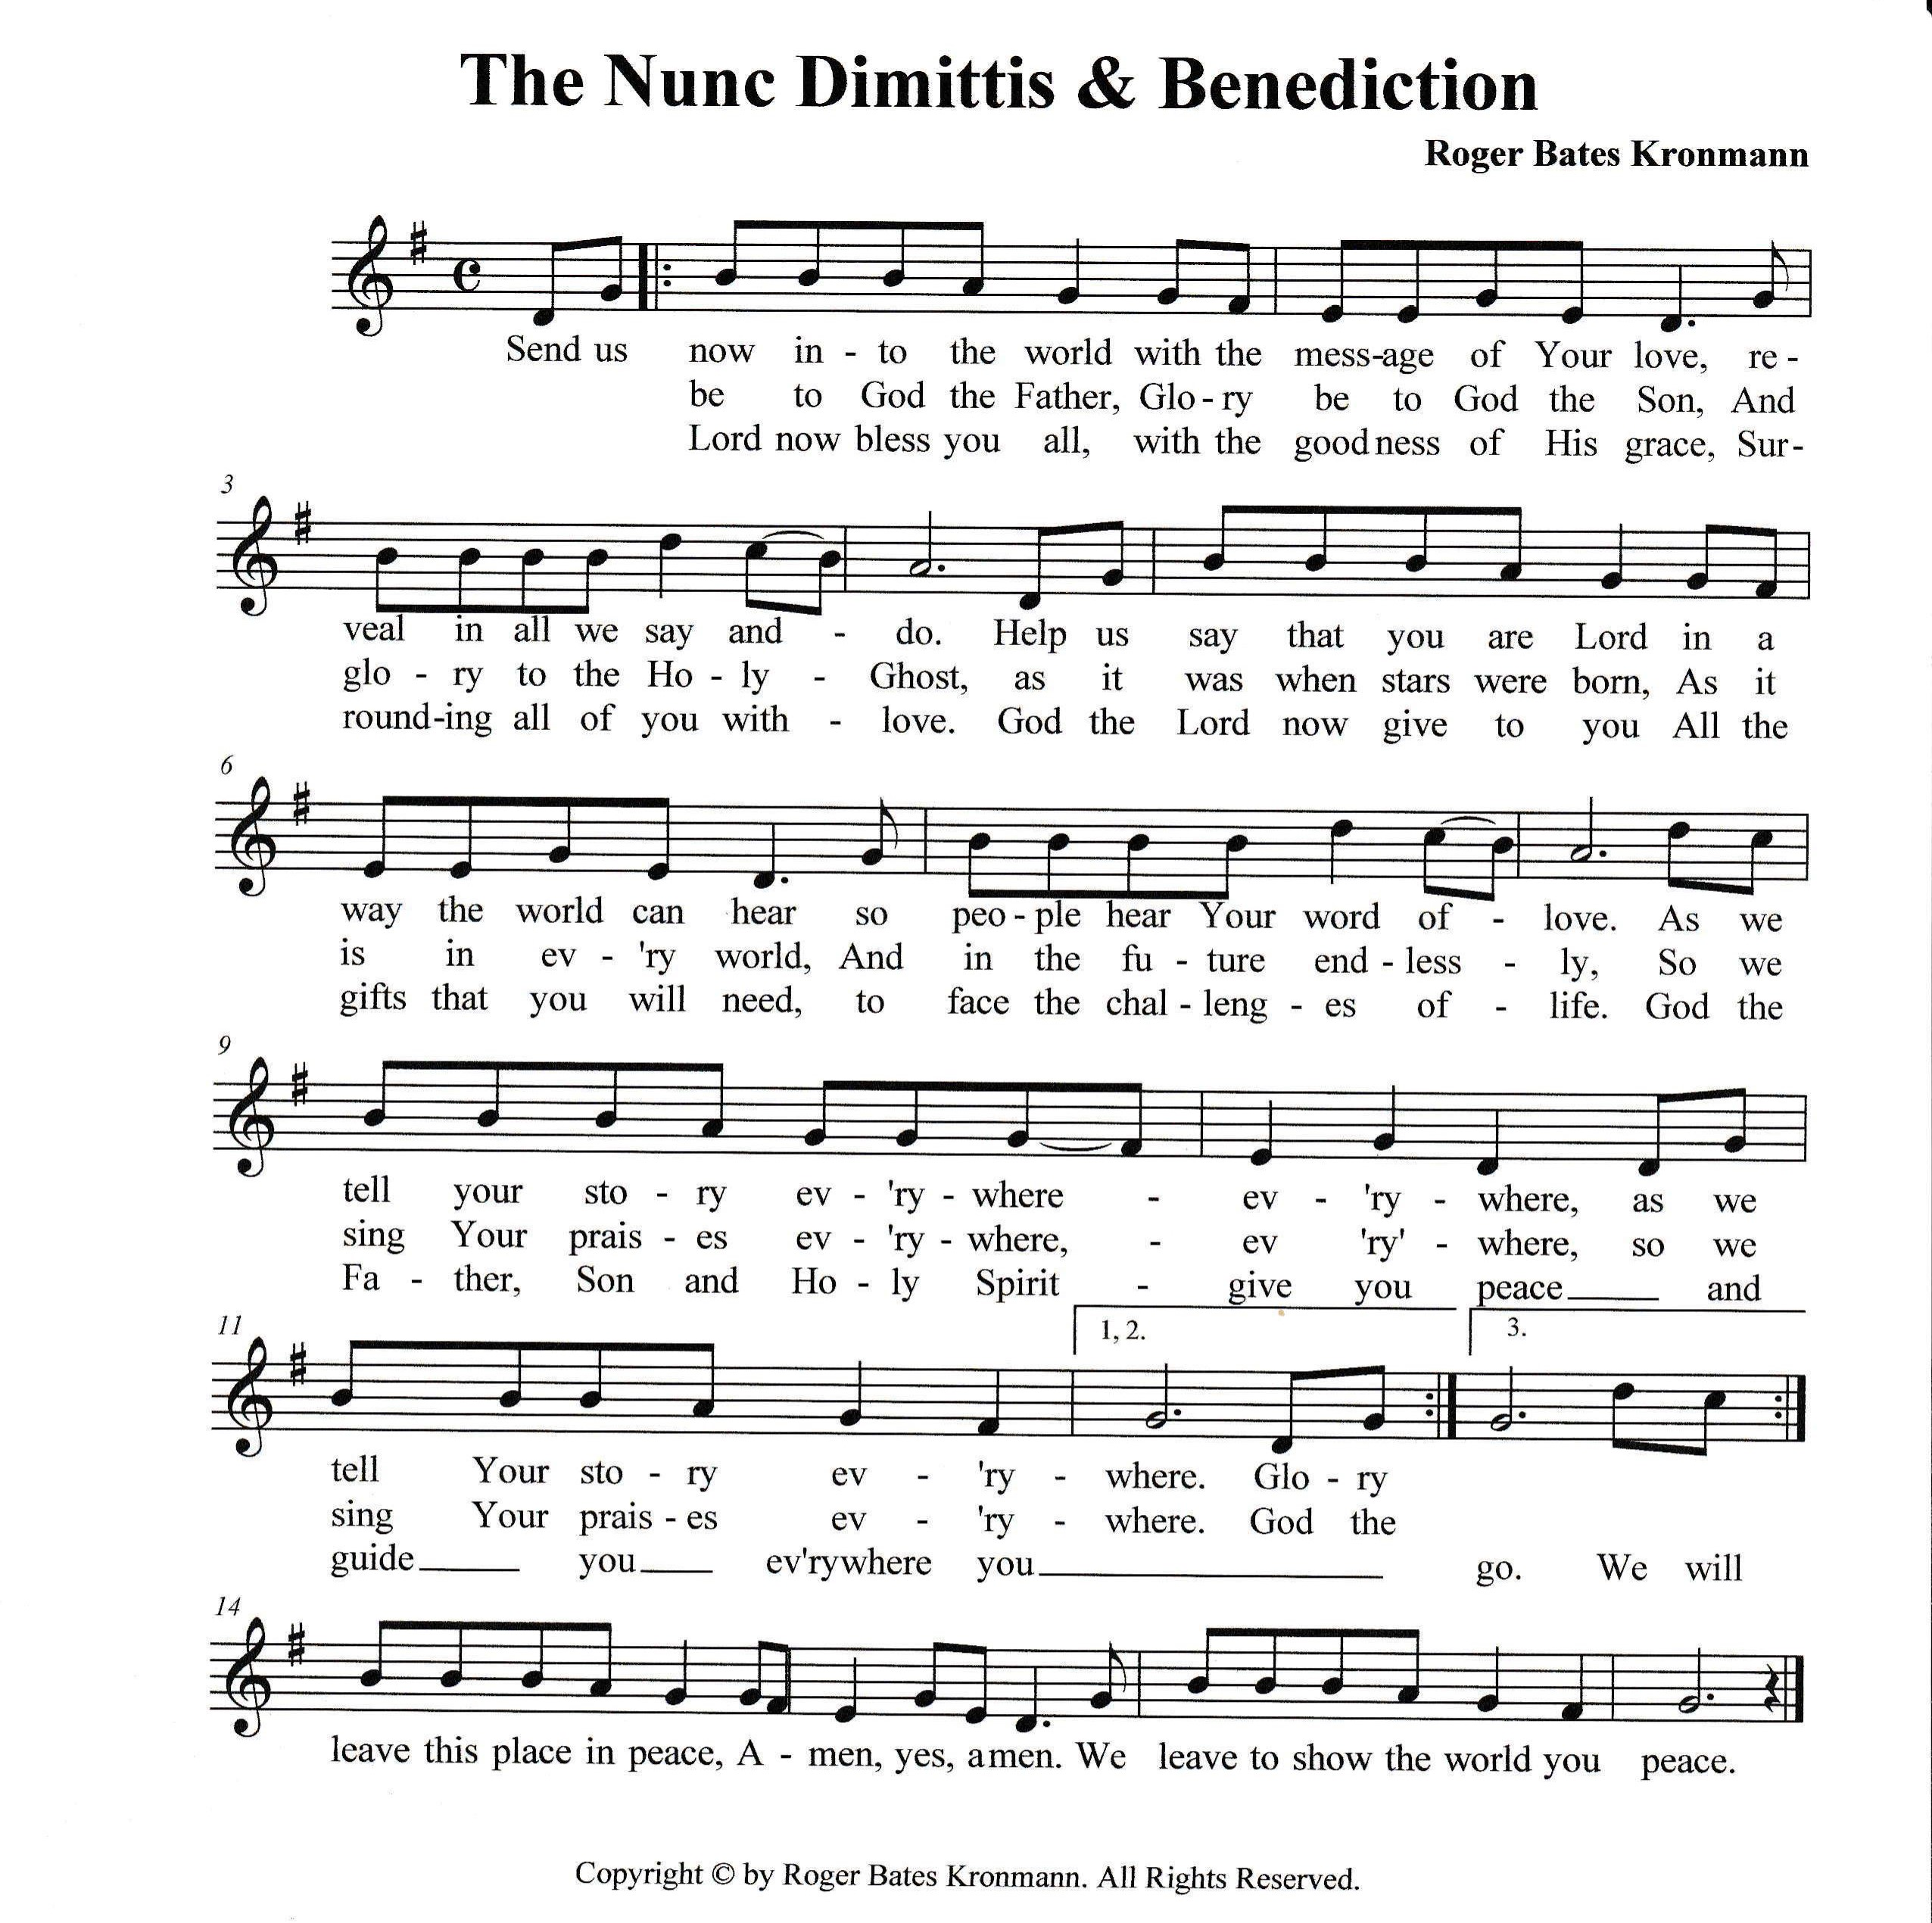

Sending Hymn: Praise the One Who Breaks the Darkness ELW 843
1 Praise the One who breaks the darkness with a liberating light;
praise the One who frees the pris'ners, turning blindness into sight.
Praise the One who preached the gospel, healing ev'ry dread disease,
calming storms and feeding thousands with the very bread of peace.

2 Praise the One who blessed the children with a strong yet gentle word;
praise the One who drove out demons with a piercing, two-edged sword. Praise the One who brings cool water to the desert's burning sand; from this well comes living water quenching thirst in ev'ry land.

3 Praise the one true love incarnate: Christ, who suffered in our place;
Jesus died and rose for many that we may know God by grace.
Let us sing for joy and gladness, seeing what our God has done.
Praise the one redeeming glory; praise the One who makes us one.
A - Go in peace. Proclaim the Good News!
C - By the Grace of God we will – Allelulia!
Postlude: Emmanuel W&P 36
Unless otherwise noted, materials used in this bulletin are:
From Sundays and Seasons.com. Copyright 2015 Augsburg Fortress. All rights reserved. Reprinted by permission under Augsburg Fortress Liturgies Annual License #SAS028635. Music is reprinted under OneLicense.Net #A712074 and/or Augsburg Fortress #SBL12176H. Scripture, unless otherwise noted, is from the New Revised Standard Version Bible, Copyright © 1989, Division of Christian Education of the National Council of the Churches of Christ in the United States of America. Used by permission. All rights reserved.

REMEMBRANCE
Jerome, translator, teacher, died 420
Jerome was a biblical scholar and translator, but rather than translating the original Hebrew and Greek scriptures into classical Latin, he worked in the commonly-spoken Latin of the day, creating a version called the Vulgate.
From sundaysandseasons.com.

Announcements for September 21st and 22nd
ATTENDANCE
Saturday, September 14th, 4pm 24
Sunday, September 15th, 9am 24
Drive-Up Communion 3
51
__________________________

MINI GRANNY’S ATTIC


CALLING ALL BAKERS!!!!
We need cookies, cakes, cupcakes, brownies, candy, breads, etc. for our Bake Sale on
Friday, October 25th.
- You may package your goodies, or we will do that for you.
- Please mark if the goodies are gluten free
and/or sugar free.
- Please note if there are nuts in the baked
goods.
- Please bring the items to the church either Thursday, October 24th or early Friday, October 25th.
Thanks so much for your help and support.
Questions? Call Eileen at 352-419-6610 or Lynn at 352-382-0435.
