St Timothy Lutheran Church
Sunday, 9:00 AM Worship
March 16, 2025
Second Sunday in Lent

"Equipping people to grow as Disciples faithfully serving our community"
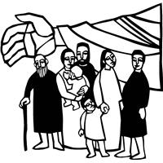

Rooted in the past and growing into the future, the church must always be reformed in order to live out the love of Christ in an ever-changing world. We celebrate the good news of God’s grace, that Jesus Christ sets us free every day to do this life-transforming work. Trusting in the freedom given to us in baptism, we pray for the church, that Christians will unite more fully in worship and mission.
(from Sundays and Seasons for Reformation Weekend)
We are glad to have you worship with us. All are welcome at communion. If you need gluten-free – please ask when you go up for communion. If you have any questions – just ask the Welcomer at the back of the sanctuary.
Please note** if you use a pew envelope for your offering – please write your name on the envelope so that the financial secretaries can post it as a gift from you. Thank You!

St Timothy Worship Planning Team
Pastor Lynn Bechdolt
Deacon Frank Hofstetter
Eric Mortensen, Director of Music

The Altar flowers are given by Jake and Marcia Jacobek, in honor of their grandchildren and to the glory of God!

This Week at St. Timothy's
Monday – March 17th 11am - Pule Service
Tuesday – March 18th 1pm - WELCA
Wednesday – March 19th 4pm – Mid-Week Lenten Svc, 5pm – Soup Supper
Thursday – March 20th 9:30 am – Prayer Group, 11:30 am – Miniatures, 4:30pm – Choir, 5:15pm - Chimes
Friday – March 21st
Saturday – March 22nd 9-3 – Garden Club Craft & Art Fair,
4 pm – Worship
Sunday – March 23rd 9am – Worship, Children’s SS, 10:15- 10:45 – Drive Up Communion, 10:30 am – Coffee Fellowship, Adult Sunday School
Welcome and Congregational News
“On Eagles’ Wings”, ELW 787 is the last music before worship – all are welcome to join in
Preparation Anthem: Come and See W&P 29
Confession and Forgiveness
P – In the name of the Father, and of the Son, (+) and of the Holy Spirit.
C – Amen
P – Almighty God, to whom all hearts are open, all desires known, and from whom no secrets are hid; Cleanse the thoughts of our hearts by the inspiration of your Holy Spirit, that we may perfectly love you and worthily magnify your holy name, through Jesus Christ our Lord.
C – Amen
P - If we say we have no sin, we deceive ourselves, and the truth is not in us, But if we confess our sins, God who is faithful and just will forgive our sins and cleanse us from all unrighteousness.
(Silence for reflection and self-examination)
P – Most Merciful God,
C – Have mercy on us. We confess to you all our sins and that in these continuing times of uncertainty and fear, we have trouble trusting you and feeling your presence. Forgive us our sins, our doubts, our fears and lack of patience with others. Strengthen our faith and help us to let your hope and light shine through us in these challenging times. We ask for mercy, wisdom and guidance, through Jesus Christ, our Savior and Lord. Amen.
P – Almighty God, in his mercy, has given his Son to die for us and for his sake, forgives us all our sins. As a called and ordained minister of the Church of Christ, and by his authority, I therefore declare to you the entire forgiveness of all your sins, in the name of the Father, and of the + Son, and of the Holy Spirit.
C – Amen

Gathering Hymn: In the Cross of Christ I Glory ELW 324
1 In the cross of Christ I glory,
tow'ring o'er the wrecks of time.
All the light of sacred story
gathers round its head sublime.

2 When the woes of life o'ertake me,
hopes deceive, and fears annoy,
never shall the cross forsake me;
lo, it glows with peace and joy.

3 When the sun of bliss is beaming
light and love upon my way,
from the cross the radiance streaming
adds more luster to the day.

4 Bane and blessing, pain and pleasure,
by the cross are sanctified;
peace is there that knows no measure,
joys that through all time abide.

Prayer of the Day
God of the covenant, in the mystery of the cross you promise everlasting life to the world. Gather all peoples into your arms, and shelter us with your mercy, that we may rejoice in the life we share in your Son, Jesus Christ, our Savior and Lord, who lives and reigns with you and the Holy Spirit, one God, now and forever.
Amen.

P - The grace of our Lord Jesus Christ, the love of God, and the communion of the Holy Spirit be with you all.
C - And also with you.

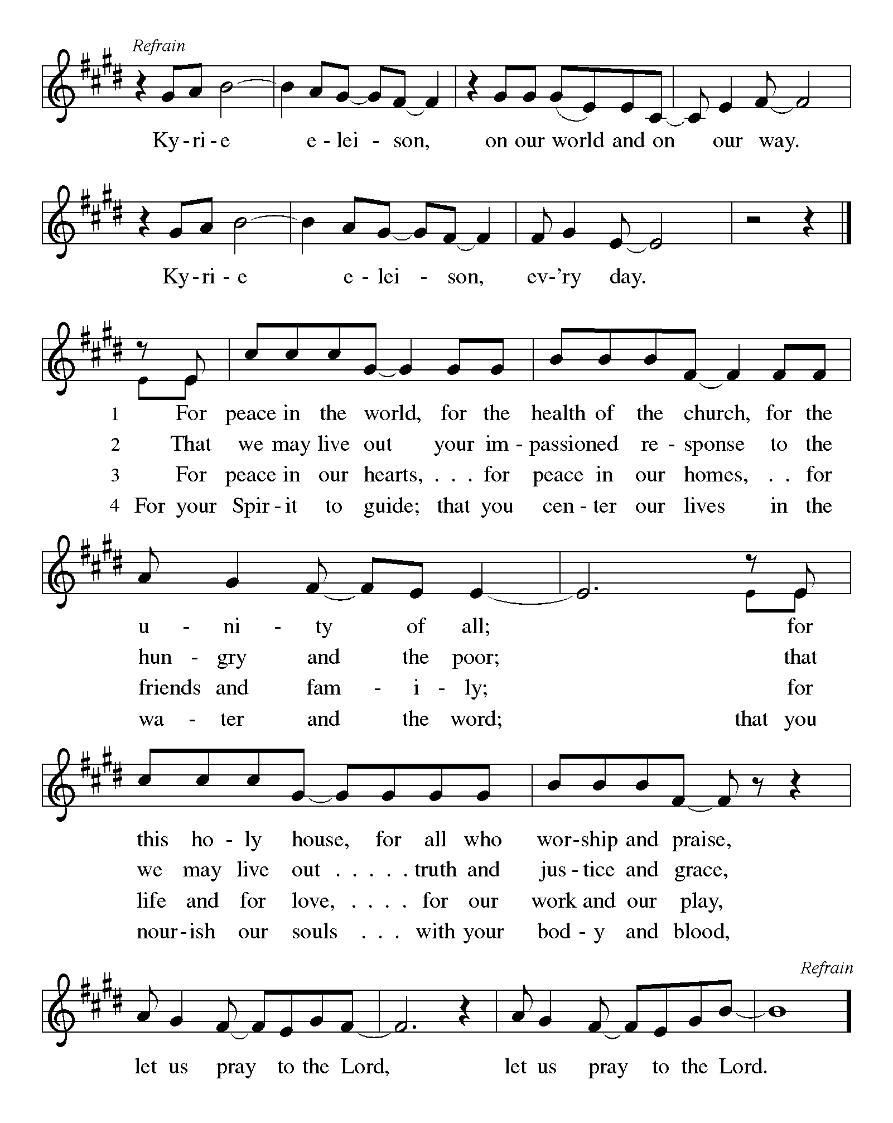

P - The Lord be with you.
C - And also with you.

First Lesson: Genesis 15:1-12, 17-18
God promises a childless and doubting Abram that he will have a child, that his descendants will be as numerous as the stars, and that the land of Canaan will be their inheritance. Abram’s trust in God is sealed with a covenant-making ceremony, a sign of God’s promise.
¹ After these things the word of the Lord came to Abram in a vision, “Do not be afraid, Abram, I am your shield; your reward shall be very great.” ² But Abram said, “O Lord God, what will you give me, for I continue childless, and the heir of my house is Eliezer of Damascus?” ³ And Abram said, “You have given me no offspring, and so a slave born in my house is to be my heir.” ⁴ But the word of the Lord came to him, “This man shall not be your heir; no one but your very own issue shall be your heir.” ⁵ He brought him outside and said, “Look toward heaven and count the stars, if you are able to count them.” Then he said to him, “So shall your descendants be.” ⁶ And he believed the Lord; and the Lord reckoned it to him as righteousness.
⁷ Then he said to him, “I am the Lord who brought you from Ur of the Chaldeans, to give you this land to possess.” ⁸ But he said, “O Lord God, how am I to know that I shall possess it?” ⁹ He said to him, “Bring me a heifer three years old, a female goat three years old, a ram three years old, a turtledove, and a young pigeon.” ¹⁰ He brought him all these and cut them in two, laying each half over against the other; but he did not cut the birds in two. ¹¹ And when birds of prey came down on the carcasses, Abram drove them away.
¹² As the sun was going down, a deep sleep fell upon Abram, and a deep and terrifying darkness descended upon him.
¹⁷ When the sun had gone down and it was dark, a smoking fire pot and a flaming torch passed between these pieces. ¹⁸ On that day the Lord made a covenant with Abram, saying, “To your descendants I give this land, from the river of Egypt to the great river, the river Euphrates.”

A – Words of God!
C – Words of Life!

Psalm 27
¹ The Lord is my light and my salvation; whom then shall I fear?
The Lord is the stronghold of my life; of whom shall I be afraid?
² When evildoers close in against me to devour my flesh,
they, my foes and my enemies, will stumble and fall.
³ Though an army encamp against me, my heart will not fear.
Though war rise up against me, my trust will not be shaken.
⁴ One thing I ask of the Lord; one thing I seek;
that I may dwell in the house of the Lord all the days of my life; to gaze upon the beauty of the Lord and to seek God in the temple.
⁵ For in the day of trouble God will give me shelter,
hide me in the hidden places of the sanctuary, and raise me high up- | on a rock.
⁶ Even now my head is lifted up above my enemies who surround me.
Therefore I will offer sacrifice in the sanctuary, sacrifices of rejoicing; I will sing and make music to the Lord.
⁷ Hear my voice, O Lord, when I call;
have mercy on me and answer me.
⁸ My heart speaks your message— “Seek my face.”
Your face, O Lord, I will seek.
⁹ Hide not your face from me, turn not away from your servant in anger.
Cast me not away—you have been my helper; forsake me not, O God of my salvation.
¹⁰ Though my father and my mother forsake me,
the Lord will take me in.
¹¹ Teach me your way, O Lord;
lead me on a level path, because of my oppressors.
¹² Subject me not to the will | of my foes,
for they rise up against me, false witnesses breathing violence.
¹³ This I believe—that I will see the goodness of the Lord
in the land of the living!
¹⁴ Wait for the Lord and be strong.
Take heart and wait for the Lord!

Second Lesson: Philippians 3:17—4:1
Although Paul’s devotion to Christ has caused him to be persecuted, he does not regret the course he has taken. Writing from prison, he expresses confidence in a glorious future and encourages other Christians to follow in his footsteps.
¹⁷ Brothers and sisters, join in imitating me, and observe those who live according to the example you have in us. ¹⁸ For many live as enemies of the cross of Christ; I have often told you of them, and now I tell you even with tears. ¹⁹ Their end is destruction; their god is the belly; and their glory is in their shame; their minds are set on earthly things. ²⁰ But our citizenship is in heaven, and it is from there that we are expecting a Savior, the Lord Jesus Christ. ²¹ He will transform the body of our humiliation that it may be conformed to the body of his glory, by the power that also enables him to make all things subject to himself. ^{4:1} Therefore, my brothers and sisters, whom I love and long for, my joy and crown, stand firm in the Lord in this way, my beloved.

A – Words of God!
C – Words of Life! (Stand)

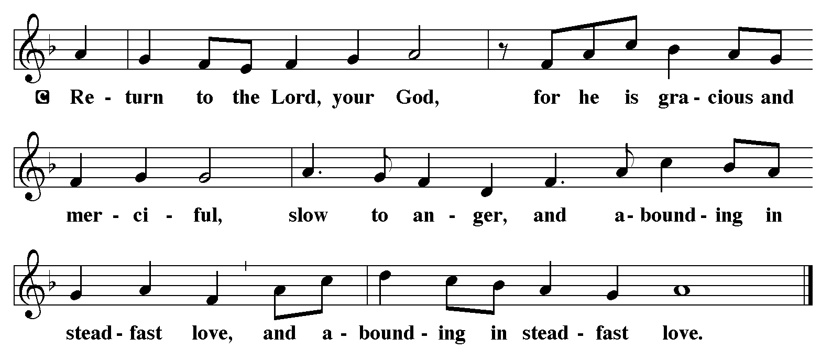
P - The Holy Gospel according to Luke, Chapter 13
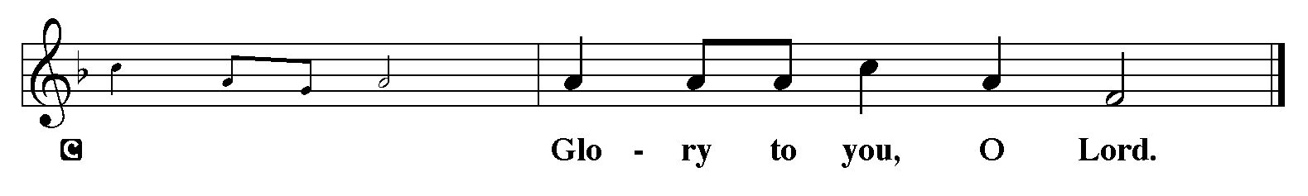

Gospel Reading: Luke 13:31-35
Neither Herod’s plotting nor Jerusalem’s resistance to maternal love will deter Jesus from his sacrificial mission.
³¹ At that very hour some Pharisees came and said to [Jesus,] “Get away from here, for Herod wants to kill you.” ³² He said to them, “Go and tell that fox for me, ‘Listen, I am casting out demons and performing cures today and tomorrow, and on the third day I finish my work. ³³ Yet today, tomorrow, and the next day I must be on my way, because it is impossible for a prophet to be killed outside of Jerusalem.’ ³⁴ Jerusalem, Jerusalem, the city that kills the prophets and stones those who are sent to it! How often have I desired to gather your children together as a hen gathers her brood under her wings, and you were not willing! ³⁵ See, your house is left to you. And I tell you, you will not see me until the time comes when you say, ‘Blessed is the one who comes in the name of the Lord.’ ”

P - The Gospel of the Lord.
C - Praise to you, O Christ. (Sit)

Message:

Hymn of the Day: God Loved the World ELW 323
1 God loved the world so that he gave
his only Son the lost to save,
that all who would in him believe
should everlasting life receive.

2 Christ Jesus is the ground of faith,
who was made flesh and suffered death;
all who confide in Christ alone
are built on this chief cornerstone.

3 If you are ill, if death draws near,
this truth your troubled heart can cheer:
Christ Jesus rescues us from death;
that is the firmest ground of faith.

4 Be of good cheer, for God's own Son
forgives all sins that you have done,
and justified by Jesus' blood,
your baptism grants the highest good.

5 All glory to the Father, Son,
and Holy Spirit, Three in One!
To you, O blessed Trinity,
be praise now and eternally!

Apostles’ Creed
I believe in One God, the Father almighty,
creator of heaven and earth.
I believe in Jesus Christ, God’s only Son, our Lord,
who was conceived by the Holy Spirit,
born of the virgin Mary,
suffered under Pontius Pilate,
was crucified, died, and was buried;
he descended to the dead.*
On the third day he rose again;
he ascended into heaven,
he is seated at the right hand of the Father,
and he will come to judge the living and the dead.
I believe in the Holy Spirit,

the holy catholic church,
the communion of saints,
the forgiveness of sins,
the resurrection of the body,
and the life everlasting. Amen.

Lord, listen to your children praying,
Lord, send your Spirit in this place;
Lord, listen to your children praying,
send us love, send us pow'r, send us grace.

Prayers of the People (Please stand, sit, or kneel, as you are able.)
Led by the Spirit, let us turn to God in prayer for the church, the world, and all those in need.
A brief silence.
Holy God, Gather St. Timothy under your wings. Bless us, O Lord, so that we may take heart and stand firm as we minister in your name. God, in your mercy, receive our prayer.
Holy God, Show the leaders of St. Timothy what it means to rely on your promises. Help them to lead St. Timothy so we can serve you more faithfully. Guide the current administration to work for justice and safeguard the world for future generations. God, in your mercy, receive our prayer.
Holy God, you are the stronghold of our life. Care tenderly for those who are ill in body or mind, and for people living in fear or need especially everyone on your prayer list and those we name out loud or silently in our hearts. May they know that they are not alone. God, in your mercy,
receive our prayer.
Holy God, you offer us citizenship in heaven. Unite communities of faith who are divided over earthly things, that following the way of your Son, they may set aside grudges and serve their neighbors with generosity and love. God, in your mercy, receive our prayer.
At this time anyone can lift up prayers…God in your mercy, receive our prayer.
Holy God, you are our light and our salvation. We give thanks for the saints who have gone before us especially our beloved Pastor Joanie. Help us to trust in you as she so faithfully did and to live according to her example. God, in your mercy, receive our prayer.
Receive the prayers of your people and draw all things together in your love, in the name of Jesus, who leads us from death to life. AMEN.

The Peace
P – The Peace of the Lord be with you always.
C – And also with you.
The Offering is Brought to the Altar
Offering Prayer

We lift our voices, we lift our hands, we lift our lives up to you; we are an Offering. Lord, use our voices, Lord, use our hands, Lord, use our lives, they are yours: we are an offering. All that we have, all that we are, all that we hope to be, we give to you, we give to you. We lift our voices, we lift our hands, we lift our lives up to you; we are an offering, we are an offering.

Jesus’ Words of Promise and Gift of Life
Dear Lord, Jesus Christ:
in the night in which you were betrayed,
You took bread, broke it and gave thanks,
then you gave it to your disciples saying:
take and eat, this is my body I am giving for you.
Do this in remembrance of me.
Again, after supper, Dear Lord Jesus,
You took the cup, gave thanks
and gave it for everyone to drink saying:
this cup is the new covenant in my blood,
I am shedding for you and for all people for the forgiveness of sin.
Do this for the remembrance of me. Amen.

Our Lord's Prayer
Our Father in heaven, hallowed be your name, your kingdom come, your will be done, on earth as in heaven. Give us today our daily bread. Forgive us our sins as we forgive those who sin against us. Save us from the time of trial and deliver us from evil. For the kingdom, the power, and the glory are yours, now and forever. Amen.
P – Come to this Table where God really does come to us!
C – Thank You Jesus.

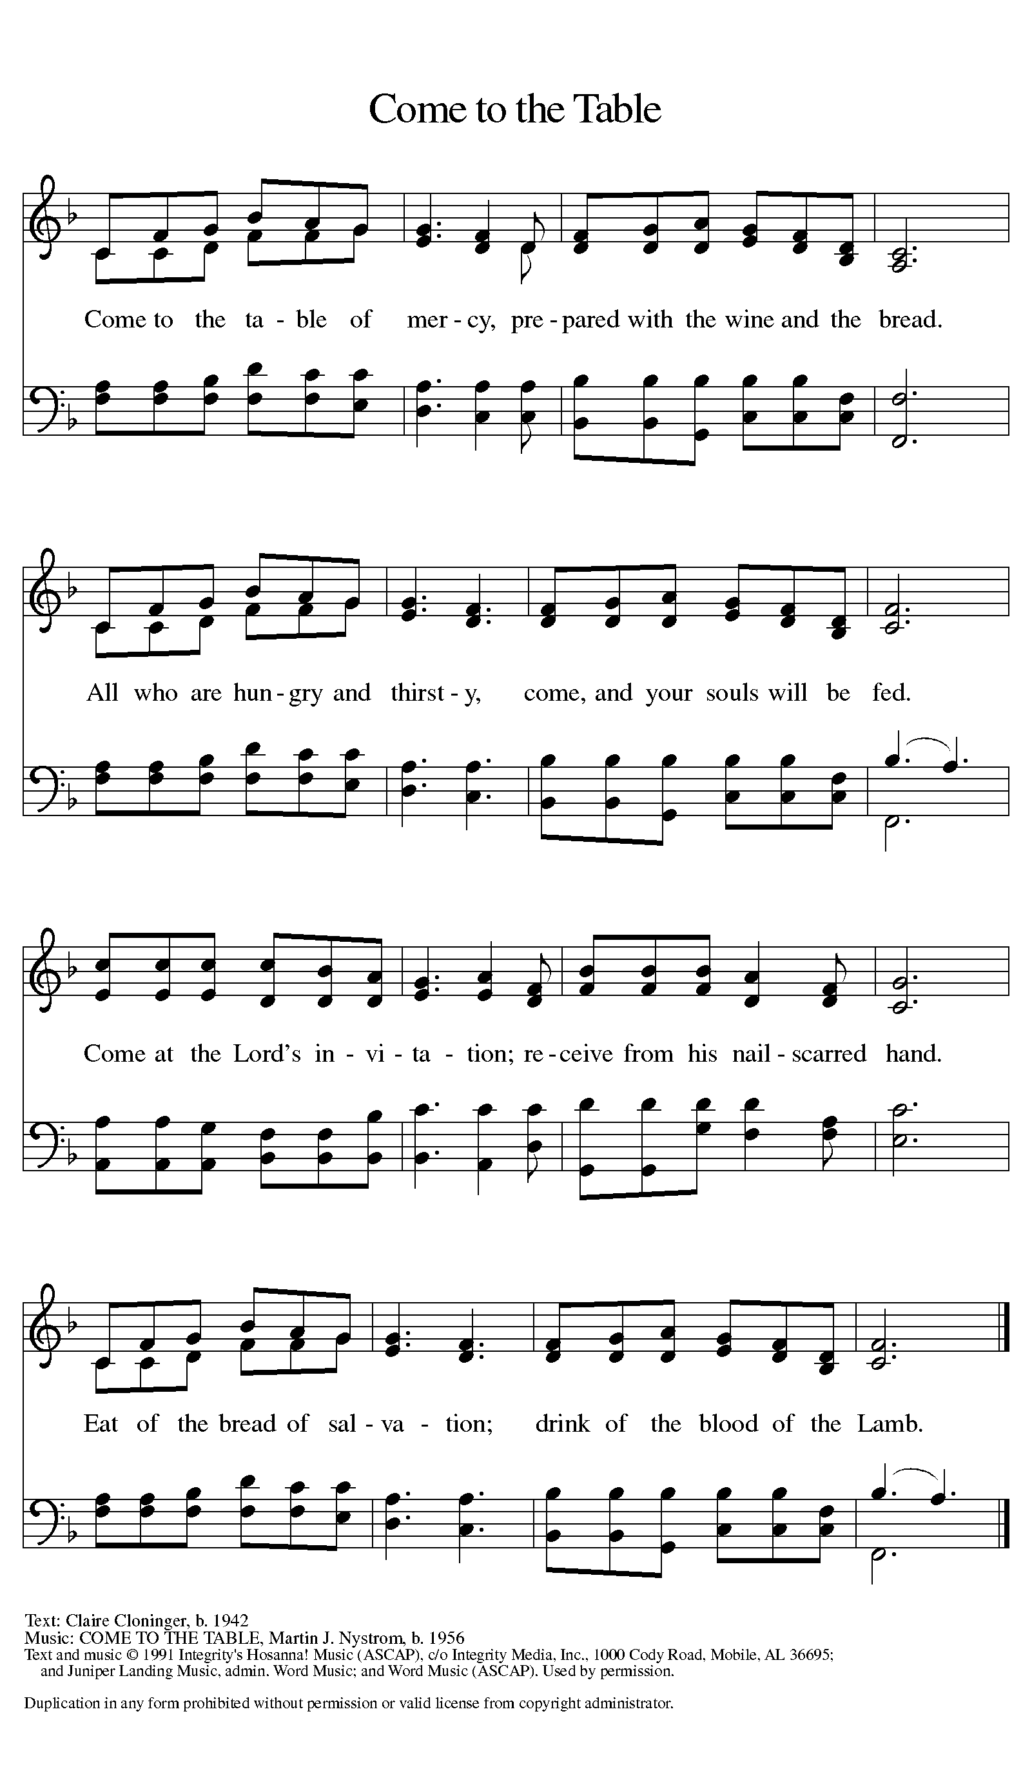

The Distribution of Communion – Come Forward to Receive
Communion Anthem: God Loved the World ELW 323
1 God loved the world so that he gave
his only Son the lost to save,
that all who would in him believe
should everlasting life receive.

2 Christ Jesus is the ground of faith,
who was made flesh and suffered death;
all who confide in Christ alone
are built on this chief cornerstone.

3 If you are ill, if death draws near,
this truth your troubled heart can cheer:
Christ Jesus rescues us from death;
that is the firmest ground of faith.

4 Be of good cheer, for God's own Son
forgives all sins that you have done,
and justified by Jesus' blood,
your baptism grants the highest good.

5 All glory to the Father, Son,
and Holy Spirit, Three in One!
To you, O blessed Trinity,
be praise now and eternally!
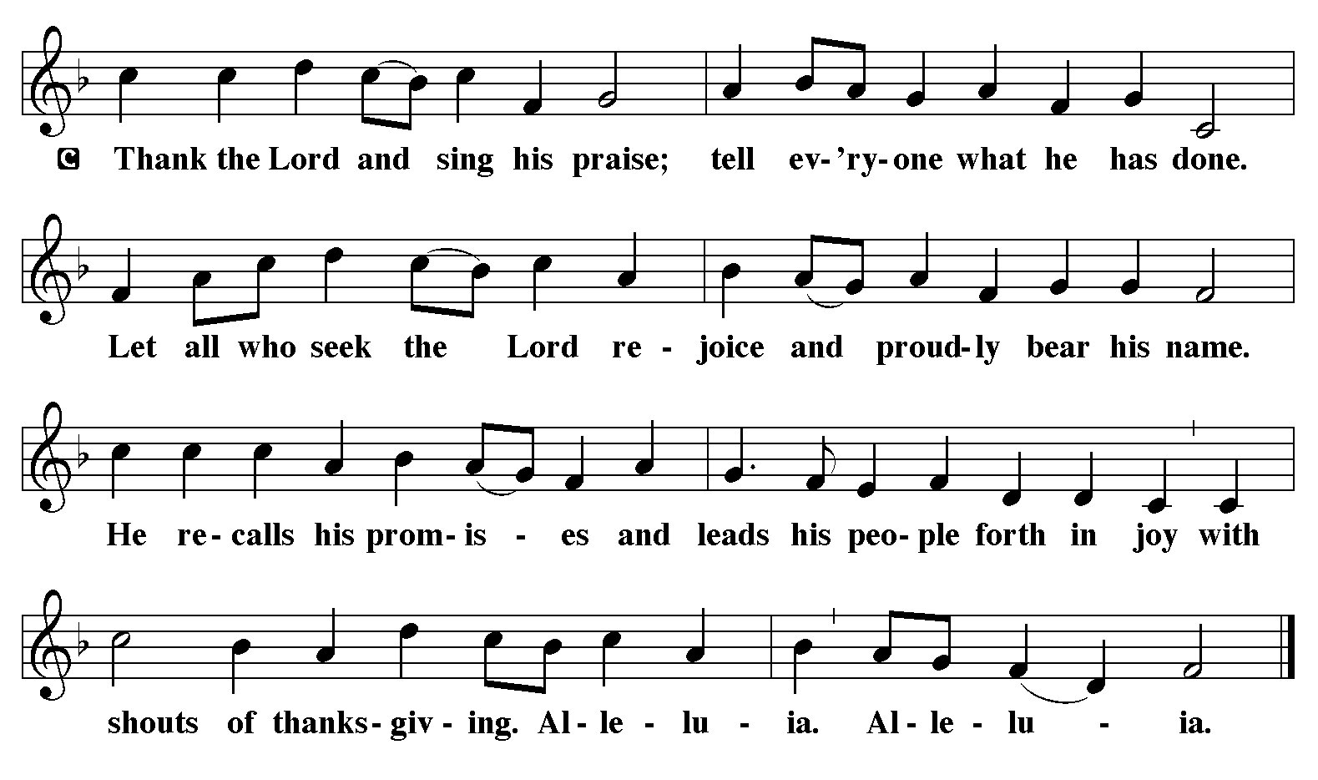
P - Now may the body and blood of our Lord and Savior Jesus Christ strengthen you and keep you in His grace…… Jesus Loves You!
C – Thank You Jesus!
Communion Prayer
Compassionate God, you have fed us with the bread of heaven. Sustain us in our Lenten pilgrimage: may our fasting be hunger for justice, our alms, a making of peace, and our prayer, the song of grateful hearts; through Christ our Lord. Amen.
Blessing
P - May God who has called us forth from the dust of the earth, and claimed us as children of the light, strengthen you on your journey into life renewed. The Lord bless you and keep you. The Lord’s face shine upon you with grace and mercy. The Lord look upon you with favor and give you ☩ peace. C - Amen.

Sending Hymn: Open Now Thy Gates of Beauty ELW 533
1 Open now thy gates of beauty,
Zion, let me enter there,
where my soul in joyful duty
waits for God who answers prayer.
Oh, how blessed is this place,
filled with solace, light, and grace!
2 Gracious God, I come before thee;
come thou also unto me;
where we find thee and adore thee,
there a heav'n on earth must be.
To my heart, oh, enter thou,
let it be thy temple now!
3 Here thy praise is gladly chanted,
here thy seed is duly sown;
let my soul, where it is planted,
bring forth precious sheaves alone,
so that all I hear may be
fruitful unto life in me.
4 Thou my faith increase and quicken,
let me keep thy gift divine;
howsoe'er temptations thicken,
may thy word still o'er me shine
as my guiding star through life,
as my comfort in all strife.
5 Speak, O God, and I will hear thee,
let thy will be done indeed;
may I undisturbed draw near thee
while thou dost thy people feed.
Here of life the fountain flows;
here is balm for all our woes.

A - Marked with the cross of Christ, go forth to love and serve the Lord.
C - By the Light of the Cross, We Will! Hallelujah!
Postlude: Go Make Disciples W&P 47
Unless otherwise noted, materials used in this bulletin are:
From Sundays and Seasons.com. Copyright 2015 Augsburg Fortress. All rights reserved. Reprinted by permission under Augsburg Fortress Liturgies Annual License #SAS028635. Music is reprinted under OneLicense.Net #A712074 and/or Augsburg Fortress #SBL12176H. Scripture, unless otherwise noted, is from the New Revised Standard Version Bible, Copyright © 1989, Division of Christian Education of the National Council of the Churches of Christ in the United States of America. Used by permission. All rights reserved.

REMEMBRANCE:
Patrick, bishop, missionary to Ireland, died 461
A native of Britain, Patrick was kidnapped by pirates at age sixteen and sold into slavery in Ireland. After a few years, he escaped, returned home, and entered the ministry. Returning to Ireland, he successfully served as a bishop and missionary there.

ATTENDANCE
Ash Wednesday, March 5th, 4pm 35
Saturday, March 8th, 4pm 35
Sunday, March 9th , 9am 48
Drive-Up Communion 2
120
We are attempting to keep this prayer list as up to date as possible. Normally, we keep names on this prayer list for three weeks unless requested otherwise. If you are aware of names that can be removed, please let Regina know. Also, where there is a first name only, if you are aware of the last/full name please help us update our list. Thank you.

