***A Service of Worship, Praise and Hope***

***Welcome to St. Timothy Saturday Evening Worship!***

***September 21st,  Pentecost Season***

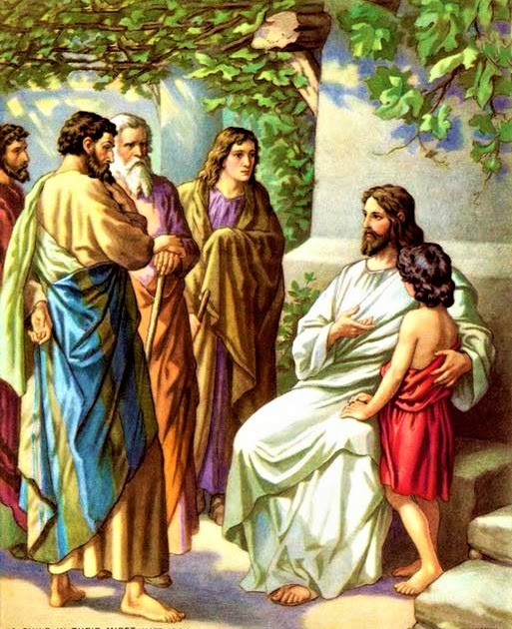

**"Equip people to grow as Disciples faithfully serving our community"**

**We are glad to have you worship with us. All are welcome at communion. If you need gluten-free – please tell Pastor Joanie when you go up for communion. If you have any questions – just ask the Welcomer at the back of the sanctuary.**

***Please note** if you use a pew envelope for your offering – please write your name on the envelope so that the financial secretaries can post it as a gift from you. Thank You!***

**St Timothy Worship Planning Team**

**The Reverend Joan E. Holden 352-423-2554**

**Eric Mortensen, Director of Music**

**Parish Deacon, Frank Hofstetter**

**The Altar Flowers are given by Sue Gable, in memory of her parents**

**This Week at St. Timothy's**

**Monday, September 23rd PJ Off**

**Tuesday, September 24th 9-12 Food Pantry**

**Wednesday, September 25th 10am – OT BS**

**Thursday, September 26th 9:30am – Prayer Group, 11:00am – Miniatures, 1:30pm – Royal Dalton, 4:30pm – Choir, 5:15 pm – Chimes**

**Friday, September 27th 10am – NT BS, 11am – PJ Continuing Ed**

**Saturday, September 28th 4pm – Worship**

**Sunday, September 29th 9am – Worship, Children’s SS, 10:30am – Adult SS, 11-11:30am – Drive-Up Communion**

***Rooted in the past and growing into the future, the church must always be reformed in order to live out the love of Christ in an ever-changing world. We celebrate the good news of God’s grace, that Jesus Christ sets us free every day to do this life-transforming work. Trusting in the freedom given to us in baptism, we pray for the church, that Christians will unite more fully in worship and mission.***

***(from Sundays and Seasons for Reformation Weekend)***

***“Shout to the Lord” is the last pre-service hymn the choir sings, it is Hymn #821 and everyone is welcome to sing with the choir.***

**Welcome and Sharing of Congregational News**

***Preparation Hymn: Bring Forth the Kingdom W&P 22***

### *Gathering Hymn: God Is Here! ELW 526*

1 God is here! As we your people meet to offer

praise and prayer, may we find in fuller measure

what it is in Christ we share. Here, as in the

world around us, all our varied skills and arts

wait the coming of the Spirit into open minds and hearts.

2 Here are symbols to remind us of our lifelong

need of grace; here are table, font, and pulpit;

here the cross has central place. Here in honesty

of preaching, here in silence, as in speech,

here, in newness and renewal, God the Spirit comes to each.

3 Here our children find a welcome in the Shepherd's

flock and fold; here as bread and wine are taken,

Christ sustains us as of old. Here the servants

of the Servant seek in worship to explore

what it means in daily living to believe and to adore.

4 Lord of all, of church and kingdom, in an age of

change and doubt, keep us faithful to the gospel;

help us work your purpose out. Here, in this day's

dedication, all we have to give, receive;

we, who cannot live without you, we adore you! We believe!

**Confession and Forgiveness**

P: Blessed be the Holy Trinity, + one God, whose name is majestic in all the earth, who rescues and heals in every time of trouble, who does all things well.

**C: Amen**

P: Let us come before God, seeking forgiveness and life.

*(Silence is kept for reflection and self-examination)*

P: Steadfast and saving God,

**C: Have mercy on us. We confess to you all our sins and that in these continuing times of uncertainty and fear, we have trouble trusting you and feeling your presence. Forgive us our sins, our doubts, our fears and lack of patience with others. Strengthen our faith and help us to let your hope and light shine through us in these troubling times. We ask for mercy, wisdom and guidance, through Jesus Christ, our Savior and Lord. Amen.**

P: In the name of + Jesus, the Son of God, receive mercy and find grace in your time of need. Your sins are forgiven; God's love is healing balm for your wounds and fears. Rejoice, for God raises you up to new life in Christ.

**C: Amen**

**Greeting**

P: The joy of our Lord Jesus Christ, the compassion of God, and the creative power of the Holy Spirit be with you all.

**C: And also with you.**

### Prayer of the Day

**O God, our teacher and guide, you draw us to yourself and welcome us as beloved children. Help us to lay aside all envy and selfish ambition, so that we can walk in your ways of wisdom and understanding as servants of your Son, Jesus Christ, our Savior and Lord. Amen.**

**Word**

### Lesson: James 3:13—4:3, 7-8a

The wisdom God gives unites our hearts and minds. Instead of living to satisfy our own wants and desires, we manifest this wisdom in peace, gentleness, mercy, and impartiality toward others.

13Who is wise and understanding among you? Show by your good life that your works are done with gentleness born of wisdom. 14But if you have bitter envy and selfish ambition in your hearts, do not be boastful and false to the truth. 15Such wisdom does not come down from above, but is earthly, unspiritual, devilish. 16For where there is envy and selfish ambition, there will also be disorder and wickedness of every kind. 17But the wisdom from above is first pure, then peaceable, gentle, willing to yield, full of mercy and good fruits, without a trace of partiality or hypocrisy. 18And a harvest of righteousness is sown in peace for those who make peace.4:  
  
 1Those conflicts and disputes among you, where do they come from? Do they not come from your cravings that are at war within you? 2You want something and do not have it; so you commit murder. And you covet something and cannot obtain it; so you engage in disputes and conflicts. You do not have, because you do not ask. 3You ask and do not receive, because you ask wrongly, in order to spend what you get on your pleasures. 7Submit yourselves therefore to God. Resist the devil, and he will flee from you. 8aDraw near to God, and he will draw near to you.

### A: Word of God!

**C: Words of Life!**

P: The Holy Gospel according to **Mark, Chapter 9**

**C: Glory to you O Lord.**

### Gospel: Mark 9:30-37

Jesus’ teaching and action in this text are directed to the church whenever it is seduced by the world’s definition of greatness: prestige, power, influence, and money. The antidote to such a concern for greatness is servanthood.

30[Jesus and the disciples went on] and passed through Galilee. He did not want anyone to know it;31for he was teaching his disciples, saying to them, “The Son of Man is to be betrayed into human hands, and they will kill him, and three days after being killed, he will rise again.” 32But they did not understand what he was saying and were afraid to ask him.  
 33Then they came to Capernaum; and when he was in the house he asked them, “What were you arguing about on the way?” 34But they were silent, for on the way they had argued with one another who was the greatest. 35He sat down, called the twelve, and said to them, “Whoever wants to be first must be last of all and servant of all.” 36Then he took a little child and put it among them; and taking it in his arms, he said to them, 37“Whoever welcomes one such child in my name welcomes me, and whoever welcomes me welcomes not me but the one who sent me.”

P: The Gospel of Our Lord!

**C: Praise to You O Christ!**

***Message***

***Hymn of the Day: All Are Welcome (Let Us Build a House Where Love Can Dwell) ELW 641***

1. Let us build a house where love can dwell and all can safely

live, a place where saints and children tell how

hearts learn to forgive. Built of hopes and dreams and

visions, rock of faith and vault of grace; here the love of

Christ shall end divisions:

#### **Refrain**

**All are welcome, all are welcome,**

**all are welcome in this place.**

1. Let us build a house where prophets speak, and words are strong and true, where all God's children dare to seek to

dream God's reign anew. Here the cross shall stand as

witness and as symbol of God's grace; here as one we

claim the faith of Jesus:***Refrain***

1. Let us build a house where love is found in water, wine and

wheat: a banquet hall on holy ground where

peace and justice meet. Here the love of God, through

Jesus, is revealed in time and space; as we share in

Christ the feast that frees us:***Refrain***

1. Let us build a house where hands will reach beyond the wood and

stone to heal and strengthen, serve and teach, and

live the Word they've known. Here the outcast and the

stranger bear the image of God's face; let us bring an

end to fear and danger:***Refrain***

1. Let us build a house where all are named, their songs and visions

heard and loved and treasured, taught and claimed as

words within the Word. Built of tears and cries and

laughter, prayers of faith and songs of grace, let this house proclaim from floor to rafter:***Refrain***

**Apostles’ Creed**

**I believe in God, the Father almighty,**

**creator of heaven and earth.**

**I believe in Jesus Christ, God’s only Son, our Lord,**

**who was conceived by the Holy Spirit,**

**born of the virgin Mary,**

**suffered under Pontius Pilate,**

**was crucified, died, and was buried;**

**he descended to the dead.**

**On the third day he rose again;**

**he ascended into heaven,**

**he is seated at the right hand of the Father,**

**and he will come to judge the living and the dead.**

**I believe in the Holy Spirit,**

**the holy catholic church,**

**the communion of saints,**

**the forgiveness of sins,**

**the resurrection of the body,**

**and the life everlasting. Amen.**

**Lord, listen to your children praying,**

**Lord, send your Spirit in this place;**

**Lord, listen to your children praying,**

**send us love, send us pow'r, send us grace.**

**Prayers of the People** *(please stand, sit or kneel as you are able )*

Drawn together in the power of the Holy Spirit, we pray with confidence for the church, God’s good creation, and everyone in need.

*A brief silence.*

Loving God, you welcome everyone at your table of grace. Instill in your church a spirit of humility and curiosity, so that we embrace everyone who seeks you. We pray especially for ministries of hospitality and faith formation. Hear us, O God. **Your mercy is great.**

Creating God, you shape the world so there is more than enough for all. Curb our habits of overuse, and guide us toward more sustainable sources of energy, food, and water. Hear us, O God. **Your mercy is great.**

Gracious God, your peace brings justice and solidarity. Encourage peace among peoples, tribes, and nations; heal divisions in our country and local communities, that together we might cooperate for the good of all. Hear us, O God. **Your mercy is great.**

Faithful God, you draw near to you everyone who is in need. Bring healing and wholeness to everyone who suffers, especially everyone on our prayer list and everyone we name out loud or silently in our hearts….. Transform economic, political, and social systems that oppress vulnerable people, especially systems of structural racism and generational poverty. Hear us, O God. **Your mercy is great.**

Transforming God, you accompany everyone through changes and transitions. Help us to see where you are calling this community to new ways of living the gospel promise; assure us that even as change brings loss, it also brings hope and life. Hear us, O God. **Your mercy is great.**

Everyone is welcome to offer prayers at this time…..Hear us, O God. **Your mercy is great.**

Merciful God, you embrace us on our final pilgrimage from this life. Accompany everyone who has died, console those who mourn, and at the last, show us the way to eternal life in you. Hear us, O God. **Your mercy is great.**

We entrust these and all our prayers to you, holy God, in the name of your beloved child, Jesus Christ, our Savior.

**Amen.**

**Peace**

**Offering is Brought to the Altar**

**Offering Prayer**

**We lift our voices, we lift our hands, we lift our lives up to you; we are an Offering. Lord, use our voices, Lord, use our hands, Lord, use our lives, they are yours: we are an offering. All that we have, all that we are, all that we hope to be, we give to you, we give to you. We lift our voices, we lift our hands, we lift our lives up to you; we are an offering, we are an offering.**

**Jesus’ Words of Promise and Gift of Life**

**P:** Dear Lord, Jesus Christ:

in the night in which you were betrayed,

You took bread, broke it and gave thanks,

then you gave it to your disciples saying:

take and eat, this is my body I am giving for you.

Do this in remembrance of me.

Again, after supper, Dear Lord Jesus,

You took the cup, gave thanks

and gave it for everyone to drink saying:

this cup is the new covenant in my blood,

I am shedding for you and for all people for the forgiveness of sin.

Do this for the remembrance of me. **Amen.**

**Our Lord's Prayer**

**Our Father in heaven, hallowed be your name, your kingdom come, your will be done, on earth as in heaven. Give us today our daily bread. Forgive us our sins as we forgive those who sin against us. Save us from the time of trial and deliver us from evil. For the kingdom, the power, and the glory are yours, now and forever. Amen.**

**Invitation to Communion**

P: Come to this Table where God really does come to us!

**C: Thank You Jesus!**

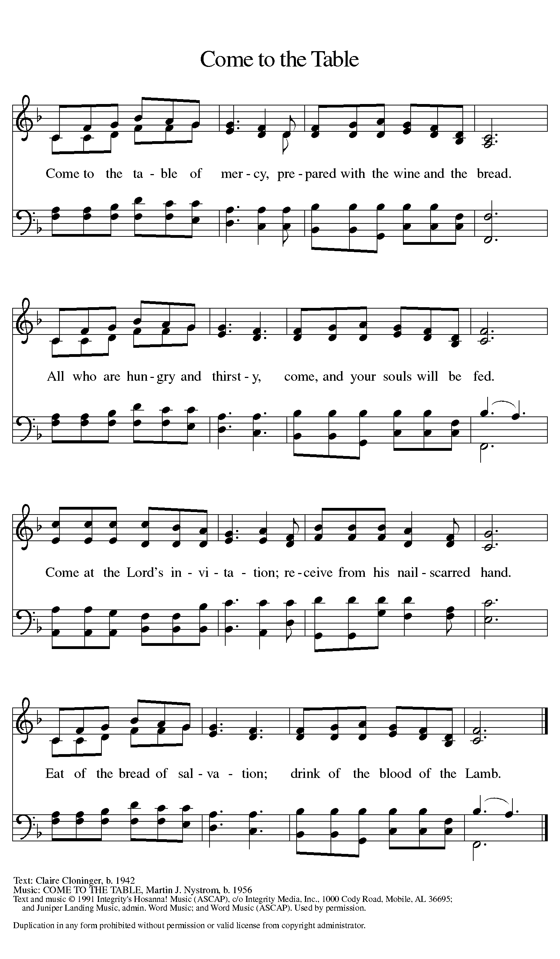

**Distribution - Please come forward to receive**

***Communion Anthems: By Grace, We Have Been Saved W&P 25***

***I Received the Living God ELW 477***

P: Now may the body and blood of our Lord Jesus Christ strengthen you and keep you in his grace.

**C: Amen**

### Prayer after Communion

**Holy God, you welcome us to this meal and feed us with dignity at your table. Send us now to welcome others and to be at peace with one another, through Jesus Christ our Lord.** **Amen.**

**Sending**

**Blessing**

### P: God all mighty, God most merciful ☩ bless you, keep you, and give you peace.

**C: Amen**

***Sending Hymn: Praise the One Who Breaks the Darkness ELW 843***

1 Praise the One who breaks the darkness with a liberating light;

praise the One who frees the pris'ners, turning blindness into sight.

Praise the One who preached the gospel, healing ev'ry dread disease,

calming storms and feeding thousands with the very bread of peace.

2 Praise the One who blessed the children with a strong yet gentle word;

praise the One who drove out demons with a piercing, two-edged sword. Praise the One who brings cool water to the desert's burning sand; from this well comes living water quenching thirst in ev'ry land.

3 Praise the one true love incarnate: Christ, who suffered in our place;

Jesus died and rose for many that we may know God by grace.

Let us sing for joy and gladness, seeing what our God has done.

Praise the one redeeming glory; praise the One who makes us one.

**Dismissal**

P: Go in peace. Proclaim the Good News!

**C: By the Grace of God we will – Alleluia!**

***Postlude:******Emmanuel W&P 36***

Unless otherwise noted, materials used in this bulletin are:

From Sundays and Seasons.com. Copyright 2015 Augsburg Fortress. All rights reserved. Reprinted by permission under Augsburg Fortress Liturgies Annual License #SAS028635. Music is reprinted under OneLicense.Net #A712074 and/or Augsburg Fortress #SBL12176H. Scripture, unless otherwise noted, is from the New Revised Standard Version Bible, Copyright © 1989, Division of Christian Education of the National Council of the Churches of Christ in the United States of America. Used by permission. All rights reserved.

REMEMBRANCE

**Jerome, translator, teacher, died 420**

Jerome was a biblical scholar and translator, but rather than translating the original Hebrew and Greek scriptures into classical Latin, he worked in the commonly-spoken Latin of the day, creating a version called the Vulgate.

From sundaysandseasons.com.

**Announcements for September 21st and 22nd**

**ATTENDANCE**

**Saturday, September 14th, 4pm 24**

**Sunday, September 15th, 9am 24**

**Drive-Up Communion 3**

**51**

