Saturday Evening Service of Worship, Praise and Hope Welcome!
March 22, 2025
Third Weekend in Lent
"Equipping people to grow as Disciples faithfully serving our community"



Rooted in the past and growing into the future, the church must always be reformed in order to live out the love of Christ in an ever-changing world. We celebrate the good news of God’s grace, that Jesus Christ sets us free every day to do this life-transforming work. Trusting in the freedom given to us in baptism, we pray for the church, that Christians will unite more fully in worship and mission.
(from Sundays and Seasons for Reformation Weekend)
We are glad to have you worship with us. All are welcome at communion. If you need gluten-free – please let us know when you go up for communion. If you have any questions – just ask the Welcomer at the back of the sanctuary.
Please note** if you use a pew envelope for your offering – please write your name on the envelope so that the financial secretaries can post it as a gift from you. Thank You!
St Timothy Worship Planning Team
Pastor Lynn Bechdolt
Deacon Frank Hofstetter
Eric Mortensen, Director of Music

The Altar flowers are given by Debbie Lawrence – “Remembering my special angels in heaven.”

This Week at St. Timothy's
Monday, March 24th
Tuesday, March 25th 9-12 – Food Pantry, Vineyard Views Deadline
Wednesday, March 26th 4pm – Lent Service, 5pm – Soup Supper
Thursday, March 27th 9:30am – Prayer Group, 11am – Miniatures, 4:30pm – Choir, 5:15pm – Chimes
Friday, March 28th 1pm – Celebration of Life for Pastor Joanie
Saturday, March 29th 4pm – Worship
Sunday, March 30th 9am – Worship, Children’s SS, 10:15- 10:45am – Drive-Up Communion, 10:30am – Adult SS, Coffee Fellowship

Welcome and Sharing of Congregational News
“On Eagles’ Wings”, ELW 787 is the last music before worship – all are welcome to join in
Preparation Anthem: All That We Have W&P 5
Gathering Hymn: Jesus Shall Reign ELW 434
1 Jesus shall reign where'er the sun
does its successive journeys run;
his kingdom stretch from shore to shore,
till moons shall wax and wane no more.

2 To him shall endless prayer be made,
and praises throng to crown his head;
his name like sweet perfume shall rise
with ev'ry morning sacrifice.

3 People and realms of ev'ry tongue
dwell on his love with sweetest song;
and infant voices shall proclaim
their early blessings on his name.

4 Blessings abound where'er he reigns:
the pris'ners leap to lose their chains,
the weary find eternal rest,
and all who suffer want are blest.

5 Let ev'ry creature rise and bring
peculiar honors to our king;
angels descend with songs again,
and earth repeat the loud amen.

Confession and Forgiveness
P: Blessed be the Holy Trinity, + one God, whose name is majestic in all the earth, who rescues and heals in every time of trouble, who does all things well.
C: Amen
P: Let us come before God, seeking forgiveness and life.
P: Steadfast and saving God,
C: Have mercy on us. We confess to you all our sins and that in these continuing times of uncertainty and fear, we have trouble trusting you and feeling your presence. Forgive us our sins, our doubts, our fears and lack of patience with others. Strengthen our faith and help us to let your hope and light shine through us in these challenging times. We ask for mercy, wisdom and guidance, through Jesus Christ, our Savior and Lord.
P: In the name of + Jesus, the Son of God, receive mercy and find grace in your time of need. Your sins are forgiven; God's love is healing balm for your wounds and fears. Rejoice, for God raises you up to new life in Christ.
C: Amen
Greeting
P: The joy of our Lord Jesus Christ, the compassion of God, and the creative power of the Holy Spirit be with you all.
C: And also with you.

Prayer of the Day
Eternal God, your kingdom has broken into our troubled world through the life, death, and resurrection of your Son. Help us to hear your word and obey it, and bring your saving love to fruition in our lives, through Jesus Christ, our Savior and Lord, who lives and reigns with you and the Holy Spirit, one God, now and forever. Amen.

Word

Lesson: 1 Corinthians 10:1-13
Paul uses images from Hebrew Scriptures and prophecy to speak the truth of Jesus Christ: He is our rock, our water, our food, and our drink. Christ is the living sign of God’s faithfulness.
¹ I do not want you to be unaware, brothers and sisters, that our ancestors were all under the cloud, and all passed through the sea, ² and all were baptized into Moses in the cloud and in the sea, ³ and all ate the same spiritual food, ⁴ and all drank the same spiritual drink. For they drank from the spiritual rock that followed them, and the rock was Christ. ⁵ Nevertheless, God was not pleased with most of them, and they were struck down in the wilderness.
⁶ Now these things occurred as examples for us, so that we might not desire evil as they did. ⁷ Do not become idolaters as some of them did; as it is written, “The people sat down to eat and drink, and they rose up to play.” ⁸ We must not indulge in sexual immorality as some of them did, and twenty-three thousand fell in a single day. ⁹ We must not put Christ to the test, as some of them did, and were destroyed by serpents. ¹⁰ And do not complain as some of them did, and were destroyed by the destroyer. ¹¹ These things happened to them to serve as an example, and they were written down to instruct us, on whom the ends of the ages have come. ¹² So if you think you are standing, watch out that you do not fall. ¹³ No testing has overtaken you that is not common to everyone. God is faithful, and he will not let you be tested beyond your strength, but with the testing he will also provide the way out so that you may be able to endure it.

A: Words of God!
C: Words of Life!

P: The Holy Gospel according to Luke, Chapter 13

C: Glory to you O Lord.

Gospel: Luke 13:1-9
Asked about current tragic events, Jesus turns a lesson about whether suffering is deserved into a hard call to obedience. He then tells a parable that holds out hope that the timeline for ultimate judgment will be tempered by patience.
¹ At that very time there were some present who told him about the Galileans whose blood Pilate had mingled with their sacrifices.² [Jesus] asked them, “Do you think that because these Galileans suffered in this way they were worse sinners than all other Galileans?³ No, I tell you; but unless you repent, you will all perish as they did. ⁴ Or those eighteen who were killed when the tower of Siloam fell on them—do you think that they were worse offenders than all the others living in Jerusalem? ⁵ No, I tell you; but unless you repent, you will all perish just as they did.”
⁶ Then he told this parable: “A man had a fig tree planted in his vineyard; and he came looking for fruit on it and found none. ⁷ So he said to the gardener, ‘See here! For three years I have come looking for fruit on this fig tree, and still I find none. Cut it down! Why should it be wasting the soil?’ ⁸ He replied, ‘Sir, let it alone for one more year, until I dig around it and put manure on it. ⁹ If it bears fruit next year, well and good; but if not, you can cut it down.’ ”

P: The Gospel of Our Lord!
C: Praise to You O Christ!

Message:

Hymn of the Day: Jesus, Keep Me Near the Cross ELW 335
1 Jesus, keep me near the cross,
there's a precious fountain;
free to all, a healing stream
flows from Calv'ry's mountain.

Refrain
In the cross, in the cross
be my glory ever;
till my ransomed soul shall find
rest beyond the river.

2 Near the cross, a trembling soul,
love and mercy found me;
there the bright and morning star
sheds its beams around me. Refrain

3 Near the cross! O Lamb of God,
bring its scenes before me;
help me walk from day to day
with its shadow o'er me. Refrain

4 Near the cross I'll watch and wait,
hoping, trusting ever,
till I reach the golden strand
just beyond the river. Refrain

Apostles’ Creed
I believe in One God, the Father almighty,
creator of heaven and earth.
I believe in Jesus Christ, God’s only Son, our Lord,
who was conceived by the Holy Spirit,
born of the virgin Mary,
suffered under Pontius Pilate,
was crucified, died, and was buried;
he descended to the dead.*
On the third day he rose again;
he ascended into heaven,
he is seated at the right hand of the Father,
and he will come to judge the living and the dead.
I believe in the Holy Spirit,

the holy catholic church,
the communion of saints,
the forgiveness of sins,
the resurrection of the body,
and the life everlasting. Amen.

Lord, listen to your children praying,
Lord, send your Spirit in this place;
Lord, listen to your children praying,
send us love, send us pow'r, send us grace.

Prayers of the People (please stand, sit, or kneel as you are able)
Led by the Spirit, let us turn to God in prayer for the church, the world, and all those in need.
A brief silence.
We pray for St. Timothy, who are called to be a witness to all peoples. Grant humility and wisdom to our bishop, Pedro Suarez, the Synod, Pastor Lynn, Parish Deacon Frank, the council, and its leaders and this congregation, that they may call upon you in making decisions. God, in your mercy, receive our prayer.

We pray for the earth, called to provide abundantly. Teach your people the goodness of your generosity, that in sharing what we have been given, all life may flourish on this planet that is our shared home. God, in your mercy, receive our prayer.

We pray for the nations, called to protect their people in the work towards justice and peace. Forge bonds of compassion and mutual care across human borders and boundaries, that all the world may have enough space to live. God, in your mercy, receive our prayer.

We pray for those in need, called to receive your compassion, especially everyone on our prayer list and those we name silently in our hearts. Comfort those whose lives have been disrupted through natural disasters and human conflict. Aid communities in coming together to mourn, heal, and rebuild. God, in your mercy, receive our prayer.

We pray for this congregation which is called to welcome its neighbors to the table of your grace. Bless food pantries, the food boxes, Citrus Blessings and all ministries that address human hunger and thirst. God, in your mercy, receive our prayer.

At this time anyone can lift up prayers…God in your mercy, receive our prayer.

We give thanks for the faithful lives of those who proclaimed your gospel in times of challenge and strife, and for all those whose lives of love and service have ended, especially our beloved Pastor Joanie. May her witness inspire our own. God, in your mercy, receive our prayer.

Receive the prayers of your people and draw all things together in your love, in the name of Jesus, who leads us from death to life. Amen.
Peace
Offering is Brought to Altar
Offering Prayer

We lift our voices, we lift our hands, we lift our lives up to you; we are an Offering. Lord, use our voices, Lord, use our hands, Lord, use our lives, they are yours: we are an offering. All that we have, all that we are, all that we hope to be, we give to you, we give to you. We lift our voices, we lift our hands, we lift our lives up to you; we are an offering, we are an offering.
The Meal
Jesus’ Words of Promise and Gift of Life
Dear Lord, Jesus Christ:
in the night in which you were betrayed,
You took bread, broke it and gave thanks,
then you gave it to your disciples saying:
take and eat, this is my body I am giving for you.
Do this in remembrance of me.
Again, after supper, Dear Lord Jesus Christ,
You took the cup, gave thanks
and gave it for everyone to drink saying:
this cup is the new covenant in my blood,
I am shedding for you and for all people for the forgiveness of sin.
Do this for the remembrance of me.
Amen.
Our Lord’s Prayer
Our Father in heaven, hallowed be your name, your kingdom come, your will be done, on earth as in heaven. Give us today our daily bread. Forgive us our sins as we forgive those who sin against us. Save us from the time of trial and deliver us from evil. For the kingdom, the power, and the glory are yours, now and forever. Amen.

Invitation to Communion
P: Come to this table where God really does come to us!
C: Thank You Jesus!
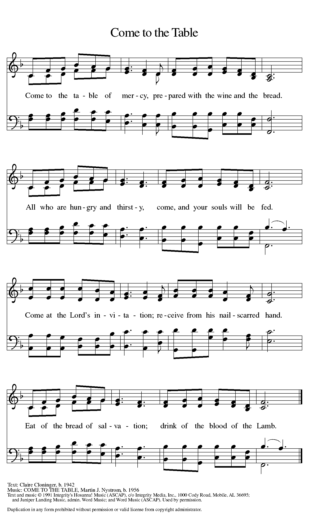

Distribution - Please Come Forward to Receive
Communion Anthem: You Are Mine W&P 158
P: Now may the body and blood of our Lord and Savior, Jesus Christ, strengthen you and keep you in His grace … Jesus Loves You.
C: Thank You Jesus!
Prayer After Communion
Compassionate God, you have fed us with the bread of heaven. Sustain us in our Lenten pilgrimage: may our fasting be hunger for justice, our alms, a making of peace, and our prayer, the song of grateful hearts; through Christ our Lord. Amen.
The Blessing
P: May God who has called us forth from the dust of the earth, and claimed us as children of the light, strengthen you on your journey into life renewed. The Lord bless you and keep you. The Lord’s face shine upon you with grace and mercy. The Lord look upon you with favor and give you ☩ peace.
C: Amen.

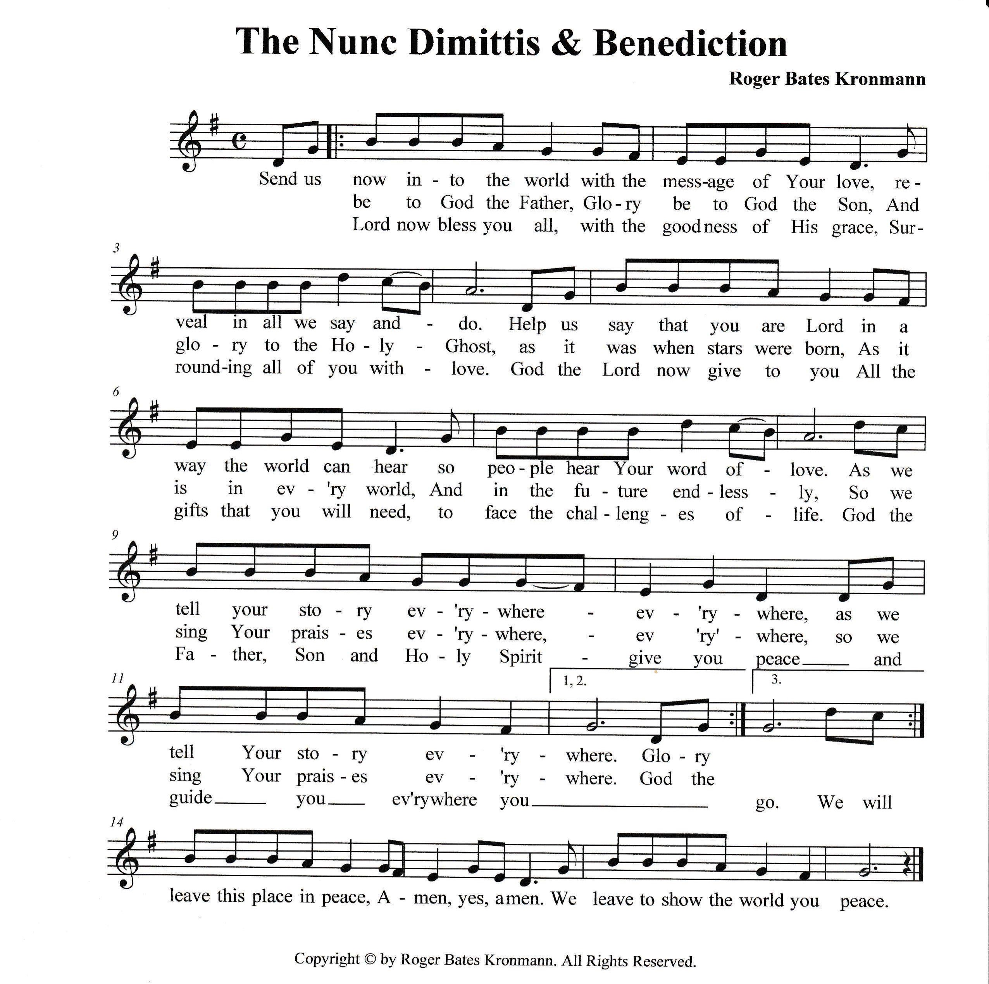

Sending Hymn: Blessing, Honor, and Glory ELW 433
Blessing, honor, glory to the Lamb
Holy, righteous, worthy is the Lamb
Blessing, honor, glory to the Lamb
Holy, righteous, worthy is the Lamb
Death could not hold Him down, for He is risen!
Seated upon the throne He is the Lamb of God!
Death could not hold Him down, for He is risen!
Seated upon the throne, he is the Lamb of God!
Death could not hold Him down, for He is risen!
Seated upon the throne, he is the Lamb of God

Dismissal
P: Marked with the cross of Christ, go forth to love and serve the Lord.
C: By the Light of the Cross, We Will! Hallelujah!
Postlude: Father We Adore You W&P 37
Unless otherwise noted, materials used in this bulletin are:
From Sundays and Seasons.com. Copyright 2015 Augsburg Fortress. All rights reserved. Reprinted by permission under Augsburg Fortress Liturgies Annual License #SAS028635. Music is reprinted under OneLicense.Net #A712074 and/or Augsburg Fortress #SBL12176H. Scripture, unless otherwise noted, is from the New Revised Standard Version Bible, Copyright © 1989, Division of Christian Education of the National Council of the Churches of Christ in the United States of America. Used by permission. All rights reserved.

REMEMBRANCE
Oscar Arnulfo Romero, Bishop of El Salvador, martyr, died 1980
Romero was deeply concerned with injustices evident toward the poor and powerless in El Salvador, and worked forthrightly against political repression. He was assassinated while presiding at the eucharist in a chapel near the cathedral in San Salvador.

ATTENDANCE
Mid-week Lent Svc Wednesday, March 12th, 4pm 18
Saturday, March 15th, 4pm 27
Sunday, March 16th , 9am 40
Drive-Up Communion 4
89

We are attempting to keep this prayer list as up to date as possible. Normally, we keep names on this prayer list for three weeks unless requested otherwise. If you are aware of names that can be removed, please let Regina know. Also, where there is a first name only, if you are aware of the last/full name please help us update our list. Thank you.

Prayer List

Barbara Carson
JoAnn Ollenborger
Randy Holden
Mary Fraley & Family
Kennedy Family
Brooklyn
Mike Perate
Keith Johns
Annie Cook
Nick Nichols
Joe Moore
Mark Owen
Dawn
Melvin VanHorn
Sallie Peña
Dawn Pitkins
Jean Fowler’s family
Pringle Family
Stephanie
Louise
Ashlee
Debra Owen
Bill & Evette Dexter
Hannah
Tim
Ben
Rosalie Jacobs
Rhonda Sheldon
Heather
Brian M.
Bill Brooks
Mary
Leonese Smith
John M
Paul Litton
Greg & Judi Schutrum
Julie
Adeline
Margo Blum
Mary D
Frani Barnes
Jamie
Michael Koch
Alec Groman
Jace & Family
Erica Wilson
Matthew Nichols
Ohsiek Family
Good Shepherd
Marcus Schoener
St. Anne’s Episcopal

Family of Carol Freeman (Randy’s mother)
Everyone recovering from surgery or illness

