St Timothy Lutheran Church
Sunday, 9:00 AM Worship
March 30, 2025
Fourth Sunday in Lent

"Equipping people to grow as Disciples faithfully serving our community"



Rooted in the past and growing into the future, the church must always be reformed in order to live out the love of Christ in an ever-changing world. We celebrate the good news of God’s grace, that Jesus Christ sets us free every day to do this life-transforming work. Trusting in the freedom given to us in baptism, we pray for the church, that Christians will unite more fully in worship and mission.
(from Sundays and Seasons for Reformation Weekend)
We are glad to have you worship with us. All are welcome at communion. If you need gluten-free – please ask when you go up for communion. If you have any questions – just ask the Welcomer at the back of the sanctuary.
Please note** if you use a pew envelope for your offering – please write your name on the envelope so that the financial secretaries can post it as a gift from you. Thank You!
St Timothy Worship Planning Team
Pastor Lynn Bechdolt
Parish Deacon Frank Hofstetter
Eric Mortensen, Director of Music

The Altar flowers are given this week by Sue Gable, to the glory of God!

This Week at St. Timothy's
Monday, March 31st
Tuesday, April 1st
Wednesday, April 2nd 10am – Citrus Blessings, 11:30am – Card Makers, 4pm – Lent Svc, 5pm – Soup Supper
Thursday, April 3rd 9:30am – Prayer Group, 11am – Miniatures, 4:30pm – Choir, 5:15 - Chimes
Friday, April 4th
Saturday, April 5th 4pm - Worship
Sunday, April 6th 9am – Worship, 10:15-10:45 – Drive-Up Communion, 10:30 – Adult SS, Coffee Fellowship

Welcome and Congregational News
“On Eagles’ Wings”, ELW 787 is the last music before worship – all are welcome to join in
Preparation Anthem: Chimes Choir – Just A Closer Walk with Thee
When I Survey the Wondrous Cross
Beautiful Savior
Confession and Forgiveness
P – In the name of the Father, and of the Son, (+) and of the Holy Spirit.
C – Amen
P – Almighty God, to whom all hearts are open, all desires known, and from whom no secrets are hid; Cleanse the thoughts of our hearts by the inspiration of your Holy Spirit, that we may perfectly love you and worthily magnify your holy name, through Jesus Christ our Lord.
C – Amen
P - If we say we have no sin, we deceive ourselves, and the truth is not in us, But if we confess our sins, God who is faithful and just will forgive our sins and cleanse us from all unrighteousness.
(Silence for reflection and self-examination)
P – Most Merciful God,
C – Have mercy on us. We confess to you all our sins and that in these continuing times of uncertainty and fear, we have trouble trusting you and feeling your presence. Forgive us our sins, our doubts, our fears and lack of patience with others. Strengthen our faith and help us to let your hope and light shine through us in these challenging times. We ask for mercy, wisdom and guidance, through Jesus Christ, our Savior and Lord. Amen.
P – Almighty God, in his mercy, has given his Son to die for us and for his sake, forgives us all our sins. As a called and ordained minister of the Church of Christ, and by his authority, I therefore declare to you the entire forgiveness of all your sins, in the name of the Father, and of the + Son, and of the Holy Spirit. C – Amen

Gathering Hymn: Dearest Jesus, at Your Word W&P 520
1 Dearest Jesus, at your word
we have come again to hear you;
let our thoughts and hearts be stirred
and in glowing faith be near you
as the promises here given
draw us wholly up to heaven.

2 All our knowledge, sense, and sight
lie in deepest darkness shrouded
till your Spirit breaks the night,
filling us with light unclouded.
All good thoughts and all good living
come but by your gracious giving.

3 Radiance of God's glory bright,
Light of light from God proceeding,
Jesus, send your blessed light;
help our hearing, speaking, heeding,
that our prayers and songs may please you,
as with grateful hearts we praise you.

4 Father, Son, and Holy Ghost,
praise to you and adoration!
Grant us what we need the most:
all your gospel's consolation
while we here on earth await you,
till in heav'n with praise we greet you.

Prayer of the Day
God of compassion, you welcome the wayward, and you embrace us all with your mercy. By our baptism clothe us with garments of your grace, and feed us at the table of your love, through Jesus Christ, our Savior and Lord, who lives and reigns with you and the Holy Spirit, one God, now and forever.
Amen.

P - The grace of our Lord Jesus Christ, the love of God, and the communion of the Holy Spirit be with you all.
C - And also with you.

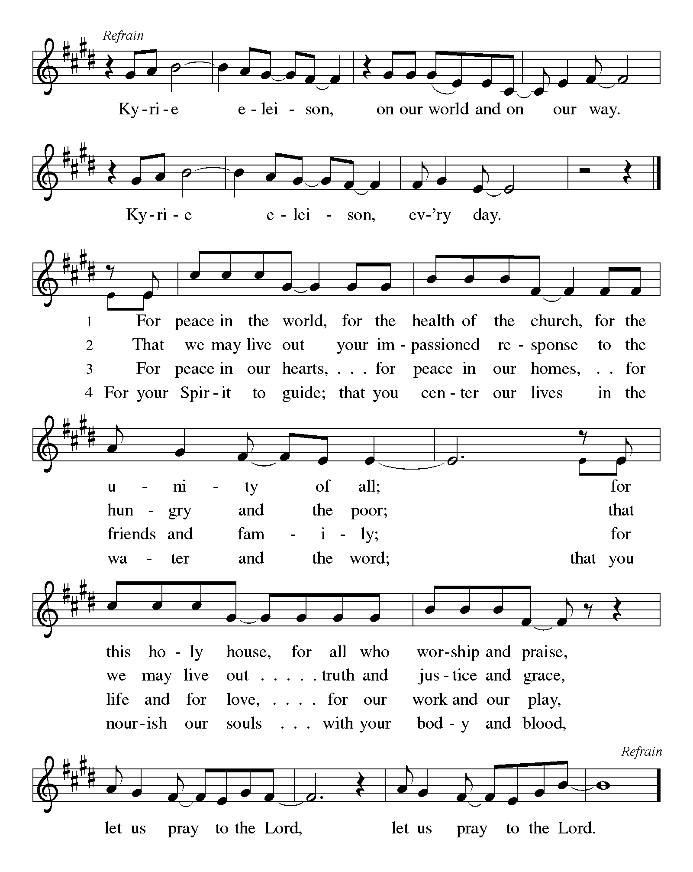

P - The Lord be with you.
C - And also with you.

First Lesson: Joshua 5:9-12
By celebrating the Passover and eating the produce of the promised land instead of the miraculous manna that had sustained them in the desert, the Israelites symbolically bring their forty years of wilderness wandering to an end at Gilgal.
⁹ The Lord said to Joshua, “Today I have rolled away from you the disgrace of Egypt.” And so that place is called Gilgal to this day.
¹⁰ While the Israelites were camped in Gilgal they kept the passover in the evening on the fourteenth day of the month in the plains of Jericho. ¹¹ On the day after the passover, on that very day, they ate the produce of the land, unleavened cakes and parched grain. ¹² The manna ceased on the day they ate the produce of the land, and the Israelites no longer had manna; they ate the crops of the land of Canaan that year.

A – Words of God!
C – Words of Life!

Psalm 32
¹ Happy are they whose transgressions are forgiven,
and whose sin is put away!
² Happy are they to whom the Lord imputes no guilt,
and in whose spirit there is no guile!
³ While I held my tongue, my bones withered away,
because of my groaning all day long.
⁴ For your hand was heavy upon me day and night;
my moisture was dried up as in the heat of summer.
⁵ Then I acknowledged my sin to you, and did not conceal my guilt.
I said, “I will confess my transgressions to the Lord.” Then you forgave me the guilt of my sin.
⁶ Therefore all the faithful will make their prayers to you in time of trouble;
when the great waters overflow, they shall not reach them.
⁷ You are my hiding-place; you preserve me from trouble;
you surround me with shouts of deliverance.
⁸ “I will instruct you and teach you in the way that you should go;
I will guide you with my eye.
⁹ Do not be like horse or mule, which have no understanding;
who must be fitted with bit and bridle, or else they will not stay near you.”
¹⁰ Great are the tribulations of the wicked;
but mercy embraces those who trust in the Lord.
¹¹ Be glad, you righteous, and rejoice in the Lord;
shout for joy, all who are true of heart.

Second Lesson: 2 Corinthians 5:16-21
One way to describe the gospel is the promise that in Christ everything is transformed into newness. All mistakes, all deliberate sins, all old history is reconciled with Christ’s resurrection. This is Paul’s strong message to the congregation in the city of Corinth.
¹⁶ From now on, therefore, we regard no one from a human point of view; even though we once knew Christ from a human point of view, we know him no longer in that way. ¹⁷ So if anyone is in Christ, there is a new creation: everything old has passed away; see, everything has become new! ¹⁸ All this is from God, who reconciled us to himself through Christ, and has given us the ministry of reconciliation; ¹⁹ that is, in Christ God was reconciling the world to himself, not counting their trespasses against them, and entrusting the message of reconciliation to us. ²⁰ So we are ambassadors for Christ, since God is making his appeal through us; we entreat you on behalf of Christ, be reconciled to God. ²¹ For our sake he made him to be sin who knew no sin, so that in him we might become the righteousness of God.

A – Words of God!
C – Words of Life! (Stand)

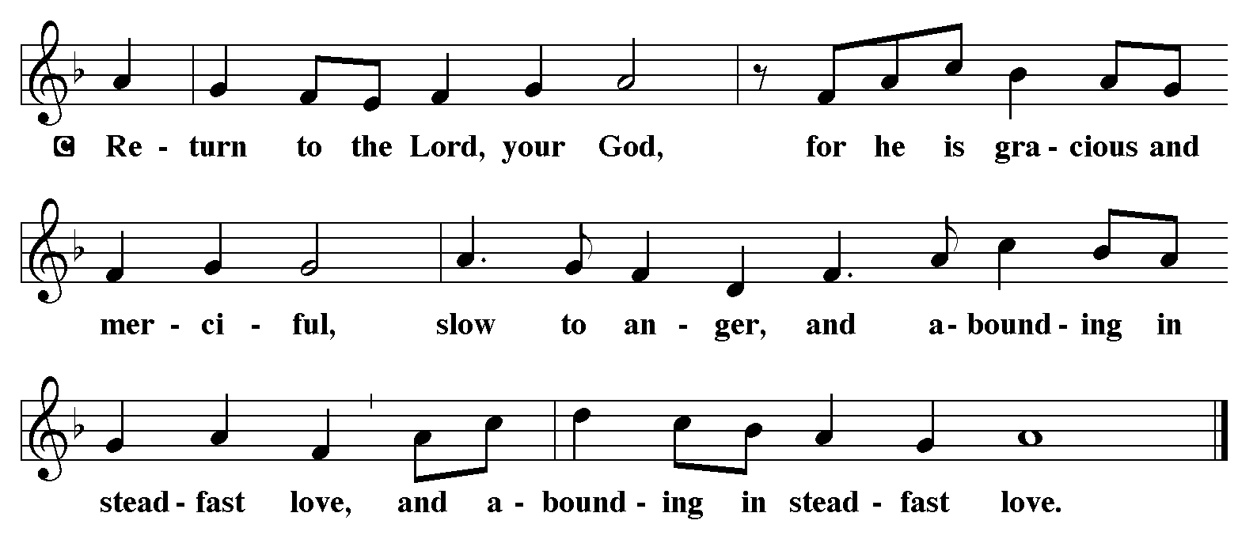
P - The Holy Gospel according to Luke, Chapter 15
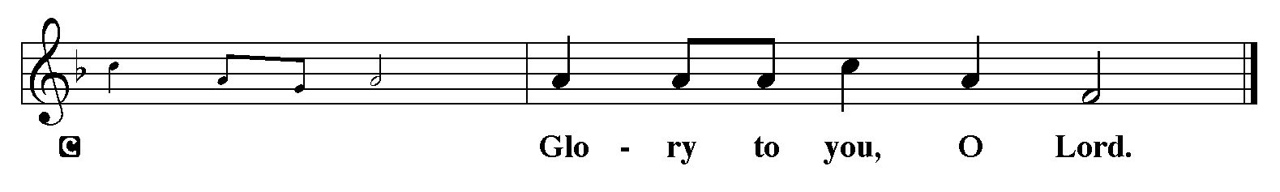

Gospel: Luke 15:1-3, 11b-32
Jesus tells a parable about a son who ponders his father’s love only after he has spurned it. The grace he receives is beyond his hopes. That same grace is a crisis for an older brother who believes it is his obedience that has earned his place in the father’s home.
¹ Now all the tax collectors and sinners were coming near to listen to [Jesus.] ² And the Pharisees and the scribes were grumbling and saying, “This fellow welcomes sinners and eats with them.”
³ So he told them this parable: ^{11b} “There was a man who had two sons. ¹² The younger of them said to his father, ‘Father, give me the share of the property that will belong to me.’ So he divided his property between them. ¹³ A few days later the younger son gathered all he had and traveled to a distant country, and there he squandered his property in dissolute living. ¹⁴ When he had spent everything, a severe famine took place throughout that country, and he began to be in need. ¹⁵ So he went and hired himself out to one of the citizens of that country, who sent him to his fields to feed the pigs. ¹⁶ He would gladly have filled himself with the pods that the pigs were eating; and no one gave him anything. ¹⁷ But when he came to himself he said, ‘How many of my father’s hired hands have bread enough and to spare, but here I am dying of hunger! ¹⁸ I will get up and go to my father, and I will say to him, “Father, I have sinned against heaven and before you; ¹⁹ I am no longer worthy to be called your son; treat me like one of your hired hands.” ’ ²⁰ So he set off and went to his father. But while he was still far off, his father saw him and was filled with compassion; he ran and put his arms around him and kissed him. ²¹ Then the son said to him, ‘Father, I have sinned against heaven and before you; I am no longer worthy to be called your son.’ ²² But the father said to his slaves, ‘Quickly, bring out a robe—the best one—and put it on him; put a ring on his finger and sandals on his feet. ²³ And get the fatted calf and kill it, and let us eat and celebrate; ²⁴ for this son of mine was dead and is alive again; he was lost and is found!’ And they began to celebrate.
²⁵ “Now his elder son was in the field; and when he came and approached the house, he heard music and dancing. ²⁶ He called one of the slaves and asked what was going on. ²⁷ He replied, ‘Your brother has come, and your father has killed the fatted calf, because he has got him back safe and sound.’ ²⁸ Then he became angry and refused to go in. His father came out and began to plead with him. ²⁹ But he answered his father, ‘Listen! For all these years I have been working like a slave for you, and I have never disobeyed your command; yet you have never given me even a young goat so that I might celebrate with my friends. ³⁰ But when this son of yours came back, who has devoured your property with prostitutes, you killed the fatted calf for him!’ ³¹ Then the father said to him, ‘Son, you are always with me, and all that is mine is yours. ³² But we had to celebrate and rejoice, because this brother of yours was dead and has come to life; he was lost and has been found.’ ”

P - The Gospel of the Lord.
C - Praise to you, O Christ. (Sit)

Message:

Hymn of the Day: Beneath the Cross of Jesus ELW 338
1 Beneath the cross of Jesus
I long to take my stand;
the shadow of a mighty rock
within a weary land,
a home within a wilderness,
a rest upon the way,
from the burning of the noontide heat
and burdens of the day.
2 Upon the cross of Jesus,
my eye at times can see
the very dying form of one
who suffered there for me.
And from my contrite heart, with tears,
two wonders I confess:
the wonder of his glorious love
and my unworthiness.
3 I take, O cross, your shadow
for my abiding place;
I ask no other sunshine than
the sunshine of his face;
content to let the world go by,
to know no gain nor loss,
my sinful self my only shame,
my glory all, the cross.

Apostles’ Creed
I believe in One God, the Father almighty,
creator of heaven and earth.
I believe in Jesus Christ, God’s only Son, our Lord,
who was conceived by the Holy Spirit,
born of the virgin Mary,
suffered under Pontius Pilate,
was crucified, died, and was buried;
he descended to the dead.*
On the third day he rose again;
he ascended into heaven,
he is seated at the right hand of the Father,
and he will come to judge the living and the dead.
I believe in the Holy Spirit,

the holy catholic church,
the communion of saints,
the forgiveness of sins,
the resurrection of the body,
and the life everlasting. Amen.

Lord, listen to your children praying,
Lord, send your Spirit in this place;
Lord, listen to your children praying,
send us love, send us pow'r, send us grace.
Prayers of the People (please stand, sit, or kneel as you are able)
Led by the Spirit, let us turn to God in prayer for the church, the world, and all those in need.
A brief silence.
God of promise, make St. Timothy a new creation in Christ. As you reconcile us to yourself, guide us also in your way of reconciliation, that through confession, forgiveness, and repentance, your church may bear witness to your love. God, in your mercy, receive our prayer.

God of new beginnings, restore balance to the earth. Send rain to places of drought and sunshine to places of flooding, that the fruits of the land may again support life. God, in your mercy, receive our prayer.

God of grace, unite the nations as fellow members of the human family. Give our leaders the courage to put aside pride and ego, to stop needless wasting of time, and to work for the well-being of all. God, in your mercy,
receive our prayer.

God of boundless love, receive with open arms any in need of compassion especially everyone on our prayer list and those we name out loud or silently in our hearts. Embrace all who are far from home or cut off from loved ones, and all who live with regret. Give courage to your people to offer and seek forgiveness. God, in your mercy, receive our prayer.

God of compassion, you are our hiding place, whenever we are afraid help us to rely on you to deliver us. God, in your mercy, receive our prayer.

At this time anyone can lift up prayers…God in your mercy, receive our prayer.

God of resurrection life, welcome home all who have died especially our beloved Pastor Joanie. We thank you for her life and commit her into your keeping, where true reconciliation and eternal peace are found. God, in your mercy, receive our prayer.

Receive the prayers of your people and draw all things together in your love, in the name of Jesus, who leads us from death to life.
Amen.
The Peace
P – The Peace of the Lord be with you always.
C – And also with you.
The Offering is Brought to the Altar
Offering Prayer

We lift our voices, we lift our hands, we lift our lives up to you; we are an Offering. Lord, use our voices, Lord, use our hands, Lord, use our lives, they are yours: we are an offering. All that we have, all that we are, all that we hope to be, we give to you, we give to you. We lift our voices, we lift our hands, we lift our lives up to you; we are an offering, we are an offering.

Jesus’ Words of Promise and Gift of Life
Dear Lord, Jesus Christ:
in the night in which you were betrayed,
You took bread, broke it and gave thanks,
then you gave it to your disciples saying:
take and eat, this is my body I am giving for you.
Do this in remembrance of me.
Again, after supper, Dear Lord Jesus,
You took the cup, gave thanks
and gave it for everyone to drink saying:
this cup is the new covenant in my blood,
I am shedding for you and for all people for the forgiveness of sin.
Do this for the remembrance of me. Amen.

Our Lord's Prayer
Our Father in heaven, hallowed be your name, your kingdom come, your will be done, on earth as in heaven. Give us today our daily bread. Forgive us our sins as we forgive those who sin against us. Save us from the time of trial and deliver us from evil. For the kingdom, the power, and the glory are yours, now and forever. Amen.
P – Come to this Table where God really does come to us!
C – Thank You Jesus.

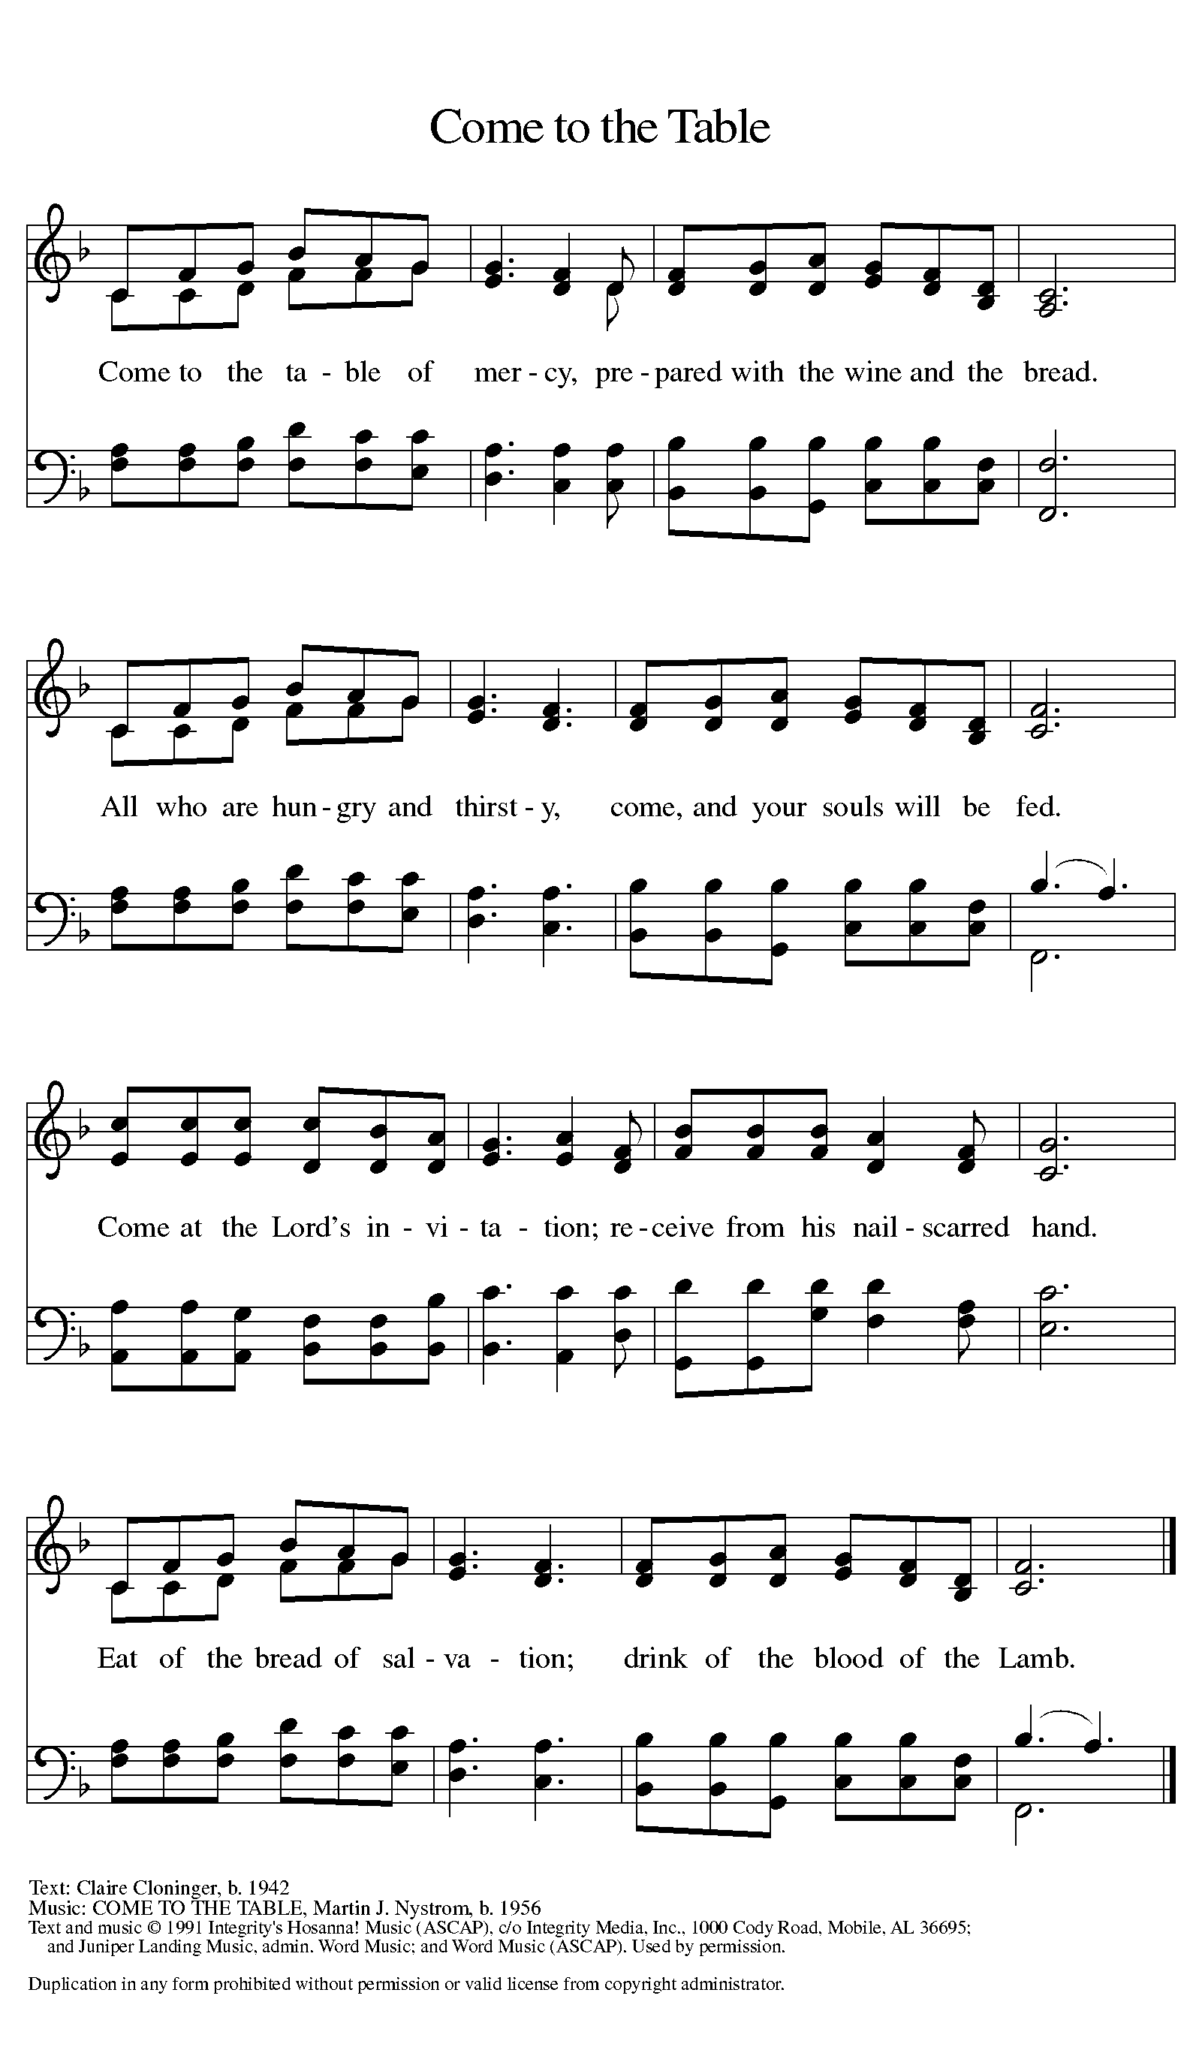

The Distribution of Communion – Come Forward to Receive
Communion Anthem: As the Grains of Wheat W&P 10
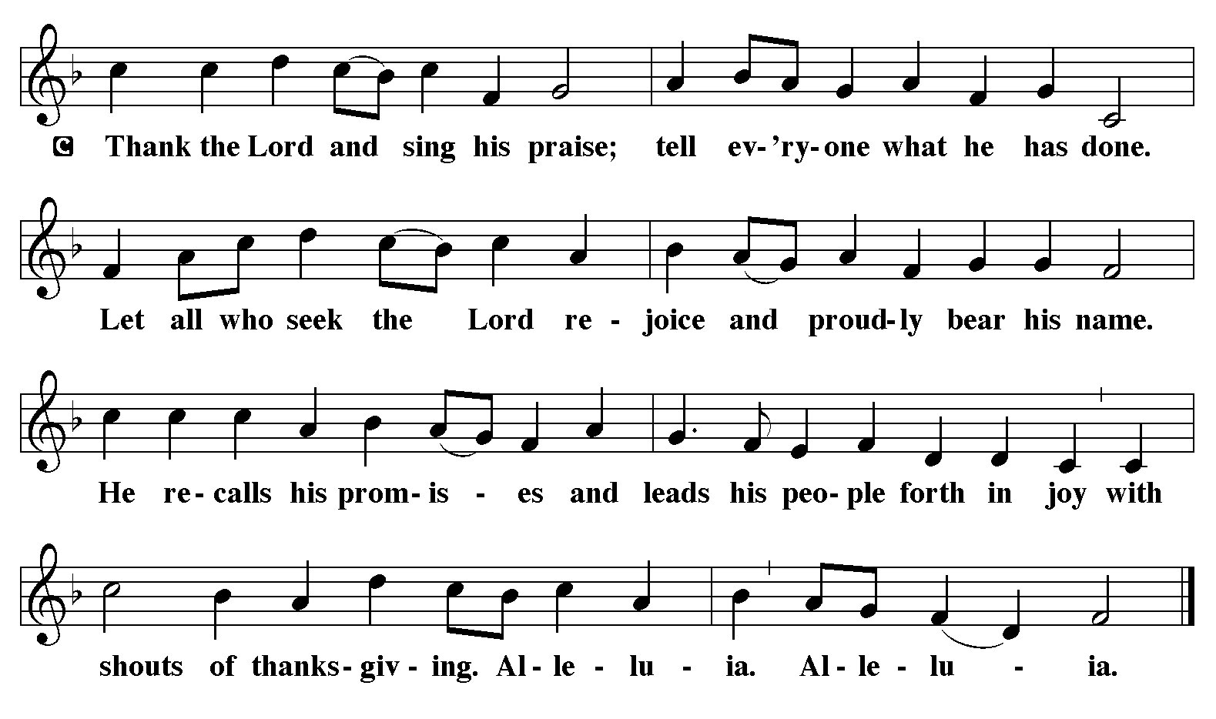
P - Now may the body and blood of our Lord and Savior Jesus Christ strengthen you and keep you in His grace…… Jesus Loves You!
C – Thank You Jesus!
Communion Prayer
Compassionate God, you have fed us with the bread of heaven. Sustain us in our Lenten pilgrimage: may our fasting be hunger for justice, our alms, a making of peace, and our prayer, the song of grateful hearts; through Christ our Lord. Amen.
Blessing
P - May God who has called us forth from the dust of the earth, and claimed us as children of the light, strengthen you on your journey into life renewed. The Lord bless you and keep you. The Lord’s face shine upon you with grace and mercy. The Lord look upon you with favor and give you ☩ peace. C - Amen.
Sending Hymn: Sent Forth by God's Blessing ELW 547
1 Sent forth by God's blessing, our true faith confessing,
the people of God from this dwelling take leave.
The supper is ended. Oh, now be extended
the fruits of this service in all who believe.
The seed of Christ's teaching, receptive souls
reaching, shall blossom in action for God and for all.
Your grace shall incite us, your love shall unite us
to work for your kingdom and answer your call.

2 With praise and thanksgiving to God ever-living,
the tasks of our ev'ryday life we will face—
our faith ever sharing, in love ever caring,
embracing God's children, the whole human race.
With your feast you feed us, with your light now
lead us; unite us as one in this life that we share.
Then may all the living with praise and thanksgiving
give honor to Christ and his name that we bear.

A - Marked with the cross of Christ, go forth to love and serve the Lord.
C - By the Light of the Cross, We Will! Hallelujah!
Postlude: He Is Exalted W&P 55
Unless otherwise noted, materials used in this bulletin are:
From Sundays and Seasons.com. Copyright 2015 Augsburg Fortress. All rights reserved. Reprinted by permission under Augsburg Fortress Liturgies Annual License #SAS028635. Music is reprinted under OneLicense.Net #A712074 and/or Augsburg Fortress #SBL12176H. Scripture, unless otherwise noted, is from the New Revised Standard Version Bible, Copyright © 1989, Division of Christian Education of the National Council of the Churches of Christ in the United States of America. Used by permission. All rights reserved.

REMEMBRANCE
John Donne, poet, died 1631
After finishing his education at Oxford University, Donne seemed headed for a career in the English public service. But a series of circumstances led him into the ordained ministry. He is well known as a writer of both secular and sacred poetry.

ATTENDANCE
Mid-week Lent Svc Wednesday, March 19th , 4pm 22
Saturday, March 22nd , 4pm 34
Sunday, March 23rd, 9am 45
Drive-Up Communion 2
103
We are attempting to keep this prayer list as up to date as possible. Normally, we keep names on this prayer list for three weeks unless requested otherwise. If you are aware of names that can be removed, please let Regina know. Also, where there is a first name only, if you are aware of the last/full name please help us update our list. Thank you.
Prayer List

JoAnn Ollenborger
Randy Holden
Mary Fraley & Family
Kennedy Family
Brooklyn
Mike Perate
Keith Johns
Annie Cook
Nick Nichols
Joe Moore
Mark Owen
Dawn
Melvin VanHorn
Sallie Peña
Dawn Pitkins
Jean Fowler’s family
Pringle Family
Stephanie
Louise
Ashlee
Debra Owen
Bill & Evette Dexter
Hannah
Tim
Ben
Rosalie Jacobs
Rhonda Sheldon
Heather
Brian M.
Bill Brooks
Mary
Leonese Smith
John M
Paul Litton
Greg & Judi Schutrum
Julie
Adeline
Margo Blum
Mary D
Frani Barnes
Jamie
Michael Koch
Alec Groman
Jace & Family
Erica Wilson
Matthew Nichols
Ohsiek Family
Good Shepherd
Marcus Schoener
St. Anne’s Episcopal

Family of Carol Freeman (Randy’s mother)
Everyone recovering from surgery or illness

