St Timothy Lutheran Church
Sunday, 9:00 AM Worship
April 6, 2025
Fifth Sunday in Lent

"Equipping people to grow as Disciples faithfully serving our community"



Rooted in the past and growing into the future, the church must always be reformed in order to live out the love of Christ in an ever-changing world. We celebrate the good news of God’s grace, that Jesus Christ sets us free every day to do this life-transforming work. Trusting in the freedom given to us in baptism, we pray for the church, that Christians will unite more fully in worship and mission.
(from Sundays and Seasons for Reformation Weekend)
We are glad to have you worship with us. All are welcome at communion. If you need gluten-free – please ask when you go up for communion. If you have any questions – just ask the Welcomer at the back of the sanctuary.
Please note** if you use a pew envelope for your offering – please write your name on the envelope so that the financial secretaries can post it as a gift from you. Thank You!
St Timothy Worship Planning Team
Pastor Lynn Bechdolt
Parish Deacon, Frank Hofstetter
Eric Mortensen, Director of Music

The Altar flowers are given this week by Diane and Eddie Mason, in memory of Pastor Joanie!

This Week at St. Timothy's
Monday, April 7 10-12 – packing Easter bags,
11am – Healthy Start
Tuesday, April 8 9-12 – Food Pantry
Wednesday, April 9 4pm – Lent Service, 5pm – Soup Supper
Thursday, April 10 9:30am – Prayer Group, 11am – Miniatures, 12pm – Food Box Packing/Pizza Party, 4:30pm – Choir, 5:15 - Chimes
Friday, April 11
Saturday, April 12 4pm - Worship
Sunday, April 13
Palm Sunday 9am – Worship, Children’s Sunday School, 10:15-10:45 Drive-Up Communion, 10:30am – Adult Sunday School, Committees
Welcome and Congregational News
“On Eagles’ Wings”, ELW 787 is the last music before worship – all are welcome to join in
Preparation Anthem: Bind Us Together W & P 18
Confession and Forgiveness
P – In the name of the Father, and of the Son, (+) and of the Holy Spirit.
C – Amen
P – Almighty God, to whom all hearts are open, all desires known, and from whom no secrets are hid; Cleanse the thoughts of our hearts by the inspiration of your Holy Spirit, that we may perfectly love you and worthily magnify your holy name, through Jesus Christ our Lord.
C – Amen
P - If we say we have no sin, we deceive ourselves, and the truth is not in us, But if we confess our sins, God who is faithful and just will forgive our sins and cleanse us from all unrighteousness.
(Silence for reflection and self-examination)
P – Most Merciful God,
C – Have mercy on us. We confess to you all our sins and that in these continuing times of uncertainty and fear, we have trouble trusting you and feeling your presence. Forgive us our sins, our doubts, our fears and lack of patience with others. Strengthen our faith and help us to let your hope and light shine through us in these challenging times. We ask for mercy, wisdom and guidance, through Jesus Christ, our Savior and Lord. Amen.
P – Almighty God, in his mercy, has given his Son to die for us and for his sake, forgives us all our sins. As a called and ordained minister of the Church of Christ, and by his authority, I therefore declare to you the entire forgiveness of all your sins, in the name of the Father, and of the + Son, and of the Holy Spirit.
C – Amen

Gathering Hymn: Open Now Thy Gates of Beauty ELW 533
1 Open now thy gates of beauty, Zion, let me enter there,
where my soul in joyful duty waits for God who answers prayer.
Oh, how blessed is this place, filled with solace, light, and grace!

2 Gracious God, I come before thee; come thou also unto me;
where we find thee and adore thee, there a heav'n on earth must be.
To my heart, oh, enter thou, let it be thy temple now!

3 Here thy praise is gladly chanted, here thy seed is duly sown;
let my soul, where it is planted, bring forth precious sheaves alone,
so that all I hear may be fruitful unto life in me.

4 Thou my faith increase and quicken, let me keep thy gift divine;
howsoe'er temptations thicken, may thy word still o'er me shine
as my guiding star through life, as my comfort in all strife.

5 Speak, O God, and I will hear thee, let thy will be done indeed;
may I undisturbed draw near thee while thou dost thy people feed.
Here of life the fountain flows; here is balm for all our woes.

Prayer of the Day
Creator God, you prepare a new way in the wilderness, and your grace waters our desert. Open our hearts to be transformed by the new thing you are doing, that our lives may proclaim the extravagance of your love given to all through your Son, Jesus Christ, our Savior and Lord, who lives and reigns with you and the Holy Spirit, one God, now and forever.
Amen.

P - The grace of our Lord Jesus Christ, the love of God, and the communion of the Holy Spirit be with you all.
C - And also with you.

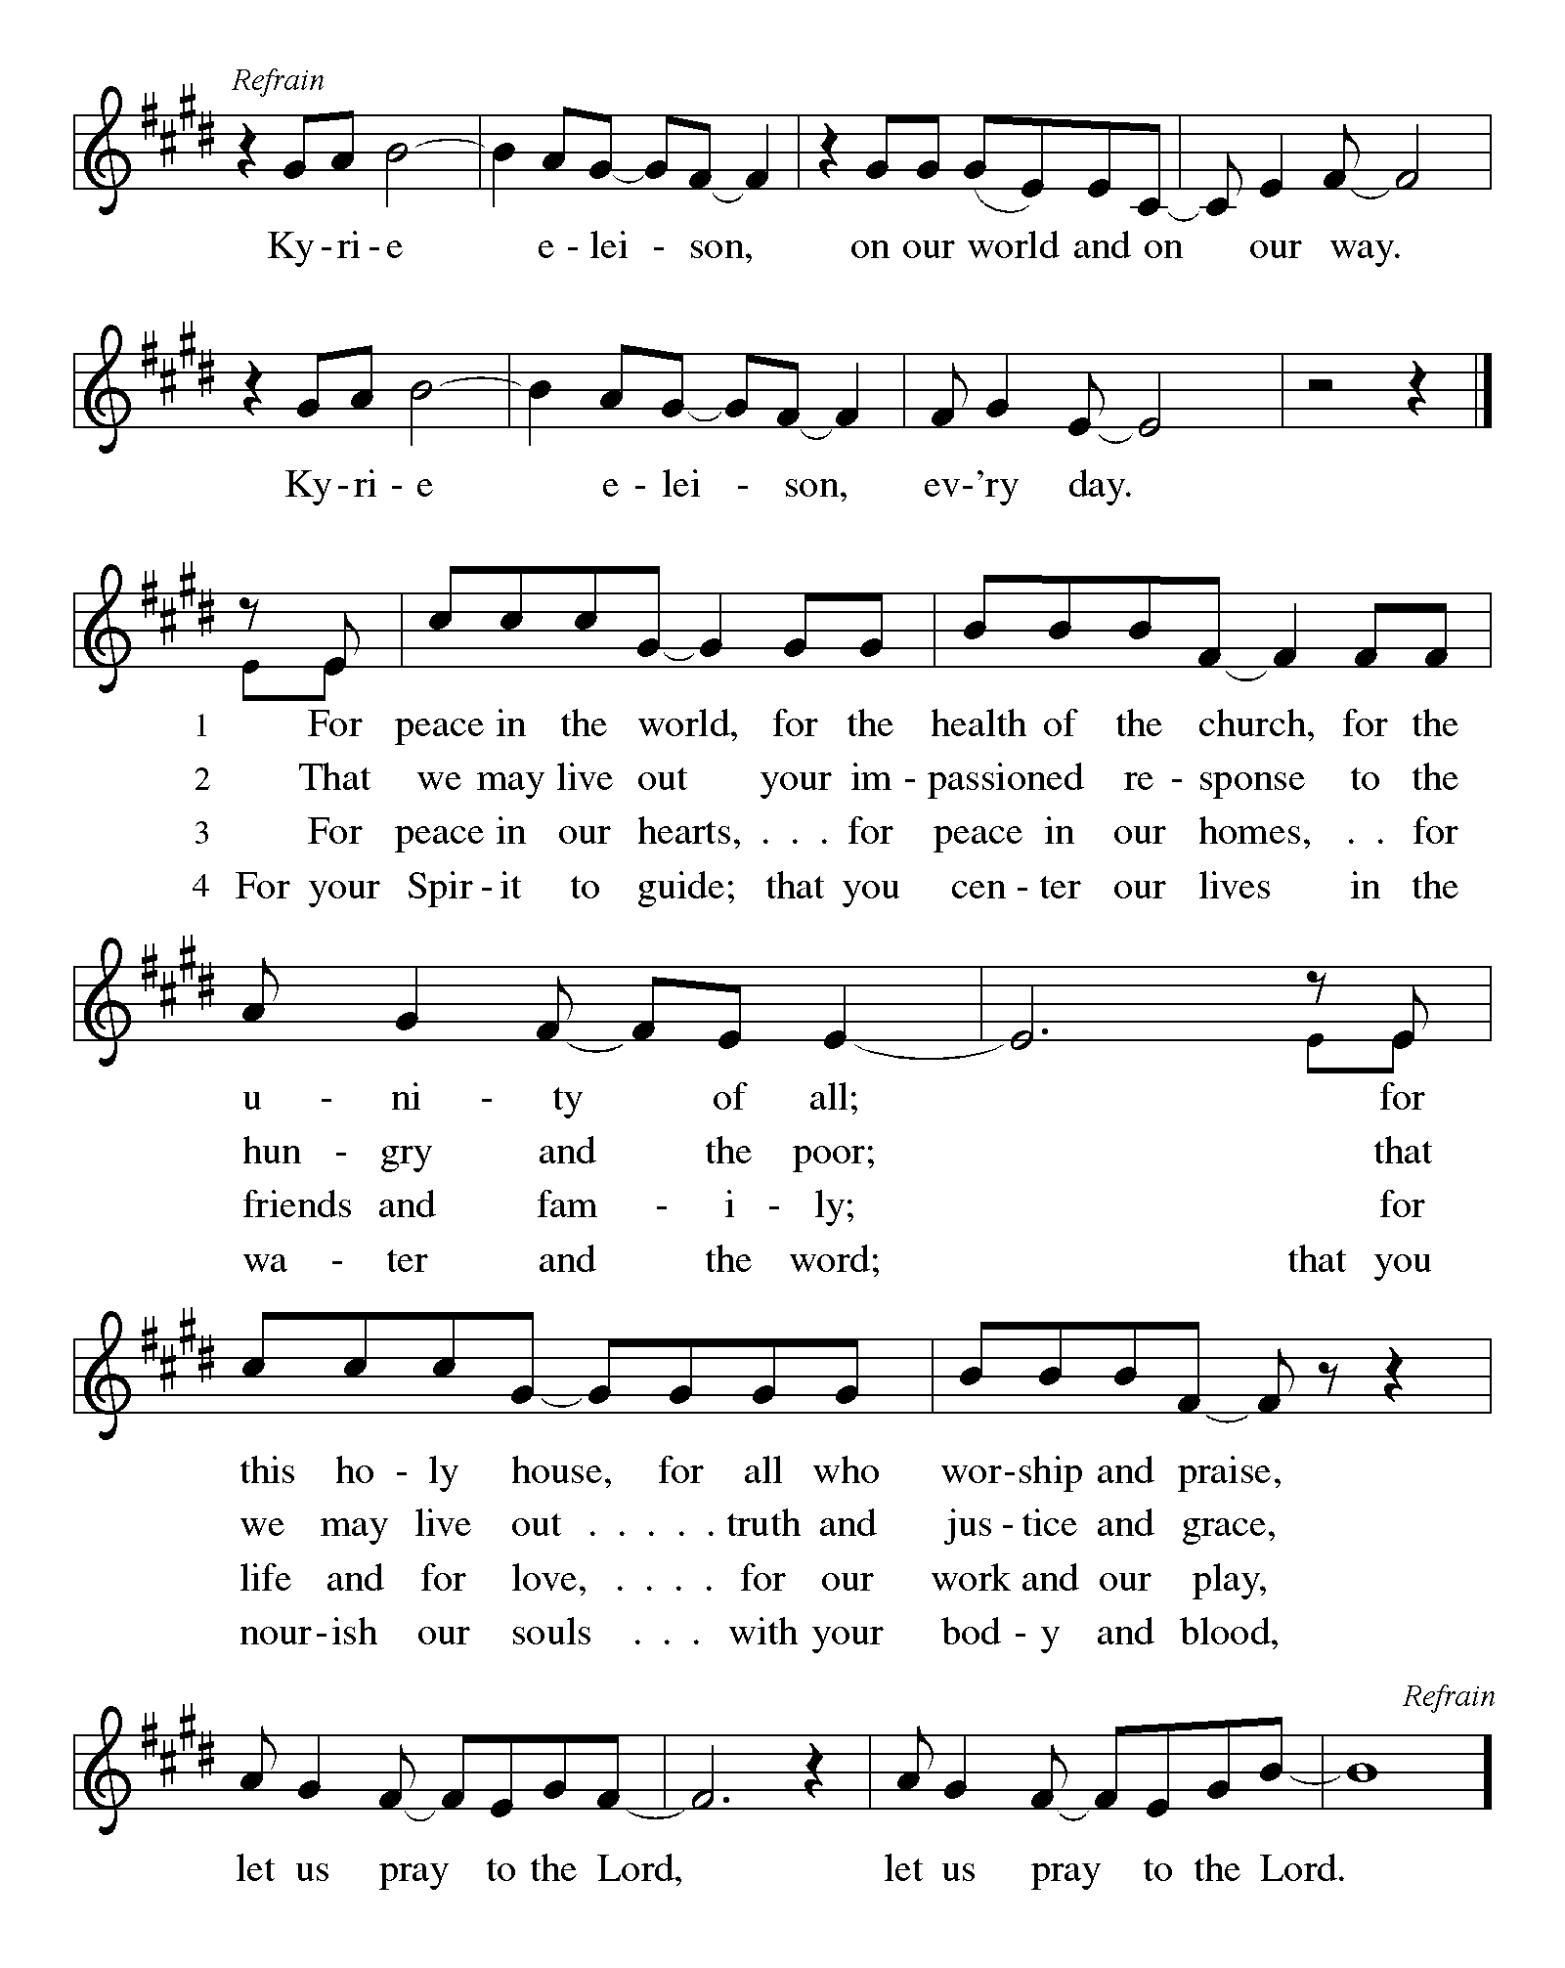

P - The Lord be with you.
C - And also with you.

First Lesson: Isaiah 43:16-21
The prophet declares that long ago God performed mighty deeds and delivered Israel from Egyptian bondage through the waters of the sea. Now, God is about to do a new thing, bringing the exiles out of Babylon and through the wilderness in a new Exodus.
¹⁶ Thus says the Lord,
who makes a way in the sea,
a path in the mighty waters,
¹⁷ who brings out chariot and horse,
army and warrior;
they lie down, they cannot rise,
they are extinguished, quenched like a wick:
¹⁸ Do not remember the former things,
or consider the things of old.
¹⁹ I am about to do a new thing;
now it springs forth, do you not perceive it?
I will make a way in the wilderness
and rivers in the desert.
²⁰ The wild animals will honor me,
the jackals and the ostriches;
for I give water in the wilderness,
rivers in the desert,
to give drink to my chosen people,
²¹ the people whom I formed for myself
so that they might declare my praise.
A – Words of God!
C – Words of Life!

Psalm 126
¹ When the Lord restored the fortunes of Zion,
then were we like those who dream.
² Then was our mouth filled with laughter, and our tongue with shouts of joy.
Then they said among the nations, “The Lord has done great things for them.”
³ The Lord has done great things for us,
and we are glad indeed.
⁴ Restore our fortunes, O Lord,
like the watercourses of the Negeb.
⁵ Those who sowed with tears
will reap with songs of joy.
⁶ Those who go out weeping, carrying the seed,
will come again with joy, shouldering their sheaves.

Second Lesson: Philippians 3:4b-14
Writing to Christians in Philippi, Paul admits that his heritage and reputation could give him more reason than most people to place confidence in his spiritual pedigree. But the overwhelming grace of God in Jesus calls Paul to a new set of values.
[Paul writes:] ^{4b} If anyone else has reason to be confident in the flesh, I have more: ⁵ circumcised on the eighth day, a member of the people of Israel, of the tribe of Benjamin, a Hebrew born of Hebrews; as to the law, a Pharisee; ⁶ as to zeal, a persecutor of the church; as to righteousness under the law, blameless.
⁷ Yet whatever gains I had, these I have come to regard as loss because of Christ. ⁸ More than that, I regard everything as loss because of the surpassing value of knowing Christ Jesus my Lord. For his sake I have suffered the loss of all things, and I regard them as rubbish, in order that I may gain Christ ⁹ and be found in him, not having a righteousness of my own that comes from the law, but one that comes through faith in Christ, the righteousness from God based on faith. ¹⁰ I want to know Christ and the power of his resurrection and the sharing of his sufferings by becoming like him in his death, ¹¹ if somehow I may attain the resurrection from the dead.
¹² Not that I have already obtained this or have already reached the goal; but I press on to make it my own, because Christ Jesus has made me his own. ¹³ Beloved, I do not consider that I have made it my own; but this one thing I do: forgetting what lies behind and straining forward to what lies ahead, ¹⁴ I press on toward the goal for the prize of the heavenly call of God in Christ Jesus.

A – Words of God!
C – Words of Life! (Stand)
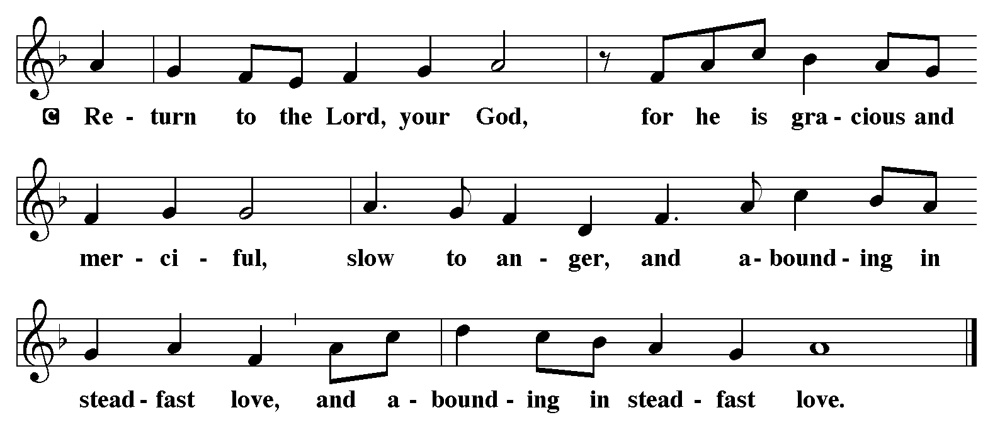
P - The Holy Gospel according to John, Chapter 12
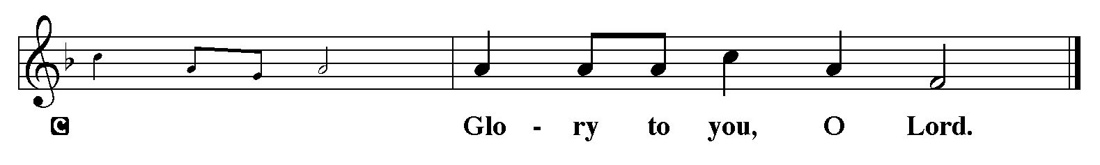

Gospel: John 12:1-8
Judas willfully misinterprets as waste Mary’s extravagant act of anointing Jesus’ feet with costly perfume. Jesus recognizes that her lavish gift is both an expression of love and an anticipation of his burial.
¹ Six days before the Passover Jesus came to Bethany, the home of Lazarus, whom he had raised from the dead. ² There they gave a dinner for him. Martha served, and Lazarus was one of those at the table with him. ³ Mary took a pound of costly perfume made of pure nard, anointed Jesus’ feet, and wiped them with her hair. The house was filled with the fragrance of the perfume. ⁴ But Judas Iscariot, one of his disciples (the one who was about to betray him), said, ⁵ “Why was this perfume not sold for three hundred denarii and the money given to the poor?” ⁶ (He said this not because he cared about the poor, but because he was a thief; he kept the common purse and used to steal what was put into it.) ⁷ Jesus said, “Leave her alone. She bought it so that she might keep it for the day of my burial. ⁸ You always have the poor with you, but you do not always have me.”

P - The Gospel of the Lord.
C - Praise to you, O Christ. (Sit)

Message:

Hymn of the Day: Will You Let Me Be Your Servant ELW 659
- Will you let me be your servant, let me be as
Christ to you? Pray that I may have the grace to
let you be my servant, too.

- We are pilgrims on a journey, we are trav'lers
on the road; we are here to help each other
walk the mile and bear the load.

- I will hold the Christ-light for you in the nighttime
of your fear; I will hold my hand out to you,
speak the peace you long to hear.

- I will weep when you are weeping; when you laugh I'll
laugh with you. I will share your joy and sorrow
till we've seen this journey through.

- Will you let me be your servant, let me be as
Christ to you? Pray that I may have the grace to
let you be my servant, too.

Apostles’ Creed
I believe in One God, the Father almighty,
creator of heaven and earth.
I believe in Jesus Christ, God’s only Son, our Lord,
who was conceived by the Holy Spirit,
born of the virgin Mary,
suffered under Pontius Pilate,
was crucified, died, and was buried;
he descended to the dead.*
On the third day he rose again;
he ascended into heaven,
he is seated at the right hand of the Father,
and he will come to judge the living and the dead.
I believe in the Holy Spirit,

the holy catholic church,
the communion of saints,
the forgiveness of sins,
the resurrection of the body,
and the life everlasting. Amen.

Lord, listen to your children praying,
Lord, send your Spirit in this place;
Lord, listen to your children praying,
send us love, send us pow'r, send us grace.
Prayers of The People (Please stand, sit, or kneel, as you are able.)
Led by the Spirit, let us turn to God in prayer for the church, the world, and all those in need.
A brief silence.
Oh God, lead and guide St. Timothy. Be with the leaders of this church and help us to trust in your promises. God, in your mercy, receive our prayer.
Oh God, make a way for the planet’s future in the sea and wilderness, the mountains, and plains. From coast to coast, repair habitats and ecosystems in the air and on the ground. God, in your mercy, receive our prayer.
Oh God, where religious differences divide people, bring together those who worship you so that faith may unite us rather than divide us. God, in your mercy, receive our prayer.
Oh God, restore hope to those who have been inflicted with a serious health diagnosis, those who have lost their jobs or homes, those conflicted with divorce, or death. Bring healing to those in need, especially those on our prayer list and those we name out loud or silently in our hearts at this time. May all those who are in sorrow be able to once again rejoice in your name. God, in your mercy, receive our prayer.
Oh God, we praise you for the gifts of the spirit. We thank you for those who proclaim the gospel. Help musicians to be able to proclaim your greatness. God, in your mercy, receive our prayer.
At this time anyone can lift up prayers…God, in your mercy, receive our prayer.
Oh God, the communion of saints declare your praise. We give thanks for those who have died. We trust in Jesus Christ, our crucified and risen Savior who had made them his own. God, in your mercy, receive our prayer.
Receive the prayers of your people and draw all things together in your love, in the name of Jesus, who leads us from death to life.
Amen.

The Peace
P – The Peace of the Lord be with you always.
C – And also with you.
The Offering is Brought to the Altar
Offering Prayer

We lift our voices, we lift our hands, we lift our lives up to you; we are an Offering. Lord, use our voices, Lord, use our hands, Lord, use our lives, they are yours: we are an offering. All that we have, all that we are, all that we hope to be, we give to you, we give to you. We lift our voices, we lift our hands, we lift our lives up to you; we are an offering, we are an offering.

Jesus’ Words of Promise and Gift of Life
Dear Lord, Jesus Christ:
in the night in which you were betrayed,
You took bread, broke it and gave thanks,
then you gave it to your disciples saying:
take and eat, this is my body I am giving for you.
Do this in remembrance of me.
Again, after supper, Dear Lord Jesus,
You took the cup, gave thanks
and gave it for everyone to drink saying:
this cup is the new covenant in my blood,
I am shedding for you and for all people for the forgiveness of sin.
Do this for the remembrance of me. Amen.
Our Lord's Prayer
Our Father in heaven, hallowed be your name, your kingdom come, your will be done, on earth as in heaven. Give us today our daily bread. Forgive us our sins as we forgive those who sin against us. Save us from the time of trial and deliver us from evil. For the kingdom, the power, and the glory are yours, now and forever. Amen.
P – Come to this Table where God really does come to us!
C – Thank You Jesus.

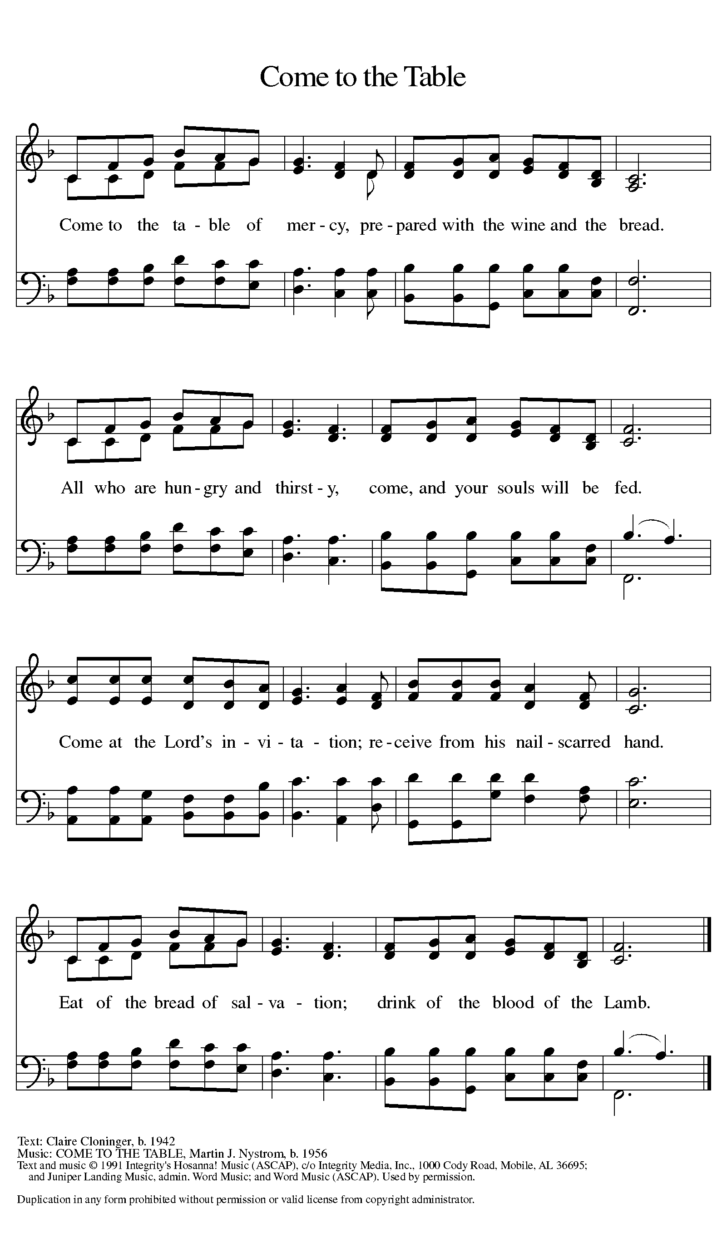
The Distribution of Communion – Come Forward to Receive
Communion Anthem: Beauty for Brokenness W&P 17

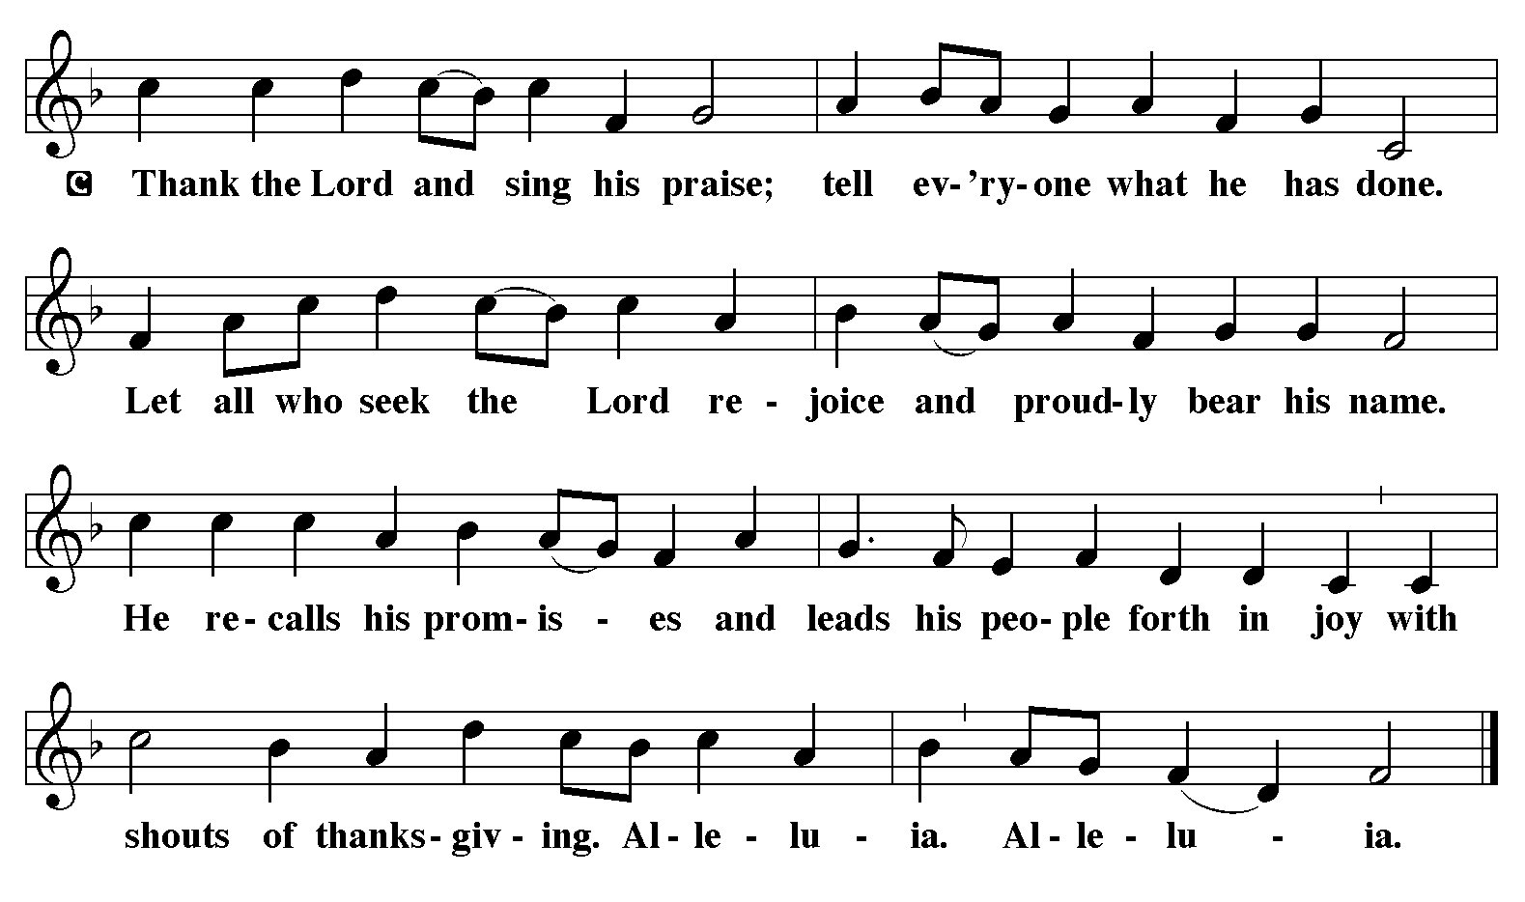
P - Now may the body and blood of our Lord and Savior Jesus Christ strengthen you and keep you in His grace…… Jesus Loves You!
C – Thank You Jesus!
Communion Prayer
Compassionate God, you have fed us with the bread of heaven. Sustain us in our Lenten pilgrimage: may our fasting be hunger for justice, our alms, a making of peace, and our prayer, the song of grateful hearts; through Christ our Lord. Amen.
Blessing
P - May God who has called us forth from the dust of the earth, and claimed us as children of the light, strengthen you on your journey into life renewed. The Lord bless you and keep you. The Lord’s face shine upon you with grace and mercy. The Lord look upon you with favor and give you ☩ peace. C - Amen.

Sending Hymn: Savior, Again to Your Dear Name ELW 534
1 Savior, again to your dear name we raise
with one accord our parting hymn of praise;
once more we bless you ere our worship cease,
then, lowly bending, wait your word of peace.
2 Grant us your peace upon our homeward way;
with you began, with you shall end the day;
guard all the lips from sin, the hearts from shame,
that in this house have called upon your name.
3 Grant us your peace, Lord, through the coming night;
for us transform its darkness into light.
Keep us from harm and danger till the dawn;
your evening presence promise to your own.
4 Grant us your peace throughout our earthly life,
our balm in sorrow, and our stay in strife;
then, when your voice shall bid our conflict cease,
call us, O Lord, to your eternal peace.
A - Marked with the cross of Christ, go forth to love and serve the Lord.
C - By the Light of the Cross, We Will! Hallelujah!
Postlude: Great Is the Lord W&P 53
Unless otherwise noted, materials used in this bulletin are:
From Sundays and Seasons.com. Copyright 2015 Augsburg Fortress. All rights reserved. Reprinted by permission under Augsburg Fortress Liturgies Annual License #SAS028635. Music is reprinted under OneLicense.Net #A712074 and/or Augsburg Fortress #SBL12176H. Scripture, unless otherwise noted, is from the New Revised Standard Version Bible, Copyright © 1989, Division of Christian Education of the National Council of the Churches of Christ in the United States of America. Used by permission. All rights reserved.
Remembrance
Albrecht Dürer, died 1528; Matthias Grünewald, died 1529; Lucas Cranach, died 1553; artists
These great artists revealed through their work the mystery of salvation and the wonder of creation. Dürer's work reflected the apocalyptic spirit of his time. Though he remained a Roman Catholic, he was sympathetic to Martin Luther's reforming work. Grünewald's paintings are known for their dramatic forms, vivid colors, and depiction of light. Cranach's work includes many fine religious examples and several portraits of Martin Luther. Cranach was also widely known for his woodcuts.

ATTENDANCE
Mid-week Lent Svc Wednesday, March 26th , 4pm 22
PJ Memorial, Friday, March 28th, 1pm 175
Saturday, March 29th , 4pm 29
Sunday, March 30^{th,} 9am 44
Drive-Up Communion 2
272
We will keep names on this prayer list for three weeks unless requested otherwise. If you are aware of names that can be removed, or last names to go with first names, please let Regina know. Thank you.
Prayer List

Ben
Ashlee
Linda C.
Steve York
David
Nate
Carol
JoAnn Ollenborger
Randy Holden
Mary Fraley & Family
Brooklyn
Mike Perate

Keith Johns
Annie Cook
Nick Nichols
Joe Moore
Mark Owen
Melvin VanHorn
Dawn Pitkins
Jean Fowler’s family
Pringle Family
Louise
Ashlee
Debra Owen

Bill & Evette Dexter
Rosalie Jacobs
Rhonda Sheldon
Bill Brooks
Leonese Smith
Margo Blum
Michael Koch
Erica Wilson
Matthew Nichols
Ohsiek Family
Good Shepherd
Marcus Schoener
St. Anne’s Episcopal

All those recovering from surgery or illness.

