St Timothy Lutheran Church
Sunday, January 5, 2025 9 AM Worship
Second Sunday of Christmas

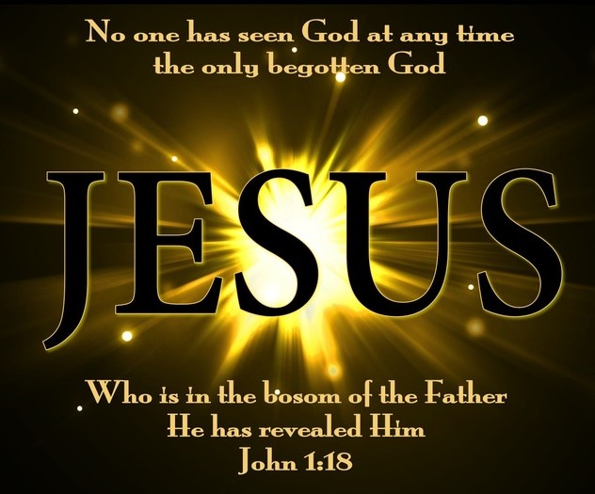

"Equip people to grow as Disciples faithfully serving our community"

We are glad to have you worship with us. All are welcome at communion. If you need gluten-free – please tell Pastor Joanie when you go up for communion. If you have any questions – just ask the Welcomer at the back of the sanctuary.

Please note** if you use a pew envelope for your offering – please write your name on the envelope so that the financial secretaries can post it as a gift from you. Thank You!
St Timothy Worship Planning Team
The Reverend Joan E. Holden 850-774-7730
Parish Deacon, Frank Hofstetter
Eric Mortensen, Director of Music

The Altar flowers are given to the glory of God!

This Week at St. Timothy's
Monday – January 6th PJ Off, 10am -Ruth Circle, 11am – Healthy Start
Tuesday – January 7th 2:30pm – Book Study
Wednesday – January 8th 10am – OT BS, NO CARD MAKERS
Thursday – January 9th 9:30am – Prayer Group, 11am – Miniatures, 1:30pm – Royal Dalton, 4:30pm - Choir
Friday – January 10th 10am – NT BS, 11am-1pm – PJ Continuing Ed
Saturday – January 11th 4pm - Worship
Sunday – January 12th 9am – Worship, Children’s SS, 10:30am – Adult SS, Coffee Fellowship, Committees, 11-11:30am – Drive-Up Communion

Rooted in the past and growing into the future, the church must always be reformed in order to live out the love of Christ in an ever-changing world. We celebrate the good news of God’s grace, that Jesus Christ sets us free every day to do this life-transforming work. Trusting in the freedom given to us in baptism, we pray for the church, that Christians will unite more fully in worship and mission.
(from Sundays and Seasons for Reformation Weekend)

Welcome and Congregational News
Preparation Hymn: Bring Forth the Kingdom W&P 22

Confession and Forgiveness
P – In the name of the Father, and of the Son, (+) and of the Holy Spirit.
C – Amen
P – Almighty God, to whom all hearts are open, all desires known, and from whom no secrets are hid; Cleanse the thoughts of our hearts by the inspiration of your Holy Spirit, that we will perfectly love you and worthily magnify your holy name, through Jesus Christ our Lord.
C – Amen
P - If we say we have no sin, we deceive ourselves, and the truth is not in us, but if we confess our sins, God who is faithful and just will forgive our sins and cleanse us from all unrighteousness.
P – Most Merciful God,
C – Have mercy on us. We confess to you all our sins and that in these continuing times of uncertainty and fear, we have trouble trusting you and feeling your presence. Forgive us our sins, our doubts, our fears and lack of patience with others. Strengthen our faith and help us to let your hope and light shine through us in these dark times. We ask for mercy, wisdom and guidance, through Jesus Christ, our Savior and Lord. Amen.
P - Almighty God, in his mercy, has given his Son to die for us and for his sake, forgives us all of our sins. As a called and ordained minister of the Church of Christ, and by his authority, I therefore declare to you the entire forgiveness of all your sins, in the name of the Father, and of the + Son, and of the Holy Spirit.
C – Amen

Gathering Hymn: Beautiful Savior ELW 838
1 Beautiful Savior, King of creation,
Son of God and Son of Man!
Truly I'd love thee, truly I'd serve thee,
light of my soul, my joy, my crown.

2 Fair are the meadows, fair are the woodlands,
robed in flow'rs of blooming spring;
Jesus is fairer, Jesus is purer,
he makes our sorrowing spirit sing.

3 Fair is the sunshine, fair is the moonlight,
bright the sparkling stars on high;
Jesus shines brighter, Jesus shines purer
than all the angels in the sky.

4 Beautiful Savior, Lord of the nations,
Son of God and Son of Man!
Glory and honor, praise, adoration,
now and forevermore be thine!

Prayer of the Day
Almighty God, you have filled all the earth with the light of your incarnate Word. By your grace empower us to reflect your light in all that we do, through Jesus Christ, our Savior and Lord, who lives and reigns with you and the Holy Spirit, one God, now and forever.
Amen.

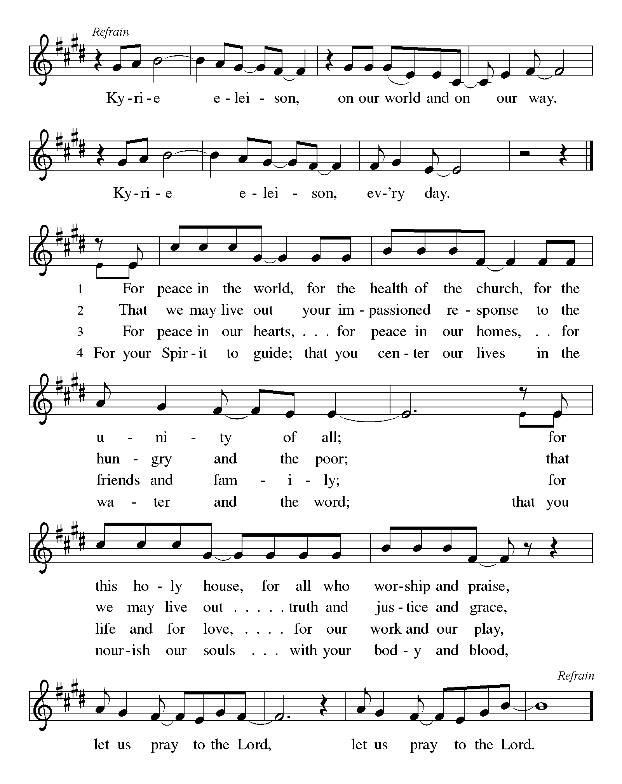
P - The grace of our Lord Jesus Christ, the love of God and the communion of the Holy Spirit be with you all.
C - And also with you.

First Lesson: Jeremiah 31:7-14
God promises to bring Israel back to its land from the most remote parts of exile. In Zion Israel will rejoice over God’s gift of food and livestock. Young women will express their joy in dancing; God will give gladness instead of sorrow.
⁷ Thus says the Lord:
Sing aloud with gladness for Jacob,
and raise shouts for the chief of the nations;
proclaim, give praise, and say,
“Save, O Lord, your people,
the remnant of Israel.”
⁸ See, I am going to bring them from the land of the north,
and gather them from the farthest parts of the earth,
among them the blind and the lame,
those with child and those in labor, together;
a great company, they shall return here.
⁹ With weeping they shall come,
and with consolations I will lead them back,
I will let them walk by brooks of water,
in a straight path in which they shall not stumble;
for I have become a father to Israel,
and Ephraim is my firstborn.
¹⁰ Hear the word of the Lord, O nations,
and declare it in the coastlands far away;
say, “He who scattered Israel will gather him,
and will keep him as a shepherd a flock.”
¹¹ For the Lord has ransomed Jacob,
and has redeemed him from hands too strong for him.
¹² They shall come and sing aloud on the height of Zion,
and they shall be radiant over the goodness of the Lord,
over the grain, the wine, and the oil,
and over the young of the flock and the herd;
their life shall become like a watered garden,
and they shall never languish again.
¹³ Then shall the young women rejoice in the dance,
and the young men and the old shall be merry.
I will turn their mourning into joy,
I will comfort them, and give them gladness for sorrow.
¹⁴ I will give the priests their fill of fatness,
and my people shall be satisfied with my bounty,
says the Lord.

A- Word of God!
C- Words of Life!

Psalm 147:12-20
¹² Worship the Lord, O Jerusalem;
praise your God, O Zion,
¹³ who has strengthened the bars of your gates
and has blessed your children within you.
¹⁴ God has established peace on your borders
and satisfies you with the finest wheat.
¹⁵ God sends out a command to the earth,
a word that runs very swiftly.
¹⁶ God gives snow like wool,
scattering frost like ashes.
¹⁷ God scatters hail like bread crumbs.
Who can stand against God’s cold?
¹⁸ The Lord sends forth the word and melts them;
the wind blows, and the waters flow.
¹⁹ God declares the word to Jacob,
statutes and judgments to Israel.
²⁰ The Lord has not done so to any other nation;
they do not know God’s judgments. Hallelujah!

Second Lesson: Ephesians 1:3-14
In Jesus, all of God’s plans and purposes have been made know as heaven and earth are united in Christ. Through Jesus, we have been chosen as God’s children and have been promised eternal salvation.
³ Blessed be the God and Father of our Lord Jesus Christ, who has blessed us in Christ with every spiritual blessing in the heavenly places, ⁴ just as he chose us in Christ before the foundation of the world to be holy and blameless before him in love. ⁵ He destined us for adoption as his children through Jesus Christ, according to the good pleasure of his will, ⁶ to the praise of his glorious grace that he freely bestowed on us in the Beloved. ⁷ In him we have redemption through his blood, the forgiveness of our trespasses, according to the riches of his grace ⁸ that he lavished on us. With all wisdom and insight ⁹ he has made known to us the mystery of his will, according to his good pleasure that he set forth in Christ, ¹⁰ as a plan for the fullness of time, to gather up all things in him, things in heaven and things on earth. ¹¹ In Christ we have also obtained an inheritance, having been destined according to the purpose of him who accomplishes all things according to his counsel and will, ¹² so that we, who were the first to set our hope on Christ, might live for the praise of his glory. ¹³ In him you also, when you had heard the word of truth, the gospel of your salvation, and had believed in him, were marked with the seal of the promised Holy Spirit; ¹⁴ this is the pledge of our inheritance toward redemption as God’s own people, to the praise of his glory.
A – Word of God!
C – Words of Life!

(Stand)
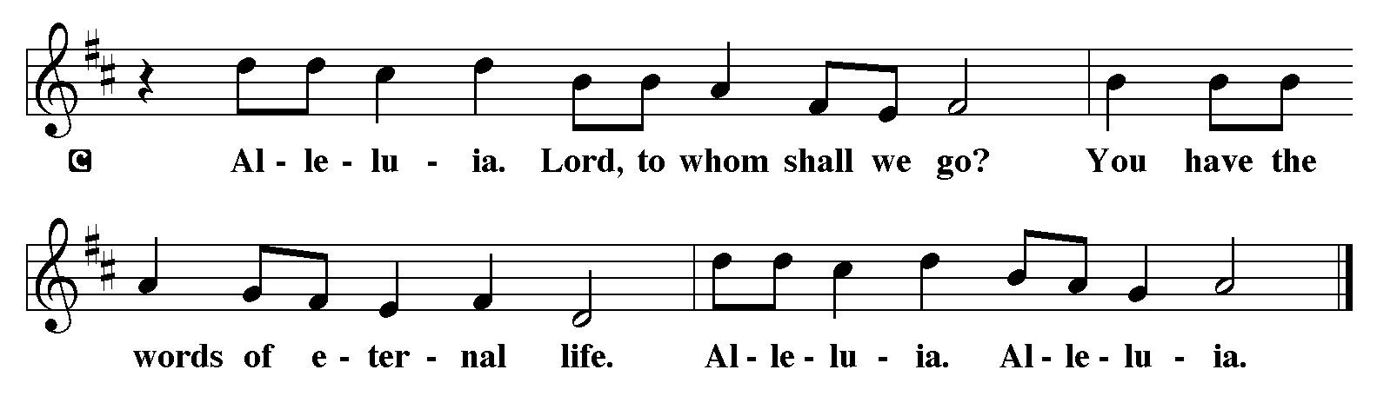
P - The Holy Gospel according to John, Chapter 1
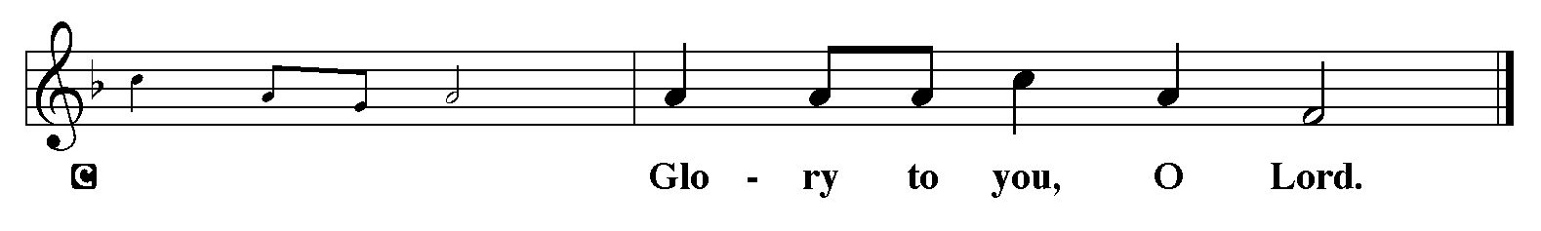

(Stand)
P - The Holy Gospel according to John, Chapter 1

Gospel: John 1:1-18
John begins his gospel with this prologue: a hymn to the Word through whom all things were created. This Word became flesh and brought grace and truth to the world.
¹ In the beginning was the Word, and the Word was with God, and the Word was God. ² He was in the beginning with God. ³ All things came into being through him, and without him not one thing came into being. What has come into being ⁴ in him was life, and the life was the light of all people. ⁵ The light shines in the darkness, and the darkness did not overcome it. ⁶ There was a man sent from God, whose name was John. ⁷ He came as a witness to testify to the light, so that all might believe through him. ⁸ He himself was not the light, but he came to testify to the light. ⁹ The true light, which enlightens everyone, was coming into the world.
¹⁰ He was in the world, and the world came into being through him; yet the world did not know him. ¹¹ He came to what was his own, and his own people did not accept him. ¹² But to all who received him, who believed in his name, he gave power to become children of God, ¹³ who were born, not of blood or of the will of the flesh or of the will of man, but of God.
¹⁴ And the Word became flesh and lived among us, and we have seen his glory, the glory as of a father’s only son, full of grace and truth.
¹⁵ (John testified to him and cried out, “This was he of whom I said, ‘He who comes after me ranks ahead of me because he was before me.’ ”) ¹⁶ From his fullness we have all received, grace upon grace. ¹⁷ The law indeed was given through Moses; grace and truth came through Jesus Christ. ¹⁸ No one has ever seen God. It is God the only Son, who is close to the Father’s heart, who has made him known.
P – The Gospel of the Lord!
C - Praise to you, O Christ. (Sit)

Message

Hymn of the Day: This Is My Father's World ELW 824
- This is my Father's world, and to my list'ning ears all
nature sings, and round me rings the music of the spheres.
This is my Father's world; I rest me in the thought of
rocks and trees, of skies and seas; his hand the wonders wrought.

- This is my Father's world; the birds their carols raise; the
morning light, the lily white, declare their maker's praise.
This is my Father's world; he shines in all that's fair. In the
rustling grass I hear him pass; he speaks to me ev'rywhere.

- This is my Father's world; oh, let me not forget that,
though the wrong seems oft so strong, God is the ruler yet.
This is my Father's world; why should my heart be sad? The
Lord is king, let heaven ring;
The Nicene Creed
We believe in one God,
the Father, the Almighty,
maker of heaven and earth,
of all that is, seen and unseen.
We believe in one Lord, Jesus Christ,
the only Son of God,
eternally begotten of the Father,
God from God, Light from Light,
true God from true God,
begotten, not made,
of one Being with the Father;
through him all things were made.
For us and for our salvation
He came down from heaven;
by the power of the Holy Spirit He
became incarnate from the virgin Mary and was made man.
For our sake he was crucified under Pontius Pilate;
he suffered death and was buried.
On the third day he rose again
in accordance with the scriptures;
he ascended into heaven
and is seated at the right hand of the Father.
He will come again in glory to judge the living and the dead,
and his kingdom will have no end.
We believe in the Holy Spirit, the Lord, the giver of life,
who proceeds from the Father and the Son,*
who with the Father and the Son is worshiped and glorified,
who has spoken through the prophets.
We believe in one holy catholic and apostolic church.
We acknowledge one baptism for the forgiveness of sins.
We look for the resurrection of the dead,
and the life of the world to come. Amen.

Lord, listen to your children praying,
Lord, send your Spirit in this place;
Lord, listen to your children praying,
send us love, send us pow'r, send us grace.

Prayers of The People (please stand, sit, or kneel as you are able)
Filled with good news of great joy, let us offer our prayers for the church, the earth, and all people.
A brief silence.
O God, you reveal yourself in this assembly. In water, wine, and bread, show us again and again your grace upon grace, that your church boldly testifies to your love. God of grace, receive our prayer.
You reveal yourself in creation. In seedlings and planets, microorganisms and galaxies, awaken us to the cry of the earth. As you nourish your people like a watered garden, empower us to nourish our creaturely companions. God of grace, receive our prayer.
You reveal yourself in every land and in the farthest parts of the earth. Deliver peoples who suffer under oppressive regimes. Thwart the foolish plans of unjust leaders. Give wisdom to our elected officials. God of grace, receive our prayer.
You reveal yourself in every human being. Help us recognize your image in our siblings in Christ who are in the strong grip of addiction, depression, anxiety, hopelessness, or other illness, especially everyone on our prayer list and everyone we name out loud or silently in our hearts. Grant us compassion in our care for your people. God of grace, receive our prayer.
You reveal yourself anew every day. In this new year, renew this congregation and its ministries in our witness to the good news of the incarnation. Transform the way we have always done things into your new future for us. God of grace, receive our prayer.
At this time, anyone may lift up prayers……. God of grace, receive our prayer.
You reveal yourself in the lives of your holy ones. We give you thanks for those who set their hope on you, trusting the inheritance we receive in you. God of grace, receive our prayer.
We commend these prayers to you, O God, trusting your grace made known to all, through the Word made flesh, Jesus Christ, our Savior and Lord. Amen.
P – The Peace of the Lord be with you always.
C – And also with you.
We Share God’s Peace
The Offering is Brought to the Altar
Offering Prayer

We lift our voices, we lift our hands, we lift our lives up to you; we are an Offering. Lord, use our voices, Lord, use our hands, Lord, use our lives, they are yours: we are an offering. All that we have, all that we are, all that we hope to be, we give to you, we give to you. We lift our voices, we lift our hands, we lift our lives up to you; we are an offering, we are an offering.

The Meal
Jesus’ Words of Promise and Gift of Life
Dear Lord, Jesus Christ:
in the night in which you were betrayed,
You took bread, broke it and gave thanks,
then you gave it to your disciples saying:
take and eat, this is my body I am giving for you.
Do this in remembrance of me.
Again, after supper, Dear Lord Jesus Christ,
You took the cup, gave thanks
and gave it for everyone to drink saying:
this cup is the new covenant in my blood,
I am shedding for you and for all people for the forgiveness of sin.
Do this for the remembrance of me. Amen.

Our Lord’s Prayer
C: Our Father in heaven, hallowed be your name, your kingdom come, your will be done, on earth as in heaven. Give us today our daily bread. Forgive us our sins as we forgive those who sin against us. Save us from the time of trial and deliver us from evil. For the kingdom, the power, and the glory are yours, now and forever. Amen.
P: Come to this table where God really does come to us!
C: Thank You Jesus!

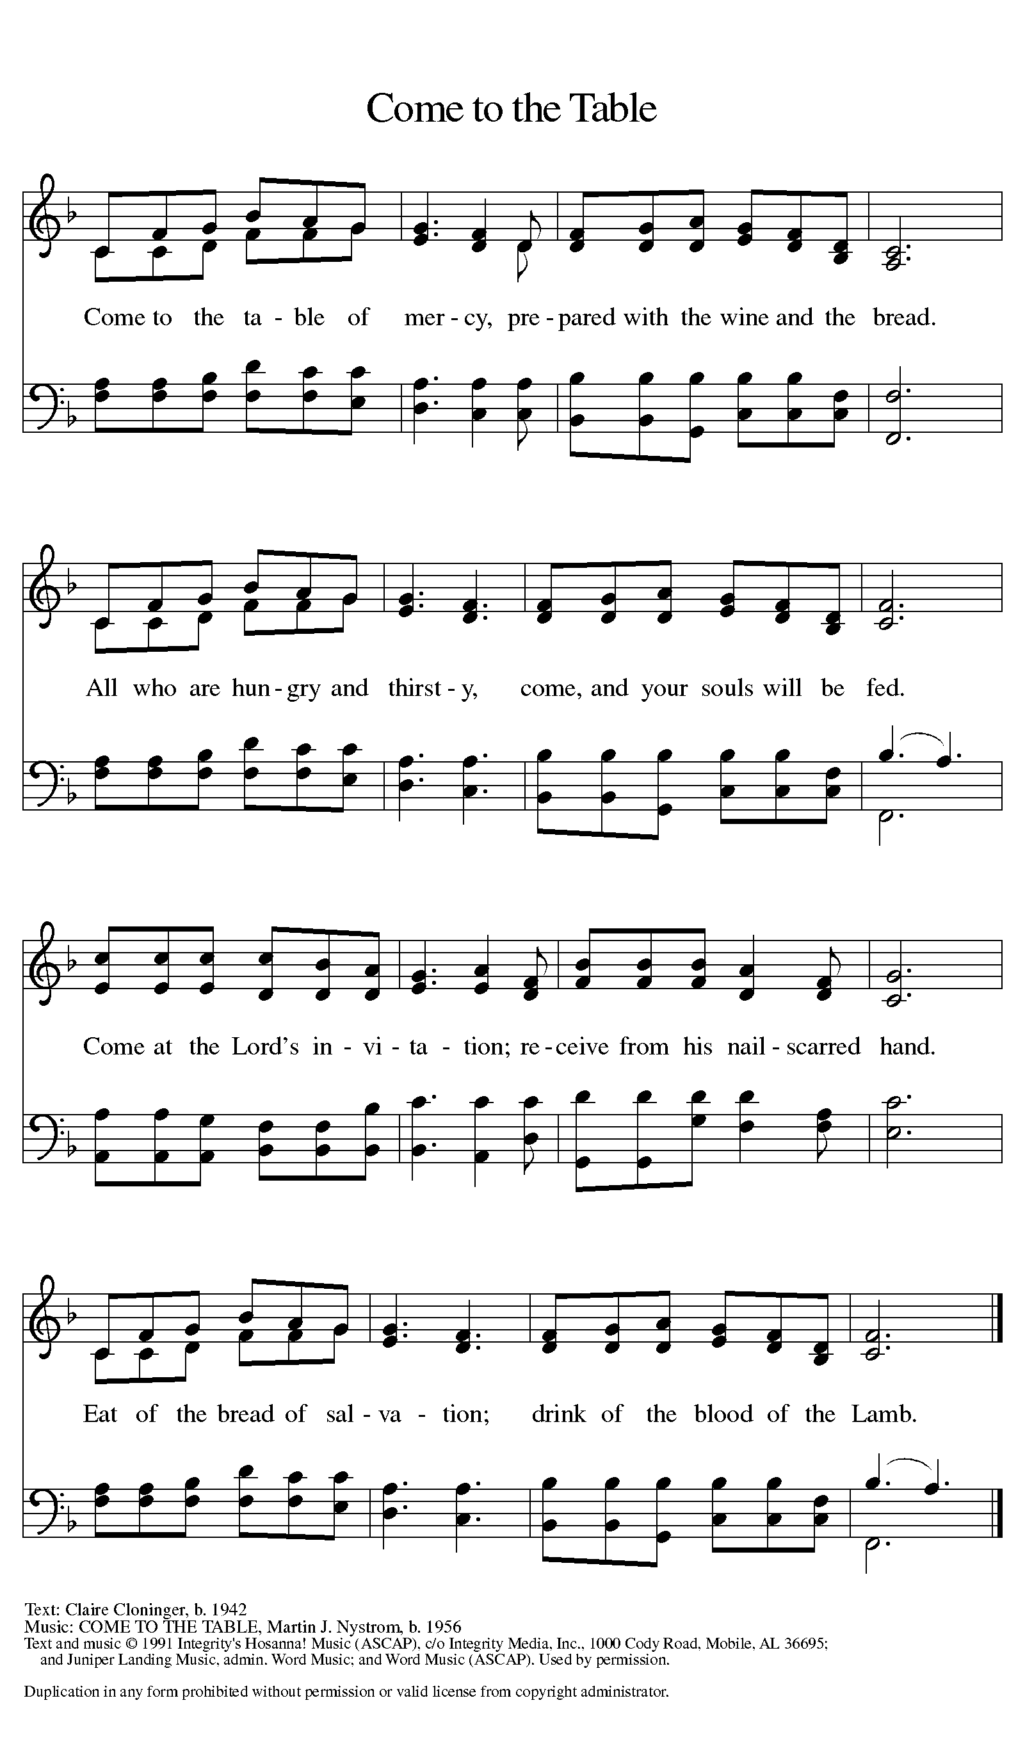

Distribution - Please come forward to receive
Communion Anthem: A Story for All People W&P 2
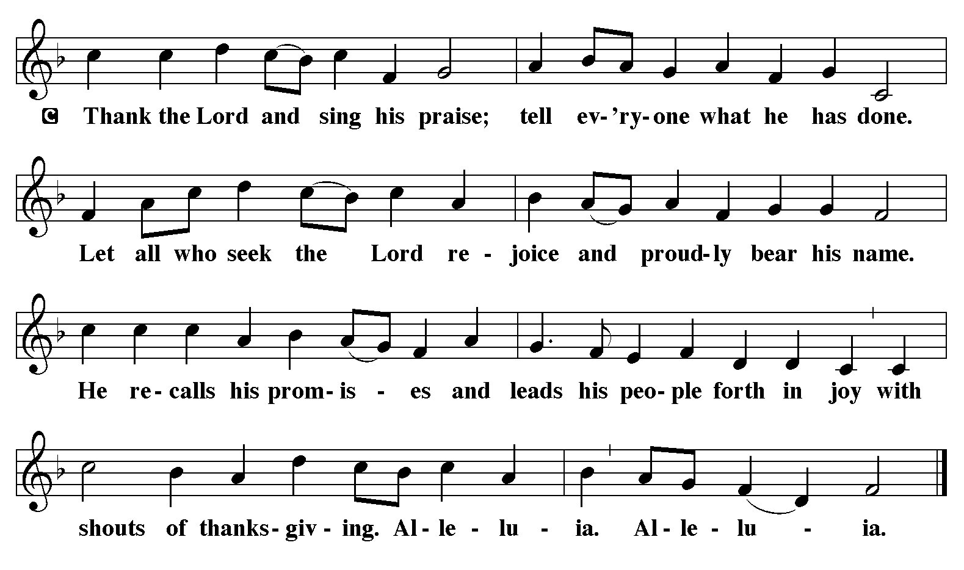
P: Now may the body and blood of our Lord Jesus Christ strengthen you and keep you in his grace … Jesus Loves You!
C: Amen
Prayer After Communion
God for whom we wait, you come to us in the broken bread and the cup we share. Make us ready always to welcome Christ into our hearts and send us forth to be your people in the world, announcing your coming among us in Jesus Christ our Lord. Amen.
Blessing
P:The God of love, Father, ☩ Son, and Holy Spirit, lavish you with grace, illumine your path, and increase your joy, today and always.
C: Amen.

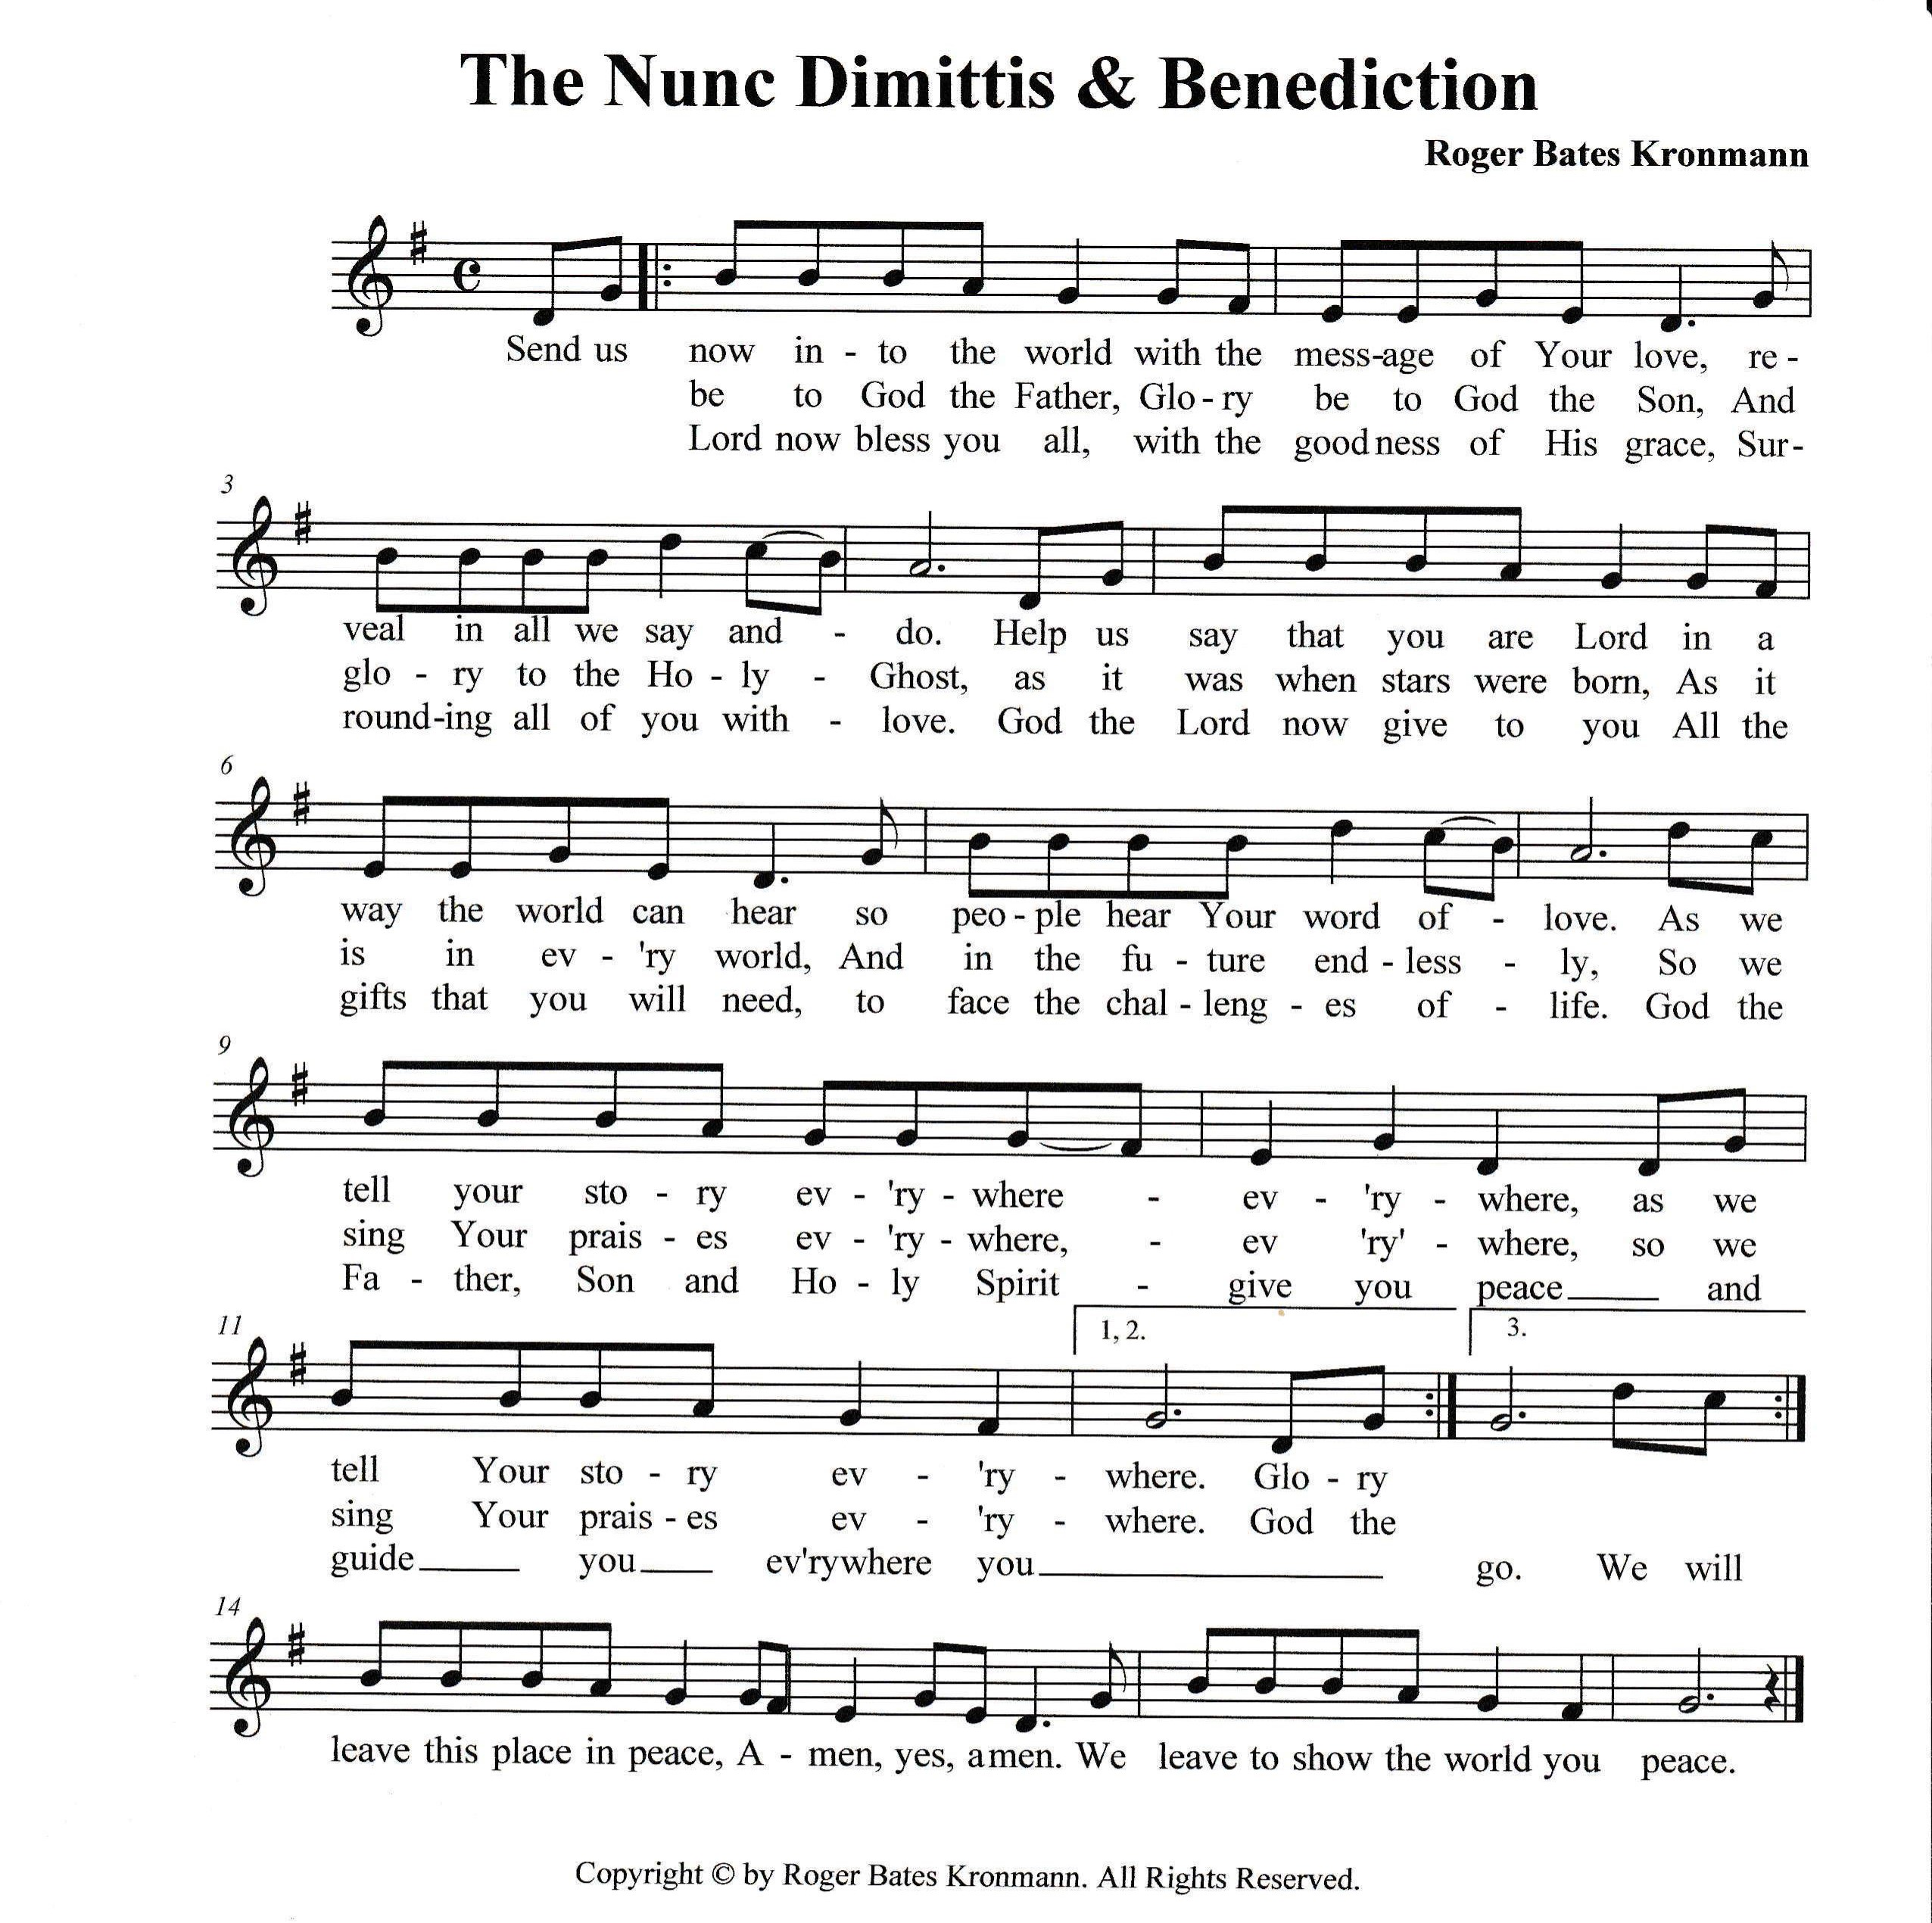

Sending Hymn: Be Thou My Vision ELW 793
1 Be thou my vision, O Lord of my heart;
naught be all else to me, save that thou art:
thou my best thought both by day and by night,
waking or sleeping, thy presence my light.

2 Be thou my wisdom, and thou my true word;
I ever with thee and thou with me, Lord.
Thou my soul's shelter, and thou my high tow'r,
raise thou me heav'nward, O Pow'r of my pow'r.

3 Riches I heed not, nor vain, empty praise,
thou mine inheritance, now and always:
thou and thou only, the first in my heart,
great God of heaven, my treasure thou art.

4 Light of my soul, after victory won,
may I reach heaven's joys, O heaven's Sun!
Heart of my own heart, whatever befall,
still be my vision, O Ruler of all.

P: Go in peace. Proclaim the Good News!
C: By the Grace of God we will – Alleluia!
Postlude: Jesus, Remember Me W&P 78
Unless otherwise noted, materials used in this bulletin are:
From Sundays and Seasons.com. Copyright 2015 Augsburg Fortress. All rights reserved. Reprinted by permission under Augsburg Fortress Liturgies Annual License #SAS028635. Music is reprinted under OneLicense.Net #A712074 and/or Augsburg Fortress #SBL12176H. Scripture, unless otherwise noted, is from the New Revised Standard Version Bible, Copyright © 1989, Division of Christian Education of the National Council of the Churches of Christ in the United States of America. Used by permission. All rights reserved.

REMEMBRANCE
Johann Konrad Wilhelm Loehe, renewer of the church, died 1872
Loehe was a pastor in nineteenth-century Germany. Loehe's chief concern was that a congregation find its life in the holy communion, and from that source evangelism and social ministries would flow. He sent pastors to North America, Australia, New Guinea, Brazil, and Ukraine.
From sundaysandseasons.com.
Announcements for January 4th and 5th

ATTENDANCE
Christmas Eve, December 24th, 3pm 67
Christmas Eve, December 24th, 7pm 37
Christmas Day, December 25th, 10am 30
Saturday, December 28th, 4pm 28
Sunday, December 29th, 9am 34
Drive-Up Communion 2
198
Pastor’s Phone
Due to some technical issues, Pastor Joanie has gone back to using her old phone and is no longer using the 423 #. If you need to reach her the number is 850-774-7730

ADDRESS CORRECTION – 12/31
If anyone would like to send sympathy cards to Joyce Santti’s family, here is the address:
Santti Family
246 W Liberty St.
Hernando FL 34442

Giving Envelopes for 2025
Giving envelopes have been placed in your mailboxes. If you did not receive envelopes but would like to please let Randy know. You do not have to be a member to receive envelopes.

Council members needed
We will need a couple more members on Council. Please prayerfully consider becoming a Council member. We usually meet on the 3rd Sunday of the month at 11:45am. Contact Pastor Joanie if you have questions or need more info.

