***A Service of Worship, Praise and Hope***

***Welcome to St. Timothy Saturday Evening Worship!***

***September 14th, Pentecost Season***



**"Equip people to grow as Disciples faithfully serving our community"**

**We are glad to have you worship with us. All are welcome at communion. If you need gluten-free – please tell Pastor Joanie when you go up for communion. If you have any questions – just ask the Welcomer at the back of the sanctuary.**

***Please note** if you use a pew envelope for your offering – please write your name on the envelope so that the financial secretaries can post it as a gift from you. Thank You!***

**St Timothy Worship Planning Team**

**The Reverend Joan E. Holden 352-423-2554**

**Eric Mortensen, Director of Music**

**Parish Deacon, Frank Hofstetter**

**The Altar Flowers are given by Carol and Barbara Johnson, in memory of Warren, who would have turned 100 on 9/16.**

**This Week at St. Timothy's**

**Monday, September 16th Pastor at Conference on Ministry**

**Tuesday, September 17th Pastor at Conference on Ministry, 1pm WELCA**

**Wednesday, September 18th Pastor at Conference on Ministry, No OT BS**

**Thursday, September 19th 9:30am – Prayer Group, 11am – Miniatures, 4:30pm – Choir, 5:15pm – Chimes**

**Friday, September 20th 9am – Stewardship Meeting, 10am – NT BS, 11am – PJ Continuing Ed**

**Saturday, September 21st 4pm – Worship**

**Sunday, September 22nd 9am – Worship, Children’s SS, 10:30am – Adult SS, 11-11:30am – Drive-Up Communion**

***Rooted in the past and growing into the future, the church must always be reformed in order to live out the love of Christ in an ever-changing world. We celebrate the good news of God’s grace, that Jesus Christ sets us free every day to do this life-transforming work. Trusting in the freedom given to us in baptism, we pray for the church, that Christians will unite more fully in worship and mission.***

***(from Sundays and Seasons for Reformation Weekend)***

***“Shout to the Lord” is the last pre-service hymn the choir sings, it is Hymn #821 and everyone is welcome to sing with the choir.***

**Welcome and Sharing of Congregational News**

***Preparation Hymn: Open Our Eyes, Lord W&P 113***

***Gathering Hymn: Lift High the Cross* *ELW 660***

***Refrain***

**Lift high the cross, the love of Christ proclaim till**

**all the world adore his sacred name.**

1 Come, Christians, follow where our captain trod,

our king victorious, Christ, the Son of God. ***Refrain***

#### 2 All newborn servants of the Crucified

bear on their brows the seal of him who died. ***Refrain***

3 O Lord, once lifted on the glorious tree,

as thou hast promised, draw us all to thee. ***Refrain***

4 So shall our song of triumph ever be:

praise to the Crucified for victory! ***Refrain***

**Confession and Forgiveness**

P: Blessed be the Holy Trinity, + one God, whose name is majestic in all the earth, who rescues and heals in every time of trouble, who does all things well.

**C: Amen**

P: Let us come before God, seeking forgiveness and life.

*(Silence is kept for reflection and self-examination)*

P: Steadfast and saving God,

**C: Have mercy on us. We confess to you all our sins and that in these continuing times of uncertainty and fear, we have trouble trusting you and feeling your presence. Forgive us our sins, our doubts, our fears and lack of patience with others. Strengthen our faith and help us to let your hope and light shine through us in these troubling times. We ask for mercy, wisdom and guidance, through Jesus Christ, our Savior and Lord. Amen.**

P: In the name of + Jesus, the Son of God, receive mercy and find grace in your time of need. Your sins are forgiven; God's love is healing balm for your wounds and fears. Rejoice, for God raises you up to new life in Christ.

**C: Amen**

**Greeting**

P: The joy of our Lord Jesus Christ, the compassion of God, and the creative power of the Holy Spirit be with you all.

**C: And also with you.**

**Prayer of the Day**

**O God, through suffering and rejection you bring forth our salvation, and by the glory of the cross you transform our lives. Grant that for the sake of the gospel we may turn from the lure of evil, take up our cross, and follow your Son, Jesus Christ, our Savior and Lord.**

**Amen.**

**Word**

### Lesson: Psalm 116:1-9

1I love the Lord, who has heard my voice,  
  and listened to my supplication,  
 2**for the Lord has given ear to me**  
  **whenever I called.**  
 3The cords of death entangled me; the anguish of the grave came upon me;  
  I came to grief and sorrow.  
 4**Then I called upon the name of the Lord:**  
  **“O Lord, I pray you, save my life.”**  
 5Gracious is the Lord and righteous;  
  our God is full of compassion.  
 6**The Lord watches over the innocent;**  
  **I was brought low, and God saved me.**  
 7Turn again to your rest, O my soul.  
  for the Lord has dealt well with you.  
 8**For you have rescued my life from death,**  
  **my eyes from tears, and my feet from stumbling;**  
 9I will walk in the presence of the Lord  
  in the land of the living.

### A: Word of God!

**C: Words of Life!**

P: The Holy Gospel according to **Mark, Chapter 8**

**C: Glory to you O Lord.**

### Gospel: Mark 8:27-38

This story provides the turning point in Mark’s gospel. Peter is the first human being in the narrative to acknowledge Jesus as the Messiah, but he cannot accept that as the Messiah Jesus will have to suffer. Moreover, Jesus issues a strong challenge to all by connecting discipleship and the cross.

27Jesus went on with his disciples to the villages of Caesarea Philippi; and on the way he asked his disciples, “Who do people say that I am?” 28And they answered him, “John the Baptist; and others, Elijah; and still others, one of the prophets.” 29He asked them, “But who do you say that I am?” Peter answered him, “You are the Messiah.” 30And he sternly ordered them not to tell anyone about him.  
  
 31Then he began to teach them that the Son of Man must undergo great suffering, and be rejected by the elders, the chief priests, and the scribes, and be killed, and after three days rise again. 32He said all this quite openly. And Peter took him aside and began to rebuke him. 33But turning and looking at his disciples, he rebuked Peter and said, “Get behind me, Satan! For you are setting your mind not on divine things but on human things.”  
 34He called the crowd with his disciples, and said to them, “If any want to become my followers, let them deny themselves and take up their cross and follow me. 35For those who want to save their life will lose it, and those who lose their life for my sake, and for the sake of the gospel, will save it. 36For what will it profit them to gain the whole world and forfeit their life? 37Indeed, what can they give in return for their life? 38Those who are ashamed of me and of my words in this adulterous and sinful generation, of them the Son of Man will also be ashamed when he comes in the glory of his Father with the holy angels.”

P: The Gospel of Our Lord!

**C: Praise to You O Christ!**

***Message***

### 

### *****Hymn of the Day:***** *Lord Jesus, You Shall Be My Song ELW 808*

1 Lord Jesus, you shall be my song as I journey;

I'll tell ev'rybody about you wherever I go:

you alone are our life and our peace and our love.

Lord Jesus, you shall be my song as I journey.

2 Lord Jesus, I'll praise you as long as I journey.

May all of my joy be a faithful reflection of you.

May the earth and the sea and the sky join my song.

Lord Jesus, I'll praise you as long as I journey.

3 As long as I live, Jesus, make me your servant,

to carry your cross and to share all your burdens and tears.

For you saved me by giving your body and blood.

As long as I live, Jesus, make me your servant.

4 I fear in the dark and the doubt of my journey;

but courage will come with the sound of your steps by my side.

And with all of the family you saved by your love,

we'll sing to your dawn at the end of our journey.

**Apostles’ Creed**

**I believe in God, the Father almighty,**

**creator of heaven and earth.**

**I believe in Jesus Christ, God’s only Son, our Lord,**

**who was conceived by the Holy Spirit,**

**born of the virgin Mary,**

**suffered under Pontius Pilate,**

**was crucified, died, and was buried;**

**he descended to the dead.**

**On the third day he rose again;**

**he ascended into heaven,**

**he is seated at the right hand of the Father,**

**and he will come to judge the living and the dead.**

**I believe in the Holy Spirit,**

**the holy catholic church,**

**the communion of saints,**

**the forgiveness of sins,**

**the resurrection of the body,**

**and the life everlasting. Amen.**

**Lord, listen to your children praying,**

**Lord, send your Spirit in this place;**

**Lord, listen to your children praying,**

**send us love, send us pow'r, send us grace.**

**Prayers of the People** *(please stand, sit or kneel as you are able )*

Drawn together in the power of the Holy Spirit, we pray with confidence for the church, God’s good creation, and all who are in need. *A brief silence.*

We pray for the church throughout the world. Form us into communities of forgiveness and grace. Help us to notice where you are calling us into new relationships, and give us courage to embrace the uncomfortable and unfamiliar. Hear us, O God. **Your mercy is great.**

We pray for the earth and all its inhabitants. Hear us, O God. **Your mercy is great.**

We pray for those who govern nations, tribes, and cities. Open them to the cries of people in need. Direct them in shaping policies that prioritize the health and well-being of all who struggle with hunger and housing insecurity. Hear us, O God. **Your mercy is great.**

We pray for everyone who is ill, everyone who is lonely or anxious, , especially everyone on our prayer list and everyone we name out loud or silently in our hearts. Draw them close to you and soothe them with the promise of your enduring love. Hear us, O God. **Your mercy is great.**

We pray for teachers, professors, librarians, school administrators, staff, and everyone who supports the education of young people. Sustain them as they shape learning communities, rooted in equity and authenticity. We pray for children of all ages in their learning. Hear us, O God. **Your mercy is great.**

Everyone is welcome to offer prayers at this time…..Hear us, O God. **Your mercy is great.**

We remember our beloved dead, who with the great cloud of witnesses bear witness to your saving grace. Accompany us in our pilgrimage of faith, that we too place our hope and trust in you. Hear us, O God. **Your mercy is great.**

We entrust these and all our prayers to you, holy God, in the name of your beloved child, Jesus Christ, our Savior.

**Amen.**

**Peace**

**Offering is Brought to the Altar**

**Offering Prayer**

**We lift our voices, we lift our hands, we lift our lives up to you; we are an Offering. Lord, use our voices, Lord, use our hands, Lord, use our lives, they are yours: we are an offering. All that we have, all that we are, all that we hope to be, we give to you, we give to you. We lift our voices, we lift our hands, we lift our lives up to you; we are an offering, we are an offering.**

**Jesus’ Words of Promise and Gift of Life**

**P:** Dear Lord, Jesus Christ:

in the night in which you were betrayed,

You took bread, broke it and gave thanks,

then you gave it to your disciples saying:

take and eat, this is my body I am giving for you.

Do this in remembrance of me.

Again, after supper, Dear Lord Jesus,

You took the cup, gave thanks

and gave it for everyone to drink saying:

this cup is the new covenant in my blood,

I am shedding for you and for all people for the forgiveness of sin.

Do this for the remembrance of me. **Amen.**

**Our Lord's Prayer**

**Our Father in heaven, hallowed be your name, your kingdom come, your will be done, on earth as in heaven. Give us today our daily bread. Forgive us our sins as we forgive those who sin against us. Save us from the time of trial and deliver us from evil. For the kingdom, the power, and the glory are yours, now and forever. Amen.**

**Invitation to Communion**

P: Come to this Table where God really does come to us!

**C: Thank You Jesus!**

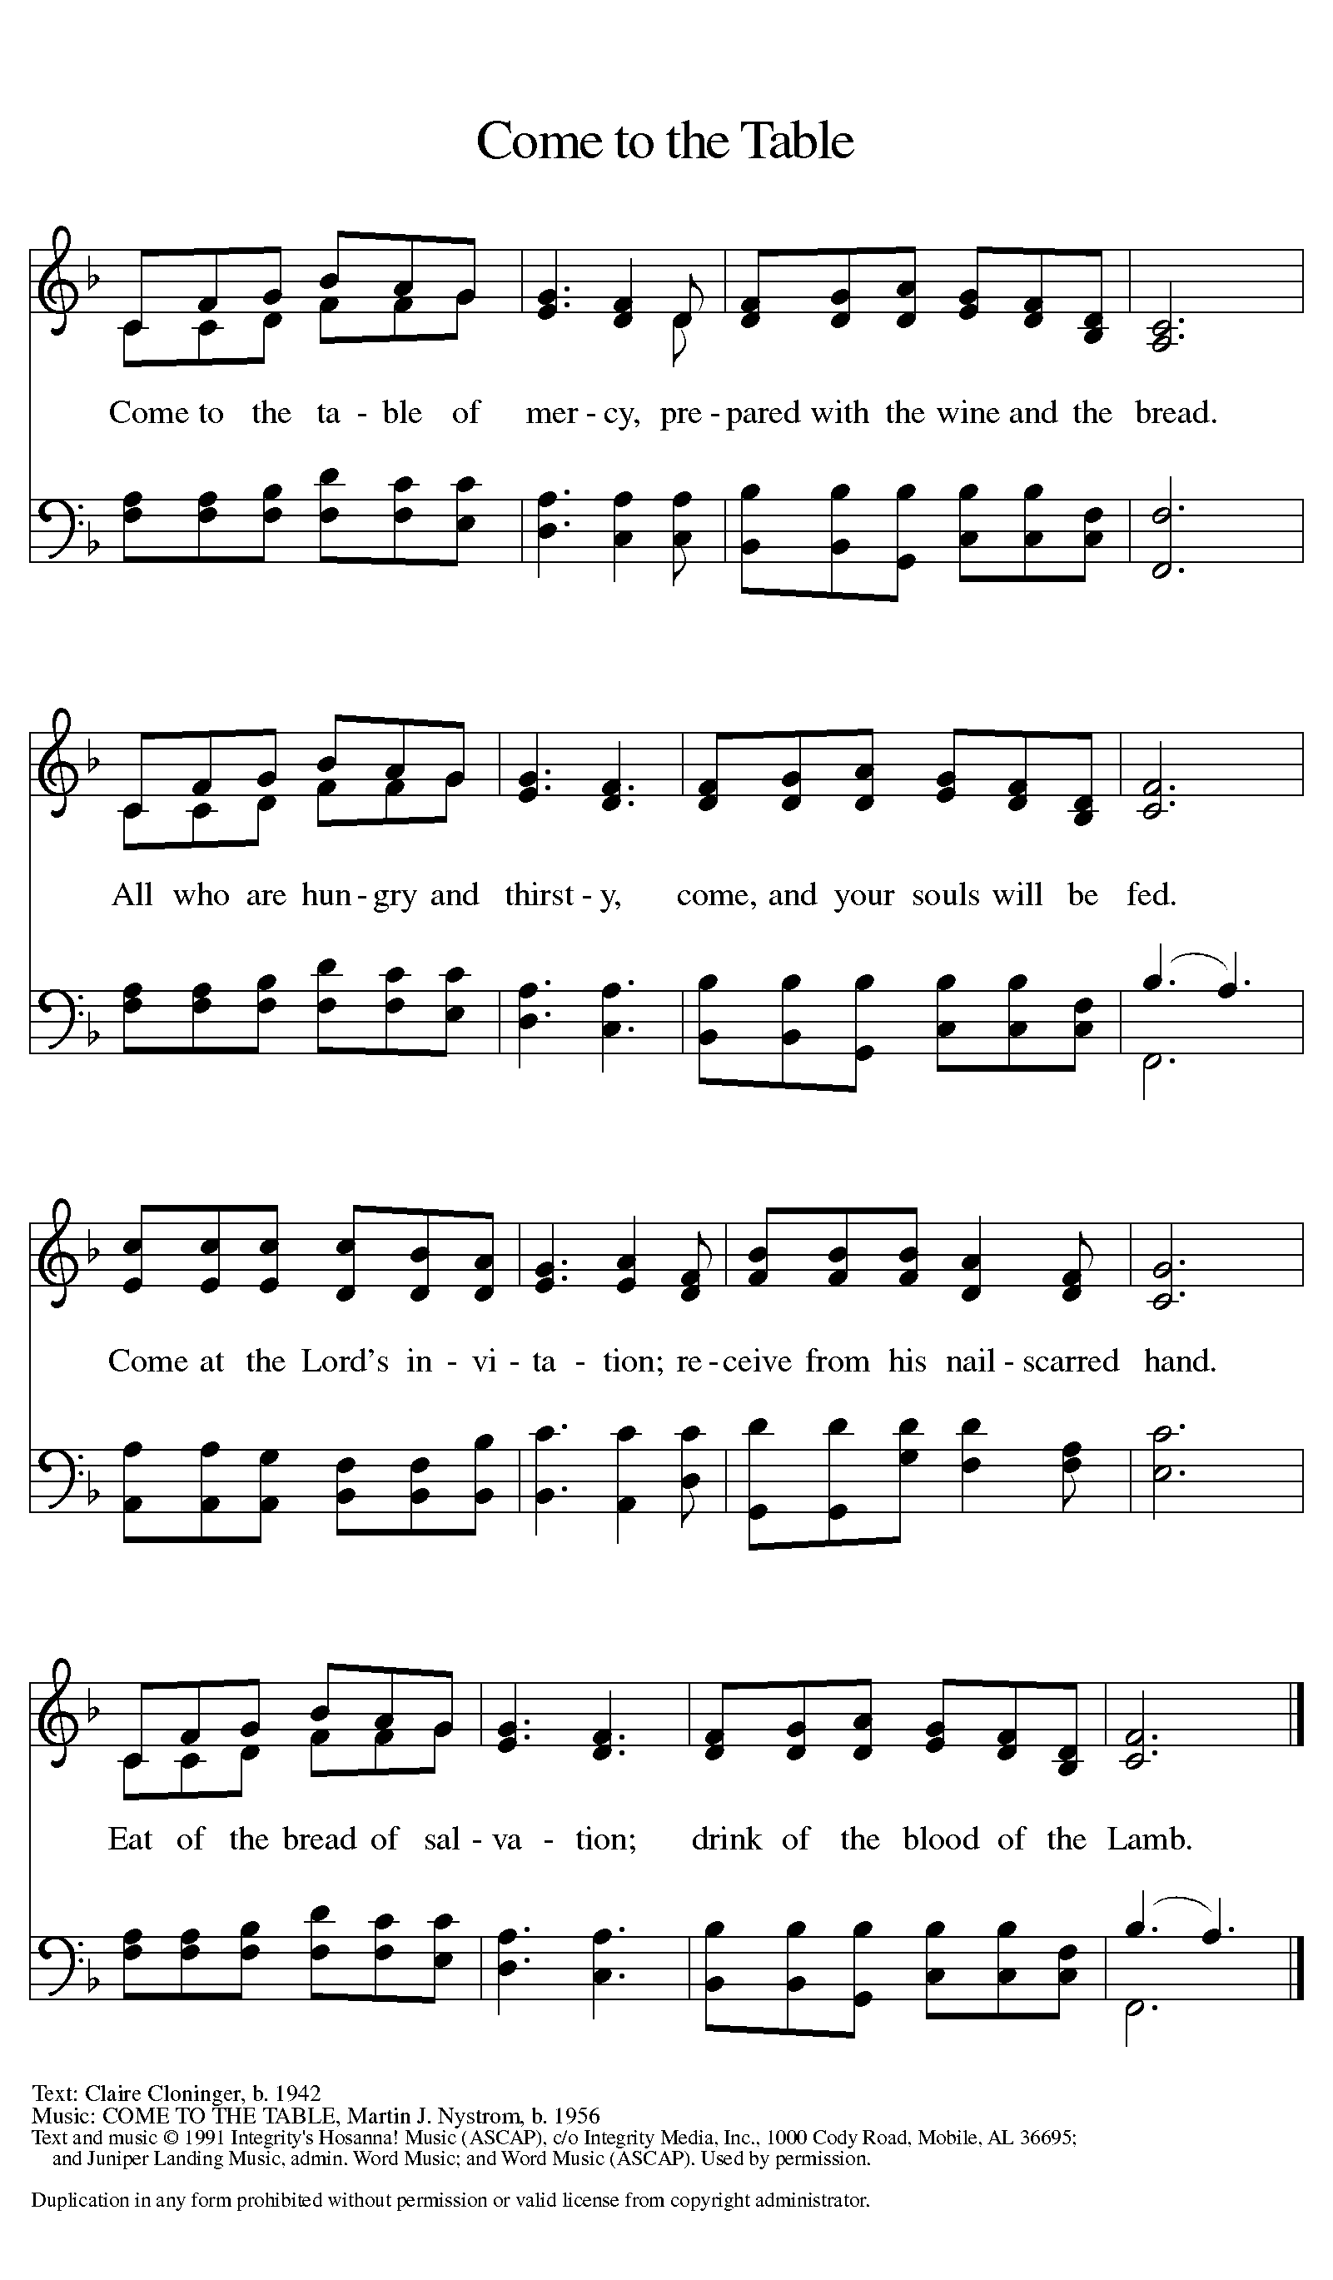

**Distribution - Please come forward to receive**

***Communion Anthems: Spirit Song W&P 130***

***I Come With Joy ELW 482***

P: Now may the body and blood of our Lord Jesus Christ strengthen you and keep you in his grace.

**C: Amen**

**Prayer After Communion**

**Holy God, you welcome us to this meal and feed us with dignity at your table. Send us now to welcome others and to be at peace with one another, through Jesus Christ our Lord.** **Amen.**

**Sending**

**Blessing**

P: God all mighty, God most merciful ☩ bless you, keep you, and give you peace.

**C: Amen**

### *Sending Hymn: Rise Up, O Saints of God! ELW 669*

1 Rise up, O saints of God! From vain ambitions turn;

Christ rose triumphant that your hearts with nobler zeal might burn.

2 Speak out, O saints of God! Despair engulfs earth's frame;

as heirs of God's baptismal grace, the word of hope proclaim.

3 Rise up, O saints of God! The kingdom's task embrace;

redress sin's cruel consequence; give justice larger place.

4 Give heed, O saints of God! Creation cries in pain;

stretch forth your hand of healing now, with love the weak sustain.

5 Commit your hearts to seek the paths which Christ has trod;

and, quickened by the Spirit's pow'r, rise up, O saints of God!

**Dismissal**

P: Go in peace. Proclaim the Good News!

**C: By the Grace of God we will – Alleluia!**

***Postlude: Father, I Adore You W&P 37***

Unless otherwise noted, materials used in this bulletin are:

From Sundays and Seasons.com. Copyright 2015 Augsburg Fortress. All rights reserved. Reprinted by permission under Augsburg Fortress Liturgies Annual License #SAS028635. Music is reprinted under OneLicense.Net #A712074 and/or Augsburg Fortress #SBL12176H. Scripture, unless otherwise noted, is from the New Revised Standard Version Bible, Copyright © 1989, Division of Christian Education of the National Council of the Churches of Christ in the United States of America. Used by permission. All rights reserved.

**REMEMBRANCE**

**Hildegard, Abbess of Bingen, died 1179**

A mystic who was widely influential within the church, Hildegard advised and reproved kings and popes, wrote poems and hymns, and produced treatises in medicine, theology, and natural history. She was also a musician and artist.

**Announcements for September 14th and 15th**

**ATTENDANCE**

**Saturday, September 7th, 4pm 22**

**Sunday, September 8th, 9am 46**

**Drive-Up Communion 3**

**71**

